Woodburn Transportation System Plan

Prepared For:
City of Woodburn
270 Montgomery Street
Woodburn, Oregon 97071
(503) 982-5246
Prepared By:
Kittelson & Associates, Inc.
851 SW 6th Avenue, Suite 600
Portland, OR 97204
(503) 228-5230

Final
September 2019
***Updated 2025***

This Project is partially funded by a grant from the Transportation and Growth Management (“TGM”) Program, a joint program of the Oregon Department of Transportation and the Oregon Department of Land Conservation and Development. This TGM grant is financed, in part, by federal Fixing America’s Surface Transportation Act (“FAST Act”), local government, and the State of Oregon funds.
The contents of this document do not necessarily reflect views or policies of the State of Oregon.

Acknowledgements
The development of the Woodburn Transportation System Plan was guided by the Project Management Team (PMT) a Technical Advisory Committee, and a volunteer Citizen Advisory Committee (CAC). The City of Woodburn would like to thank each of these individuals who devoted their time, expertise, and insight into the development of the plan.

Project Management Team (PMT)
- Chris Kerr, City of Woodburn
- Eric Liljequist, P.E., City of Woodburn
- Michael Duncan, ODOT

Citizens Advisory Committee (CAC)
- Dawn Cole – Estates Officer
- Mark Hester – Business Representative
- Kari Pankey – Parks Board
- Charlie Piper – Planning Commission Chairperson
- Sharon Schaub – City Councilor
- Peter Skei – Industrial Property Representative
- Sheryl Southwell – Industrial Property Representative
- Elias Villegas – Chemeketa College
- John Zobrist - Citizen

Consultant Team Members
- Matt Hughart, AICP, Kittelson & Associates, Inc.
- Molly McCormick, Kittelson & Associates, Inc.
- Julia Kuhn, P.E., Kittelson & Associates, Inc.
- Adrienne DeDona, JLA Public Involvement
- Clinton “CJ” Doxsee, Angelo Planning Group
- Darci Rudzinski, AICP, Angelo Planning Group

Table of Contents
Introduction 9
Why Create a Transportation System Plan? 9
Woodburn 2019 9
TSP Update Process 13
TSP Organization 14
Setting The Vision For Woodburn’s Transportation System 17
Goals and objectives 17
Motor Vehicle System 23
Functional Classification System 23
Roadway Plan 29
Freight Plan 39
Traffic Safety Plan 43
Local Street Connectivity Plan 45
Transit System 51
Existing Transit Service 51
Transit Plan Projects and Programs 55
Pedestrian System 61
Pedestrian Facilities 61
Pedestrian Plan Projects 63
Bicycle System 75
Bicycle Facilities 75
Bicycle Plan Projects 77
Other Travel Modes 85
Transportation System Management and Operations (TSMO) Plan 85
Rail Plan 89
Air Transportation 89
Marine Transportation 89
Pipeline 89
Funding 93
Funding Programs and Revenue 93
Planned Transportation System Cost Summary 95
Glossary of Terms 99

List of Tables
Table 1: Functional Classification Comparison by Jurisdiction 27
Table 2: Roadway Plan Projects 31
Table 3: Traffic Safety Projects 43
Table 4: Transit Plan 55
Table 5: Pedestrian Plan Projects 64
Table 6: Bicycle Plan Projects 77
Table 7: Transportation Demand Management Program Strategies 86
Table 8: Land Use Projects 87
Table 9: Access Management Projects 88
Table 10: Rail Projects 89
Table 11: City of Woodburn Revenue History 93
Table 12: Potential Grant Sources and Partnering Opportunities 94
Table 13: Potential New Funding Sources for Consideration by the City of Woodburn 94
Table 14: Planned Transportation System Cost Summary 95

List of Figures
Figure 1: Regional Map 11
Figure 2: Functional Roadway Classification 24
Figure 3: Roadway Plan Projects 37
Figure 4: Freight Routes 41
Figure 5: Traffic Safety Projects 47
Figure 6: Local Street Connectivity 48
Figure 7: Existing Transit Facilities 53
Figure 8: Pedestrian Plan Projects 71
Figure 9: Bicycle Plan Projects 81

***Note – 2025 TSP Update***
Woodburn’s Southwest Industrial Reserve (SWIR) has undergone significant changes since the adoption of the 2019 TSP, highlighted by the construction and recent opening of the Amazon fulfillment center along Butteville Road and the soon to be opened extension of Evergreen Road to Parr Road. These changes are occurring amidst the on-going buildout of the Smith Creek and Brighton Pointe residential neighborhoods and various other residential projects. Most recently, the City of Woodburn formally expanded its urban growth boundary (UGB) which added approximately 237 acres of land to the SWIR, creating significant future industrial development opportunities to the area.

To accommodate these land use actions, Woodburn began an sub-area planning process in 2024 to identify and develop a more detailed list of transportation infrastructure projects for the southwest portion of the City. The 2025 TSP Update is the product of this subarea refinement plan.

This page intentionally left blank

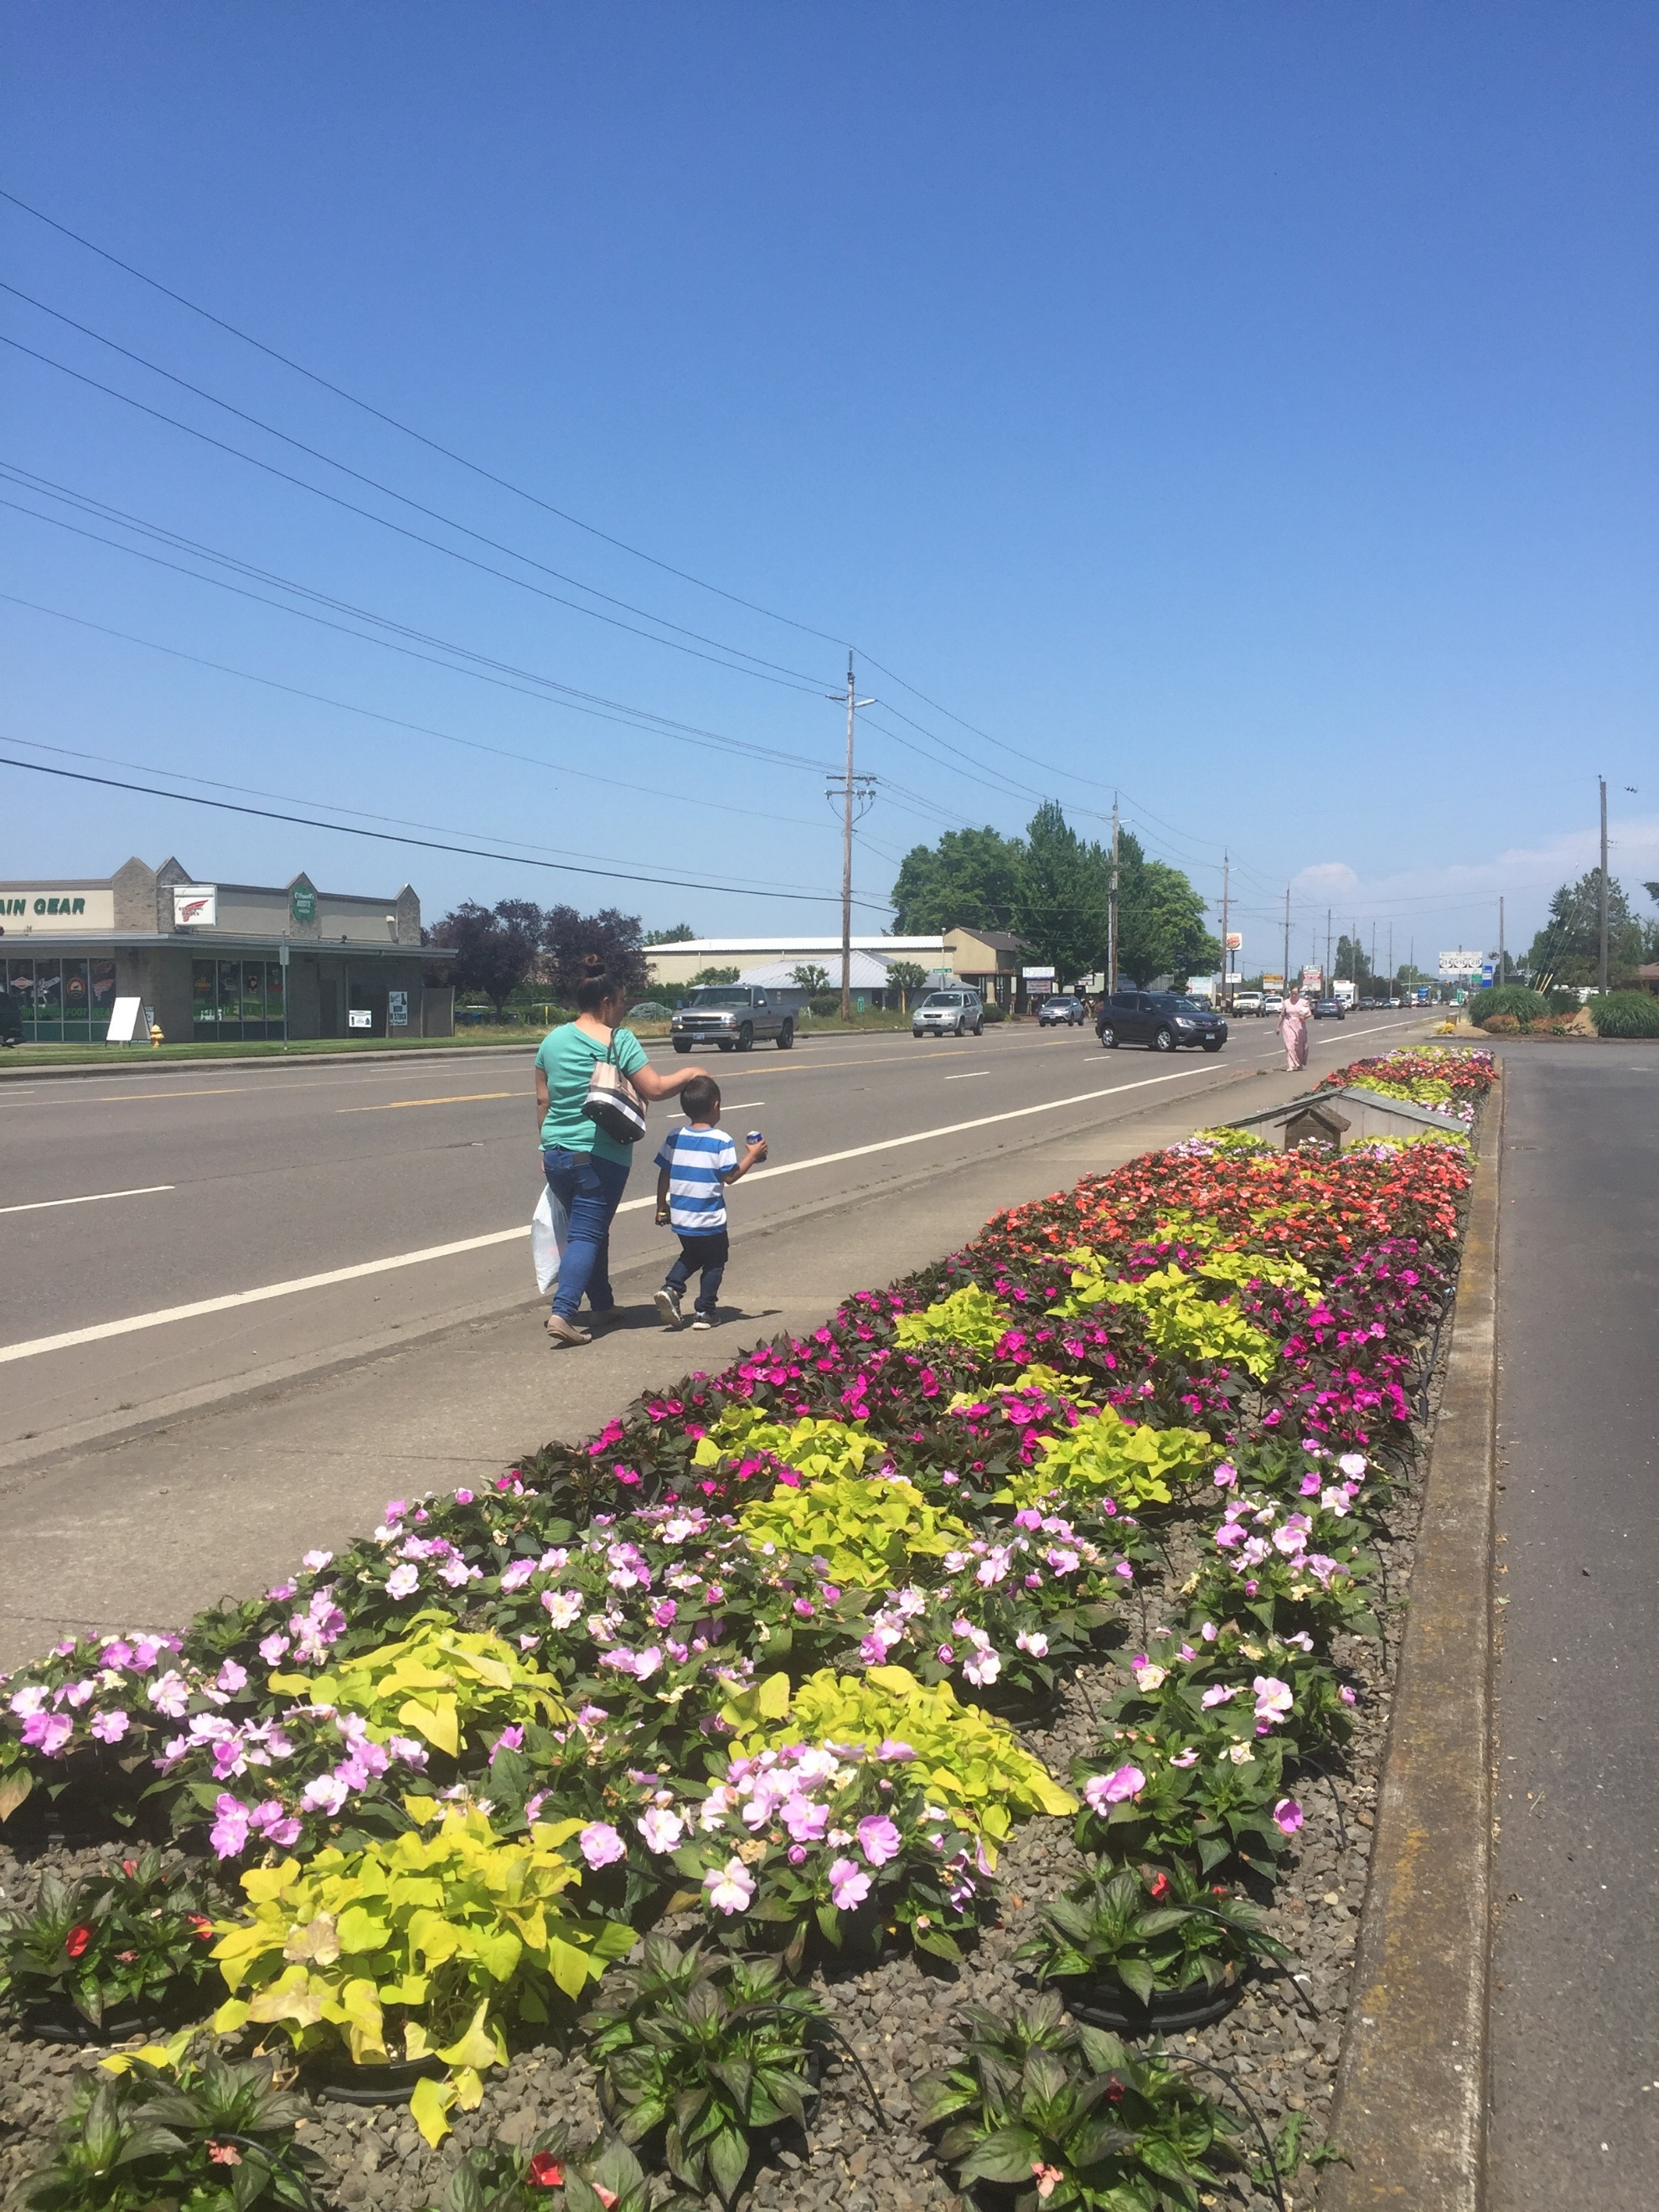

Why Create a Transportation System Plan?

Woodburn 2019

TSP Update Process

TSP Organization

1iNTRODUCTION

This page intentionally left blank

Introduction

Why Create a Transportation System Plan?
The Woodburn Transportation System Plan (TSP) is a long-range plan that sets the vision for the city’s transportation system, facilities and services to meet state, regional, and local needs for the next 20 years. The TSP was developed through community and stakeholder input and is based on the system’s existing needs, opportunities, and anticipated available funding. The plan also serves as the Transportation Element of the Woodburn Comprehensive Plan. The purpose of the 2019 TSP update is to address regulatory changes that have occurred in the region since the previous 2005 TSP, as well as to provide an updated list of projects to address local transportation needs and deficiencies.
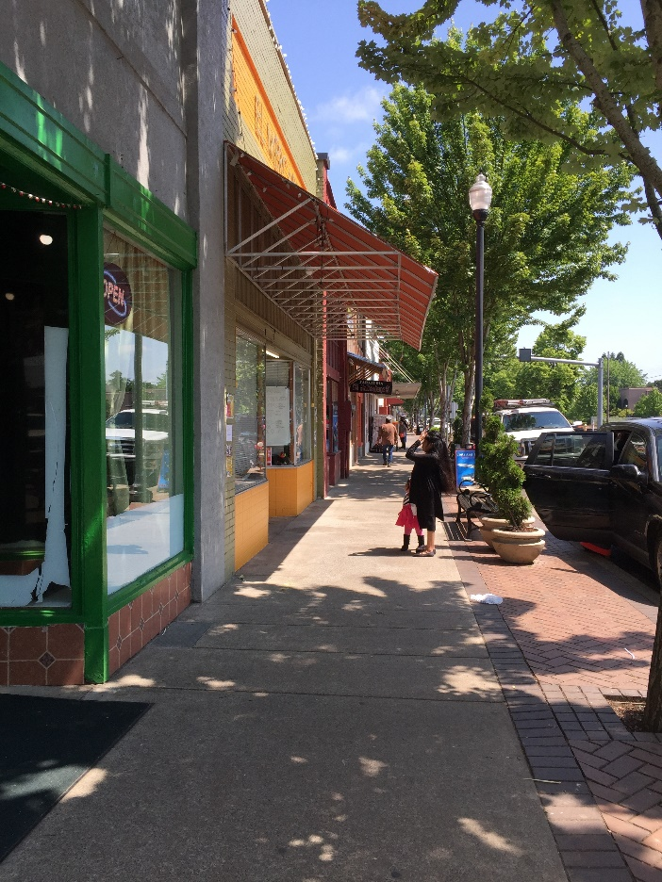 | 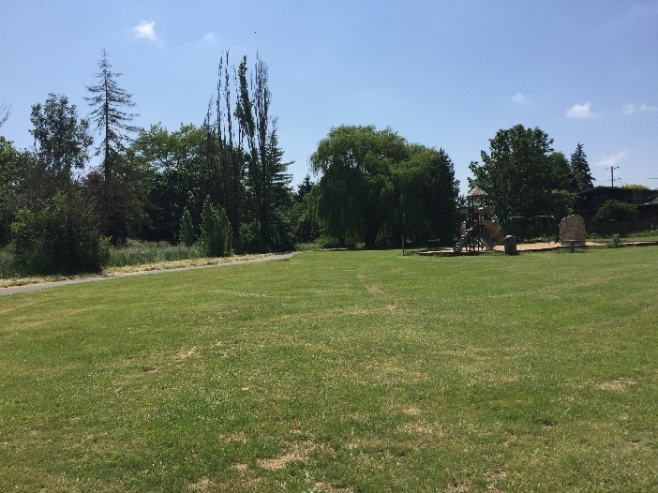
Pedestrians in Downtown Woodburn | Playground Located Along the Existing Section of Mill Creek Greenway
The TSP addresses compliance with new or amended Federal, State, and local plans policies, and regulations including the Oregon Transportation Plan (OTP), the State’s Transportation Planning Rule (TPR), the Oregon Highway Plan (OHP), and presents the investments and priorities for the Pedestrian, Bicycle, Transit, and Motor Vehicle System.

Woodburn 2019
As shown in Figure 1, the City of Woodburn lies in the Willamette Valley in Marion County, approximately 30 miles south of Portland and approximately 20 miles north of Salem. Initially starting as land purchased for a tree nursery, construction of the railroad led to rapid development and incorporation as a city in 1889. Further growth occurred as additional tracks and I-5 were constructed. Based on information from the Portland State University Population Research Center (PRC), Woodburn has an estimated 2016 population of 24,795 people, comprising 7.4% of Marion County’s 333,950 residents. The community is known for its tourism, local events, and young and diverse population. Big attractions include the Woodburn Premium Outlets, several golf courses, Tulip Festival, Fiesta Mexicana, and the Woodburn Dragstrip with over 4.5 million visitors to the area each year.

This page intentionally left blank

Figure 1: Regional Map

Blank 11x17 page

TSP Update Process
The TSP update process began with a review of local, regional, and statewide plans and policies that guide land use and transportation planning in the city. Goals and objectives were then developed collaboratively with the project’s Citizens Advisory Committee (CAC) to guide the evaluation of the existing and future transportation system conditions as well as the development of planned improvements. An inventory of the multimodal transportation system was conducted to serve as the basis for the existing and future conditions analyses. The existing and future condition analyses focused on identifying gaps and deficiencies in the multimodal transportation system based on current and forecast future performances. For each gap and deficiency, a solution, or set of potential solutions, was identified to address the system needs. The solutions were then evaluated to determine the preferred solutions, which were prioritized through the public involvement process and organized into planned project lists. The culmination of the TSP update process is this document, which presents the plans and solutions identified to address the existing and future gaps and deficiencies in the city’s transportation system.

Committees
The project team developed the TSP update in close coordination with city staff, along with representatives from the local community. One formal committee, referred to as the Citizens Advisory Committee (CAC), had a significant role in the TSP update process. The CAC consisted of local residents with an interest in transportation. The CAC provided technical guidance and coordination throughout the project. CAC members reviewed and commented on technical memorandums and participated in committee meetings and community meetings. The CAC served as the voice of the community and the caretakers of the goals and objectives of the TSP update.

Public Involvement
The Woodburn TSP is the result of a collaboration among various public agencies, the community, and the project team of city staff, Oregon Department of Transportation (ODOT), and consultants. The public involvement process consisted of continuous face-to-face interactions at multiple events. These events included three drop-in style and three on-line open houses spaced over the course of key project milestones. A detailed summary of the open house outreach methods and feedback is provided in the technical companion document to the TSP. At the deliverable level, the project was supported by Citizens Advisory Committee (CAC) made up of interested citizens, business representatives, and Planning Commission members.

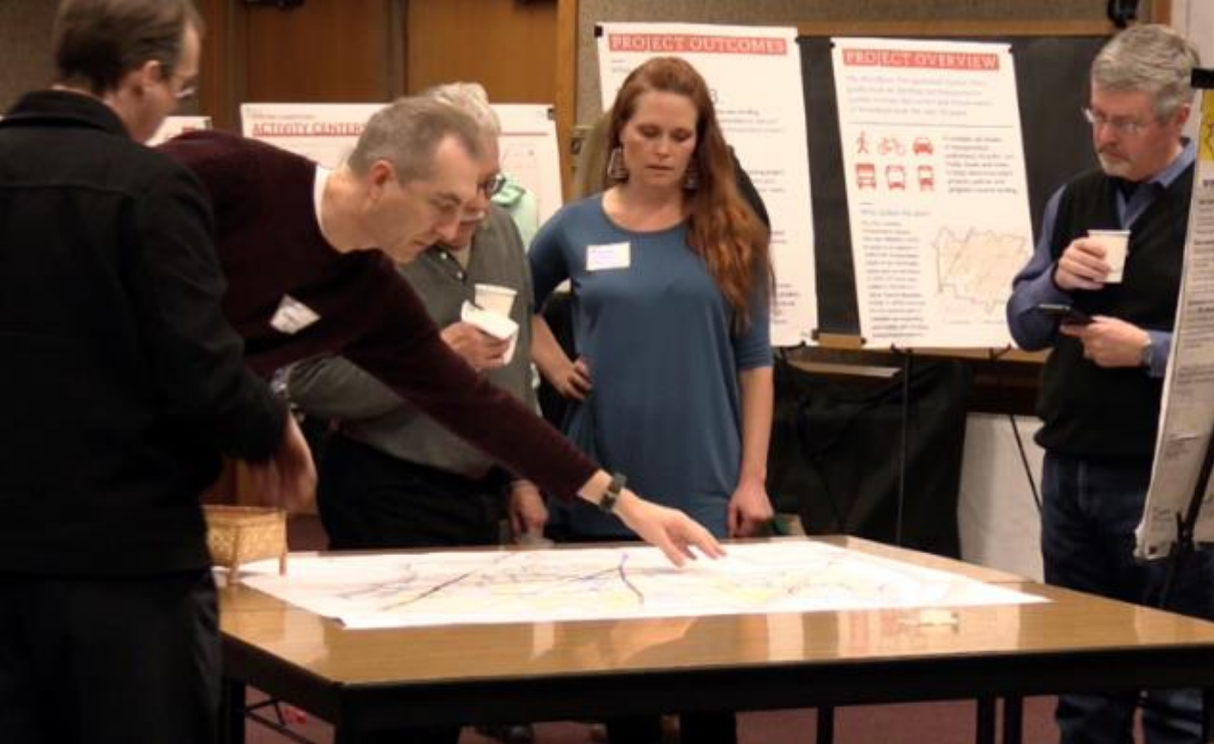 | 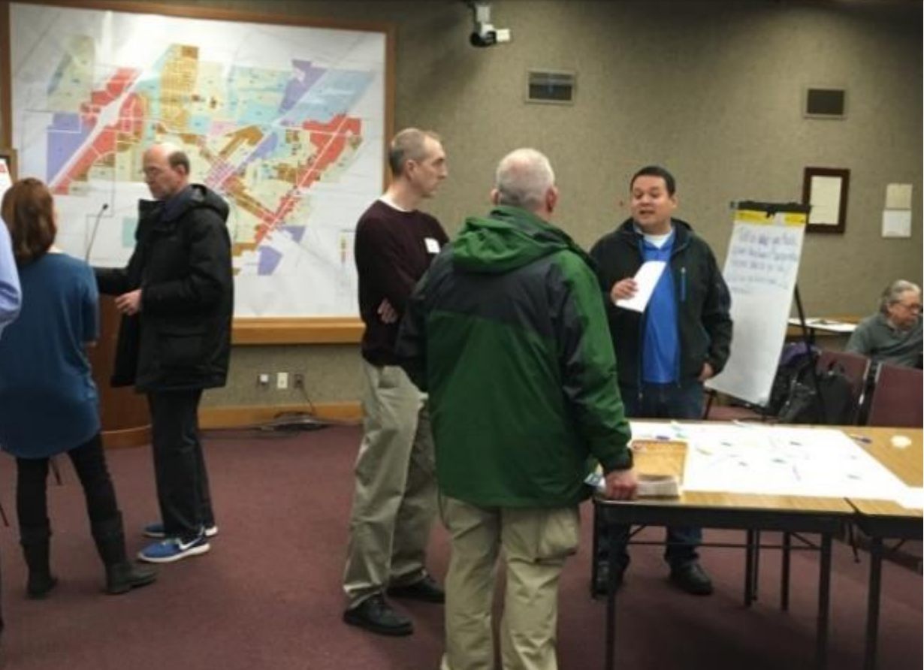
Open House #1 | Open House #1
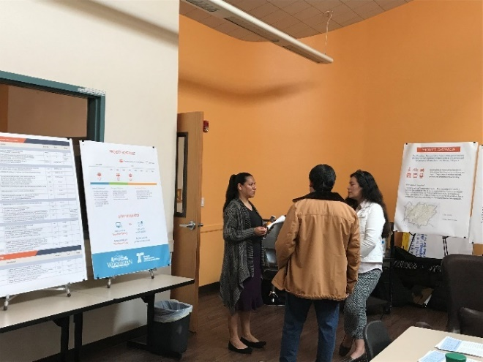 | 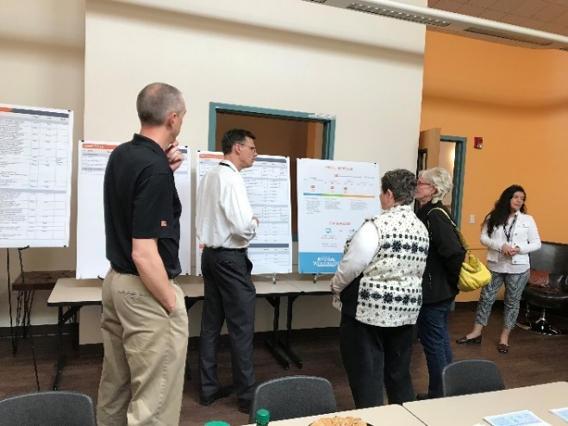
Open House #3 | Open House #3

TSP Organization
The Woodburn TSP is comprised of the main TSP summary document (Volume I) and a volume of supporting technical appendices and other supporting documentation (Volume II). Volume I (this document) is organized into the following sections:
- Chapter 1 – Introduction
- Chapter 2 – Setting The Vision for Woodburn’s Transportation System
- Chapter 3 – Motor Vehicle System
- Chapter 4 – Transit System
- Chapter 5 - Pedestrian System
- Chapter 6 – Bicycle System
- Chapter 7 – Other Travel Modes
- Chapter 8 – Funding and Implementation Outline
Chapter 9 – Glossary of Terms
Volume II (under separate cover) contains the technical memorandums prepared during the development of the TSP including the detailed data and technical analyses that informed the plan.
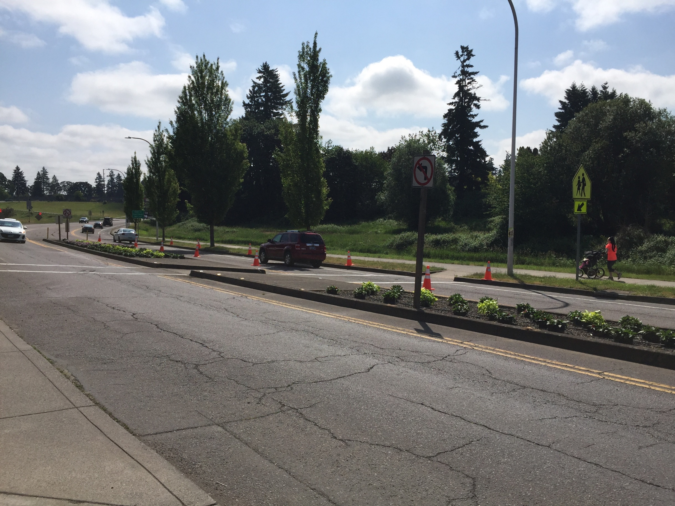

Setting the Vision for Woodburn’s Transportation System

Goals and Objectives

2 The vision for transportation

This page intentionally left blank

Setting The Vision For Woodburn’s Transportation System
Setting a vision for a city’s transportation system is an essential first step in maintaining the existing system and establishing the framework to accommodate potential growth. The public involvement process for the TSP provided a forum for the community to express their vision for the future of Woodburn’s transportation network. The community advisory committee and other community members expressed a desire for a transportation system that maintains community livability, enhances existing transportation infrastructure, increases safety for all users, and provides a framework for potential growth.

Goals and objectives
The project team developed goals and objectives for the TSP update to help guide the review and documentation of the preferred future Woodburn transportation system. As described in Technical Memorandum #6: Preferred Alternatives, the goals and objectives through a range of evaluation criteria that were applied to select preferred alternatives and priority rankings among the identified projects. In compliance with state, regional, and local planning requirements, the goals and objective below emphasize a multimodal system that supports all modes and users.

Goal 1 – Multimodal Mobility
Provide a multimodal transportation system that avoids or reduces a reliance on one form of transportation and minimizes energy consumption and air quality impacts.

Objective 1A
Develop an expanded intracity bus transit system that provides added service and route coverage to improve the mobility and accessibility of the transportation disadvantaged and to attract traditional auto users to use the system.

Objective 1B
Develop a plan for providing travel options between Woodburn and Portland or Salem, including intercity bus service and potential bus/carpool park-and-ride facilities.

Objective 1C
Develop a comprehensive low stress network of bicycle lanes and routes that link major activity centers such as residential neighborhoods, schools, parks, commercial areas, and employment centers.

Objective 1D
Develop a comprehensive network of sidewalks and off-street pathways that improve pedestrian mobility within neighborhoods and link residential areas to schools, parks, commercial areas, and employment centers.

Objective 1E
Maintain adequate intersection and roadway capacity on the key east-west and north-south arterials.

Goal 2 – Connectivity
Provide an interconnected street system that is adequately sized to accommodate existing and projected traffic demands in the Woodburn area.

Objective 2A
Verify and Incorporate the relevant strategies and infrastructure projects from the existing TSP, I-5/OR 214 IAMP, and 99E Refinement Plan

Objective 2B
Identify new east-west and north-south collector/minor arterial streets within the City to relieve traffic demands on Oregon 219/214, 211, and 99E, and coordinate with Marion County to construct the street connections needed outside of the urban growth boundary (UGB).

Objective 2C
Develop updated street design standards for arterials, collectors, and local streets.

Goal 3 – Safety
Provide a transportation system that enhances the safety and security of all transportation modes in the Woodburn area.

Objective 3A
Address existing and potential future safety issues by identifying high collision locations and locations near schools or with a history of fatal, severe injury, and/or pedestrian/bicycle-related crashes and developing strategies to address those issues.

Objective 3B
Identify street and railroad crossings in need of improvement, as well as those that should be closed or relocated.

Objective 3C
Develop a plan for designated truck routes through the City, and a plan to handle truck and rail hazardous cargoes

Goal 4 – Strategic Investment
Provide a financially sustainable transportation system through responsible stewardship of assets and financial resources.

Objective 4A
Identify new and innovative funding sources for transportation improvements

Objective 4B
Preserve and maintain the existing transportation system assets to extend their useful life.

Goal 5 – Land Use and Transportation Integration
Review and update land use standards and ordinances to create a balanced built environment where existing and planned land uses are supported by an efficient multi-modal transportation system.

Objective 5A
Identify a range of potential Transportation Demand Management (TDM) strategies that can be used to improve the efficiency of the transportation system by shifting single-occupant vehicle trips to other modes and reducing automobile reliance at times of peak traffic volumes.

Objective 5B
Identify revisions to the Woodburn Zoning Ordinance for compliance with the Transportation Planning Rule

This page intentionally left blank

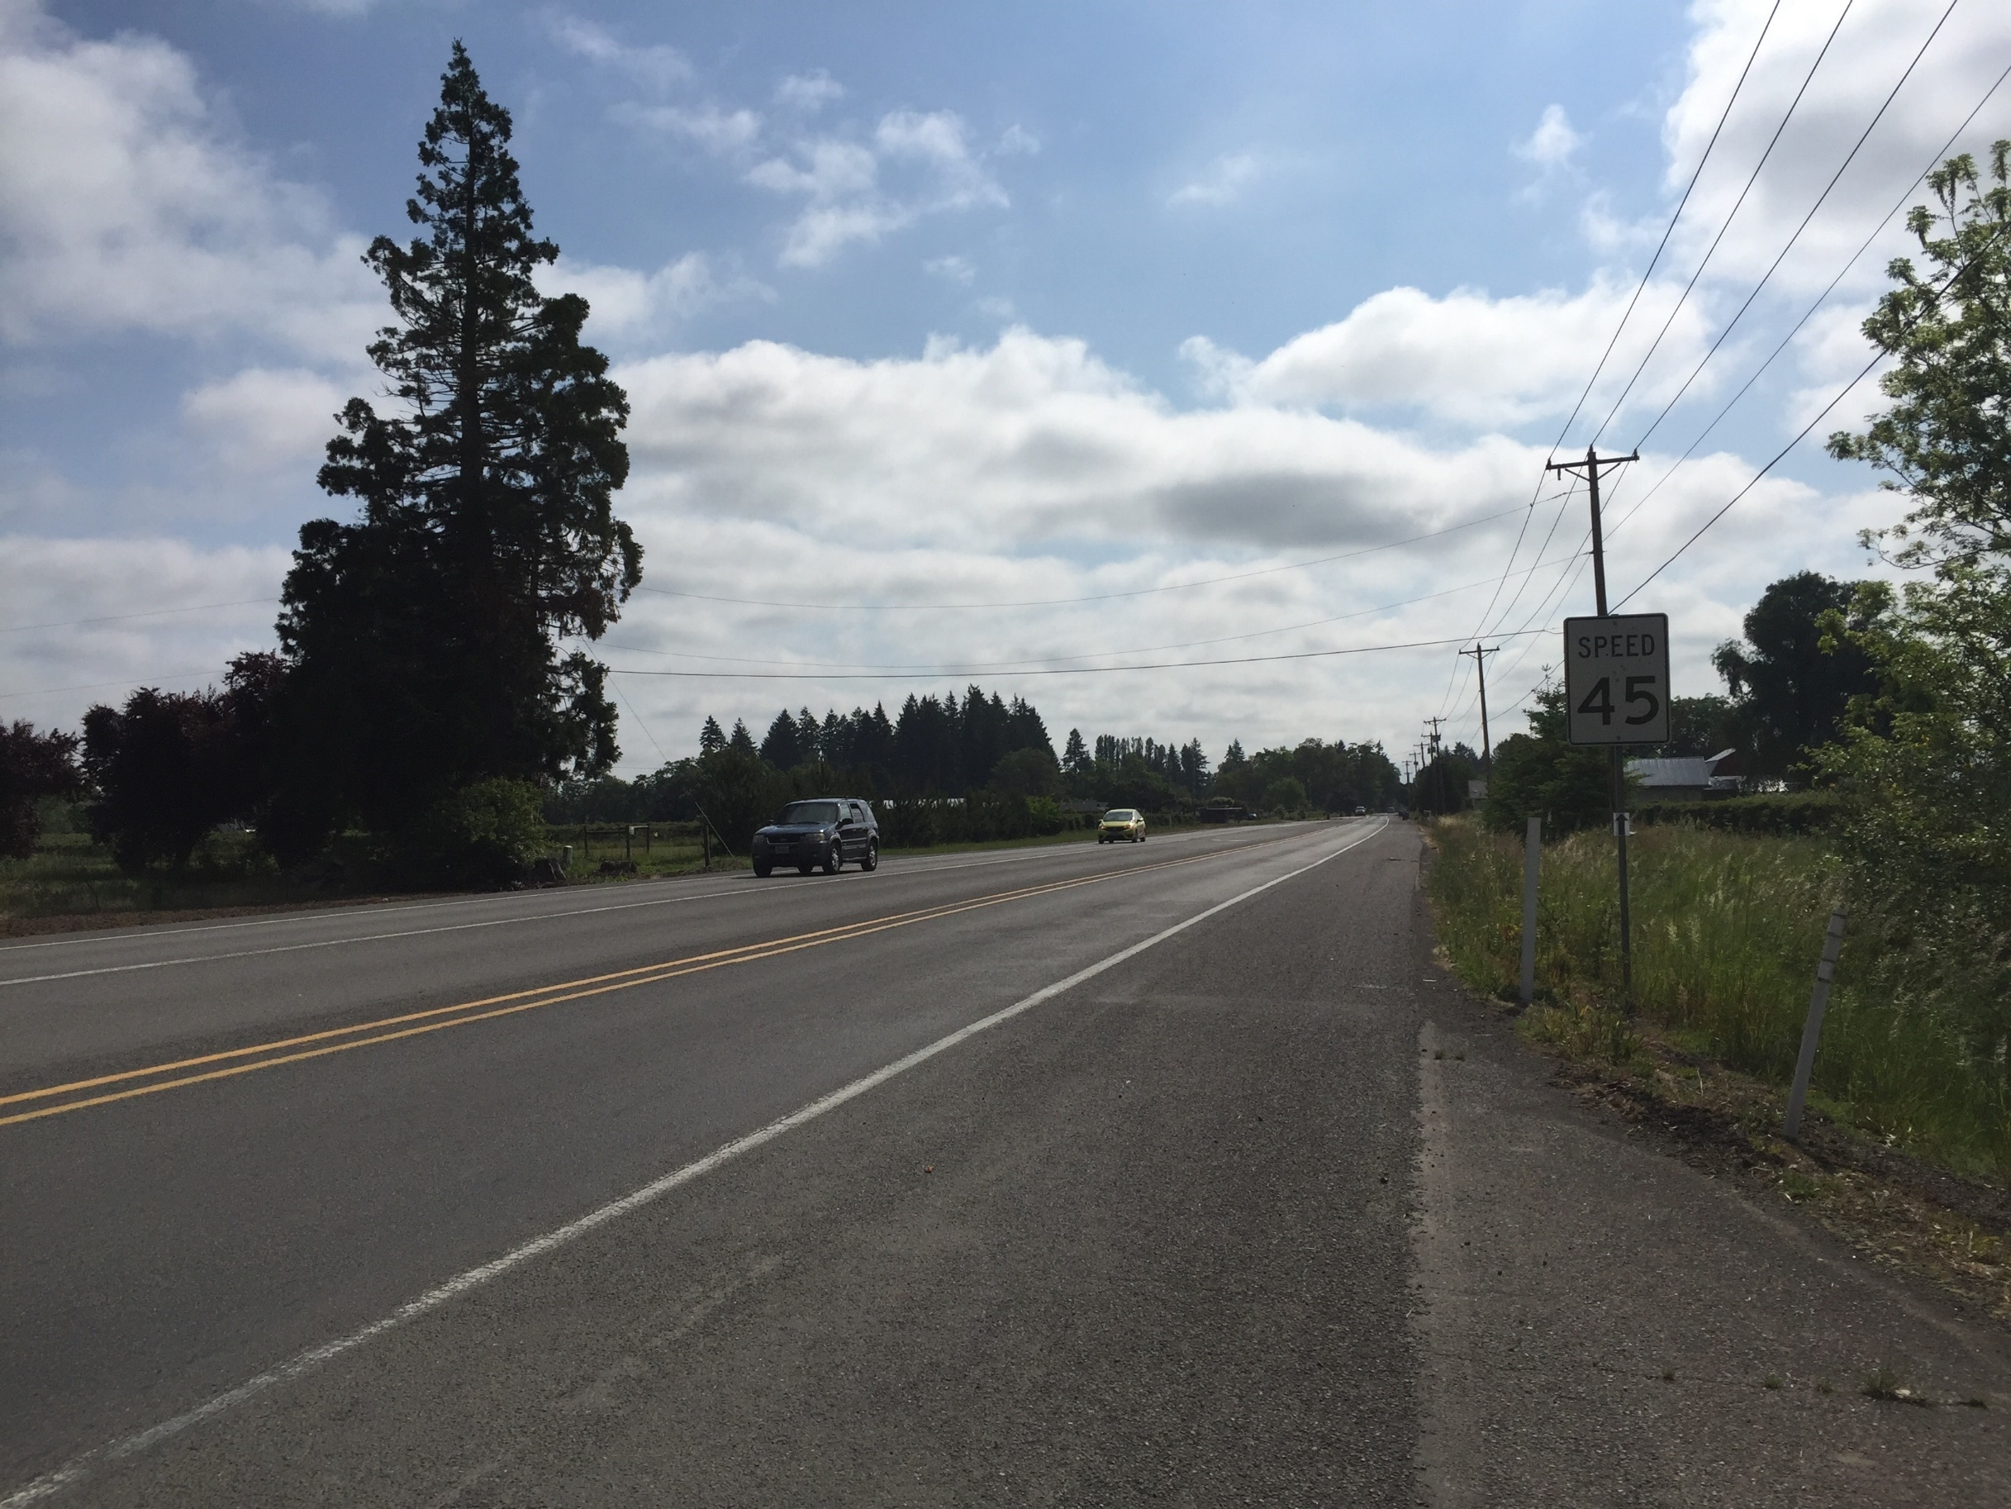

Functional Classification System

Roadway Plan

Freight Plan

Traffic Safety Plan

Local Street Connectivity Plan

3 Motor Vehicle System

This page intentionally left blank

Motor Vehicle System
Streets serve a majority of all trips within Woodburn across all travel modes. In addition to motorists in private vehicles, pedestrians, bicyclists, and public transit riders use streets to access areas locally and regionally. This section summarizes the updated functional classification system, roadway plan, freight plan, safety plan, and local street connectivity plan that make up Woodburn’s motor vehicle system.

Functional Classification System
A street’s functional classification defines its role in the transportation system and reflects desired operational and design characteristics such as right-of-way requirements, pavement widths, pedestrian and bicycle features, and driveway (access) spacing standards.
Figure 2 illustrates the functional classification of streets within Woodburn, which includes the following designations as defined by the current Woodburn TSP:
- Freeways – The primary function of the interstate is mobility, because freeways connect major cities, regions within Oregon, and other states, and serve as major freight routes. The freeway should provide “safe and efficient high-speed continuous flow.” The freeway has full access control with access limited to the interchange. Only motorized vehicle traffic is served.
- Major Arterials – Primary functions are to serve local and through traffic as it enters and leaves the urban area, connect Woodburn with other urban centers and regions, and provide connections to major activity centers within the UGB. Emphasis should be on traffic flow, pedestrian and bicycle movements. On-street bicycle lanes and sidewalks should be provided.
- Minor Arterials – Primary functions are to connection major activity centers and neighborhoods within the UGB and to support the major arterial system. Minor arterials should have a higher degree of access, shorter trip lengths, lesser traffic volumes, and lower travel speeds than major arterials. Like major arterials, emphasis should be on traffic flow, pedestrian and bicycle movements. On-street bicycle lanes and sidewalks should be provided.
- Service Collector - Primary function is to provide connections between neighborhoods and major activity centers and the arterial street system. Some degree of access is provided to adjacent properties, while maintaining circulation and mobility for all users. Service collectors carry lower traffic volumes at slower speeds than major and minor arterials. On-street bicycle lanes and sidewalks should be provided.

- Access Streets – Primary function is to connect residential neighborhoods with service collectors or arterials. On-street parking and access to adjacent properties is prevalent. Slower speeds should be provided to ensure community livability and safety for pedestrians and cyclists. In many cases, cyclists can “Share the road” with motor vehicles because of low traffic volumes and speeds. Sidewalks or pathways should be provided for pedestrians.
- Local Streets – Primary function is to provide direct access to adjacent land uses. Short roadway distances, slow speeds, and low traffic volumes characterize local streets. Cyclists can share the road with motor vehicles. Sidewalks or pathways should be provided for pedestrians. Local street designations include residential local streets and industrial local streets.

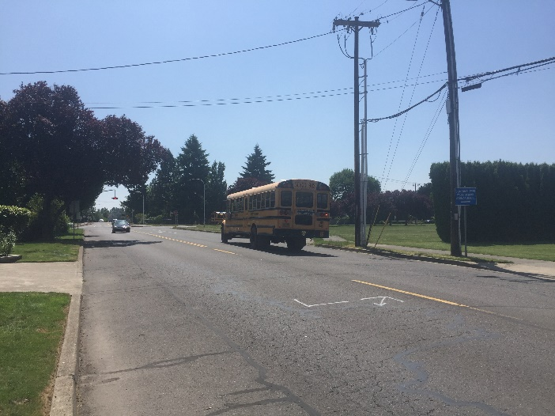 | 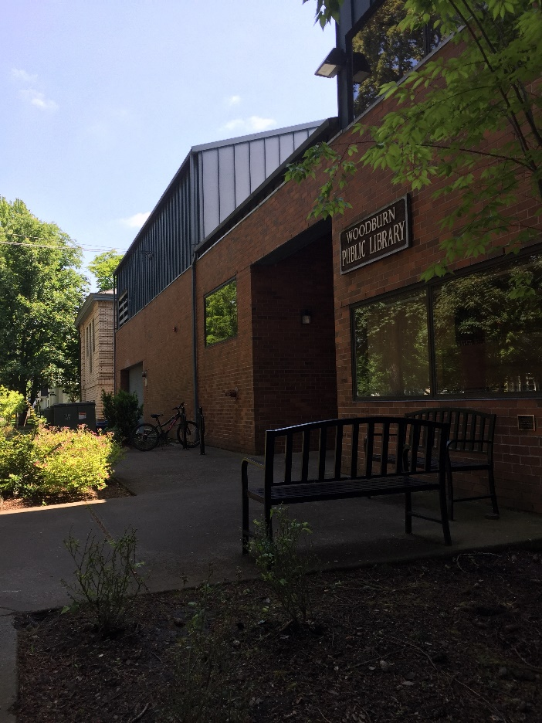
School Bus | Woodburn Public Library

Table 1 summarizes the functional classifications of the major arterial, minor arterial, and service collector streets within Woodburn and identifies the overlapping ownership/maintenance and jurisdictional relationships that exist.
The functional classifications used in local TSPs should be consistent with other regional planning efforts. As shown in Table 1, there are several streets that currently have conflicting classifications.

Figure 2: Functional Roadway Classification

Blank 11x17 page

Table 1: Functional Classification Comparison by Jurisdiction
Roadway | Jurisdiction | Functional Classification |  |  | Consistent between Jurisdictions?
 |  | Woodburn | Marion County | Federal
Butteville Road  (north of OR 219 and south of OR 219) | County/City | Minor Arterial | Major Collector | Major Collector | No
Butteville Road  (segment where aligned with OR 219) | ODOT | Minor Arterial |  | Minor Arterial | Yes
OR 219 (Butteville Road to Woodland Avenue) | ODOT | Major Arterial |  | Minor Arterial | No
OR 219 (Woodland Avenue to I-5) | ODOT | Major Arterial |  | Principal Arterial | No
Woodland Avenue | City | Access Street |  | Major Collector | No
Arney Road | City/Private | Service Collector |  | Major Collector | No
I-5 | ODOT | Freeway |  | Interstate | Yes
OR 214 (I-5 to OR 99E) | ODOT | Major Arterial |  | Principal Arterial | Yes
OR 214 (OR 99E to UGB east limits) | ODOT | Major Arterial |  | Minor Arterial | No
Stacy Allison Way | City | Service Collector |  | Local | No
Center Street | City | Service Collector |  | Local | No
Evergreen Road (OR 219 to Boean Lane) | City | Minor Arterial |  | Major Collector | No
Evergreen Road (Boean Lane to end of road) | City | Minor Arterial |  | Local | No
Harvard Drive | City | Access Street |  | Local | No
Stubb Road | City | Access Street | No Designation | Local | No
Parr Road | City | Service Collector | Major Collector | Major Collector | No
Hayes Street | City | Service Collector |  | Major Collector | No
Oregon Way | City | Access Street |  | Major Collector | No
Astor Way | City | Access Street |  | Major Collector | No
Country Club Road | City | Access Street |  | Major Collector | No
Boones Ferry Road/Settlemier Avenue  (north of Parr Road) | County/City | Minor Arterial | Arterial | Minor Arterial | Yes
Boones Ferry Road/Settlemier Avenue  (south of Parr Road) | County/City | Minor Arterial | Major Collector | Minor Arterial | Yes
Tukwila Drive | City | Access Street |  | Major Collector | No
Hazelnut Drive | City | Access Street |  | Major Collector | No
5th Street | City | Access Street |  | Major Collector | No
Harrison Street | City | Service Collector |  | Major Collector | No
Lincoln Street | County/City | Service Collector | Local | Major Collector | No
Garfield Street | City | Minor Arterial |  | Minor Arterial | Yes
Young Street | City | Minor Arterial |  | Minor Arterial | Yes
Cleveland Street | City | Service Collector |  | Major Collector | No
Front Street | City | Minor Arterial |  | Minor Arterial | Yes
Industrial Avenue | City | Service Collector |  | Major Collector | No
Progress Way | City | Service Collector |  | Major Collector | No
OR 211 | ODOT | Major Arterial |  | Minor Arterial | Yes
Park Avenue | City | Access Street |  | Major Collector | No
Hardcastle Avenue | County/City | Service Collector | No Designation | Major Collector | No
Gatch Street | City | Access Street |  | Major Collector | No
Brown Street | City | Service Collector |  | Major Collector | No
OR 99E  (north of OR 214 and south of Young Street) | ODOT | Major Arterial |  | Minor Arterial | No
OR 99E (segment where aligned with OR 214) | ODOT | Major Arterial |  | Principal Arterial | No
Cooley Road | City | Service Collector | Local | Major Collector | No

Roadway Cross-section Standards
A functional classification system as shown in Figure 2 has to work together with roadway cross-section standards to allow for standardization of key characteristics within roadway classifications while also providing some flexibility based on context. A roadway’s cross-section and design will vary between streets and between segments based on adjacent land uses and demands, but the overall street network should also be considered. The Woodburn Development Ordinance Section 3.01.04 contains the current roadway cross-sections standards for the city that work together with the identified functional classification system shown in Figure 2.

Roadway Plan

Roadway Facilities
The roadway facility types that are currently utilized or that are recommended through the roadway plan projects are described below.

Turn Lanes
Separate left- and right-turn lanes, as well as two-way left-turn lanes (TWLTL) can provide separation between slowed or stopped vehicles waiting to turn and through vehicles. The design of turn lanes is largely determined based on a traffic study that identifies the storage length needed to accommodate vehicle queues. Turn lanes are commonly used at intersections where the turning volumes warrant the need for separation.

Traffic Signals
Traffic signals allow opposing streams of traffic to proceed in an alternating pattern. National and state guidance indicates when it is appropriate to install traffic signals at intersections. When used, traffic signals can effectively manage high traffic volumes and provide dedicated times in which pedestrians and cyclists can cross roadways. Because they continuously draw from a power source and must be periodically re-timed, signals typically have higher maintenance costs than other types of intersection control. Signals can improve safety at intersections where signal warrants are met, however, they may result in an increase in rear-end crashes compared to other solutions. Signals have a significant range in costs depending on the number of approaches, how many through and turn lanes each approach has, and if it is located in an urban or rural area. The cost of a new traffic signal ranges from approximately $250,000 in rural areas to $500,000 in urban areas.

Signal Timing/Phasing Modifications
Signal retiming and optimization offers a relatively low-cost option to increase system efficiency. Retiming and optimization refers to updating timing plans to better match prevailing traffic conditions and coordinating signals. Timing optimization can be applied to existing systems or may include upgrading signal technology, such as signal communication infrastructure, signal controllers, or cabinets. Signal retiming can reduce travel times and be especially beneficial to improving travel time reliability. In high pedestrian or desired pedestrian areas, signal retiming can facilitate pedestrian movements through intersections by increasing minimum green times to give pedestrians time to cross during each cycle, which may create additional delay for other intersection users. Signals can also facilitate bicycle movements with the inclusion of bicycle detectors.
Signal upgrades often come at a higher cost than signal timing and phasing modifications and usually require further coordination between jurisdictions. However, upgrading signals provides the opportunity to incorporate advanced signal systems to further improve the efficiency of a transportation network. Strategies include coordinated signal operations across jurisdictions, centralized control of traffic signals, adaptive or active signal control, and transit or freight signal priority as further described in the Transportation System Management and Operations (TSMO) section. These advanced signal systems can reduce delay, travel time, and the number of stops for transit, freight, and other vehicles. In addition, these systems may help reduce vehicle emissions and improve travel time reliability.

Roundabouts
Roundabouts are circular intersections where entering vehicles yield to vehicles already in the circle. They are designed to slow vehicle speeds to 20 to 30 mph or less before they enter the intersection, which promotes a more comfortable environment for pedestrians, bicyclists, and other non-motorized users. Roundabouts have fewer conflict-points and have been shown to reduce the severity of crashes, as compared to signalized intersections. Roundabouts can be more costly to design and install when compared to other intersection control types, but they have a lower operating and maintenance cost than traffic signals. Topography must be carefully evaluated in considering a roundabout, given that slope characteristics at an intersection may render a roundabout infeasible. The cost of a new roundabouts ranges from approximately $2 million to $4 million depending upon the number of lanes and the slope conditions.

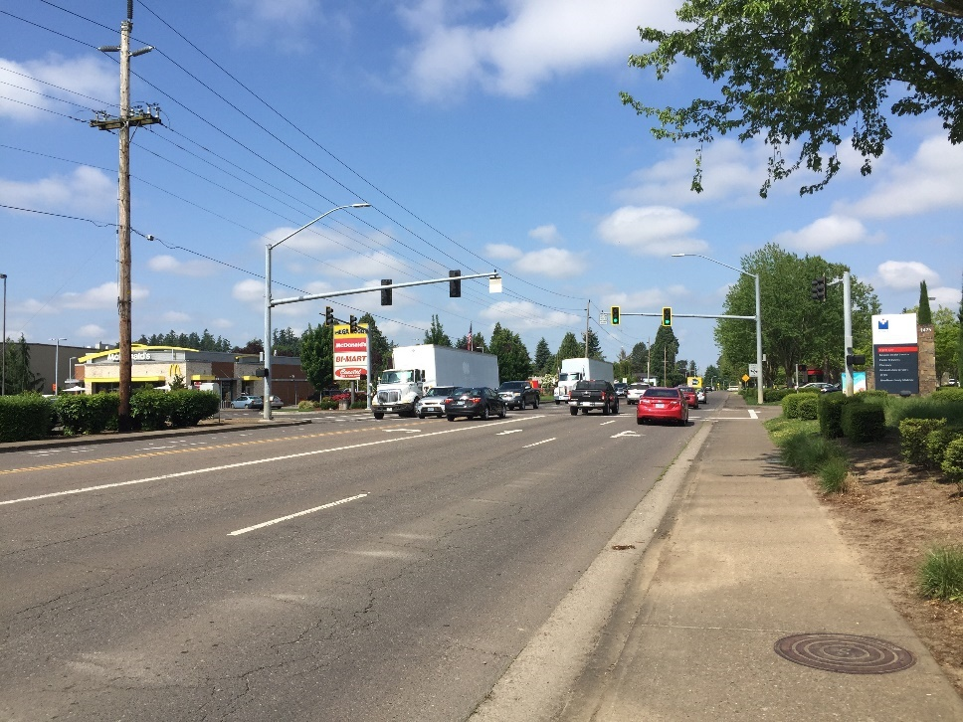  Traffic Signal | 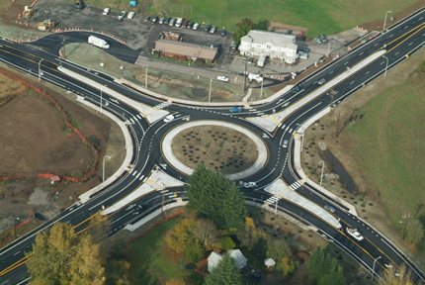  Roundabout

Through Lanes
When the demand per lane on a roadway segment has reached saturation, a potential solution is to construct additional through lanes. Although this theoretically adds capacity to the corridor, added lanes can allow latent demand from the system to show an increase in demand. Added lanes may also create induced demand where drivers see that roadway as less of a barrier with its increased capacity, drawing in additional new demand and potentially maintaining or worsening the rate of congestion.
When a roadway does not have a consistent number of travel lanes per direction along a corridor, an added through lane may provide a consistent cross-section allowing for less weaving by vehicles traveling the corridor.

Roadway Plan Projects
The projects developed for the roadway plan are summarized in Table 2 and shown in Figure 3. These projects are intended to address existing and projected future transportation system needs for motor vehicles as well as all other modes of transportation that depend on the roadway system for travel, such as pedestrians, bicyclists, transit users, and truck freight.
Table 2: Roadway Plan Projects
Project Number | Location | Responsible Jurisdiction | Type | Description | Priority | Cost Estimate²
R1 | Southern OR 219/Butteville Road Intersection | State/ County | Intersection - geometric considerations | Enhanced traffic control (traffic signal, roundabout, or other appropriate geometric enhancements) in coordination with ODOT | High | $2,750,000
R2 | OR 219 from Butteville Road to Willow Road | State | Street design | Widen roadway to include two lanes in each direction and a two-way left-turn lane (in conjunction with pedestrian and bicycle facility improvements) in coordination with ODOT | High | $1,700,000  (Cost includes B1 and P1)
R3 | OR 214 from Cascade Drive to OR 99E | State | Street design | Widen roadway to include two lanes in each direction and a two-way left-turn lane, including changes to signal timing as appropriate, in coordination with ODOT (and in conjunction with bicycle facility improvements) | Medium | $20,300,000  (Cost includes B2)
R4 | OR 99E from Lincoln Street to south UGB | State | Street design | As identified in the Highway 99E Corridor Plan, widen roadway to provide a continuous two-way left-turn lane and wider shoulders, including changes to signal timing as appropriate, in coordination with ODOT (and in conjunction with pedestrian and bicycle facility improvements) | Medium | $12,300,000  (Cost includes B3, B4, P3, and P4)
R5 | Parr Road from Stubb Road to Evergreen Road | City | Street design | Upgrade to Service Collector urban standards including bicycle and pedestrian enhancements | Low | $0¹  (Project includes B21 and P14)
R6 | Butteville Road from current improved extents to southern UGB | City | Street design | Upgrade to Minor Arterial urban standards including bicycle and pedestrian enhancements on the east side | Low | $0¹  (Project includes B7 and P5)
R7 | Brown Street from Comstock Avenue to Vine Avenue | City | Street design | Upgrade Brown Street to Service Collector urban standards including bicycle and pedestrian enhancements | Low | $0¹  (Project includes P19)
R8 | OR 214/  I-5 Southbound Ramp Intersection | State | Traffic signal timing | Investigate corridor signal timing and coordination adjustments in coordination with ODOT | Medium | $15,000
R9 | OR 214/  I-5 Northbound Ramp Intersection | State | Traffic signal timing | Investigate corridor signal timing and coordination adjustments in coordination with ODOT | Medium | $15,000
R10 | OR 214/  Evergreen Road Intersection | State | Traffic signal timing | Investigate corridor signal timing and coordination adjustments in coordination with ODOT | Medium | $15,000
R11 | OR 214/  Oregon Way/  Country Club Road Intersection | State | Traffic signal timing | Investigate corridor signal timing and coordination adjustments in coordination with ODOT | Medium | $15,000
R12 | OR 214/  Front Street Ramp Intersection | State | Traffic control | Install intersection capacity improvement such as traffic signal (if warranted), turn lanes, or roundabout in coordination with ODOT | Medium | $1,000,000
R13 | OR 214/  Park Street Intersection | State | Traffic control | Install intersection capacity improvement such as traffic signal (if warranted), turn lanes, or roundabout in coordination with ODOT | Medium | $1,000,000
R14 | OR 214/  OR 211/  OR 99E Intersection | State | Intersection - geometric considerations | Install a second left-turn lane on the southbound approach, install a second receiving lane on the east leg, install a second westbound left-turn lane, and update signal timing in coordination with ODOT | Medium | $1,900,000
R15 | Parr Road/ Settlemier Avenue Intersection | City | Traffic control | Install intersection capacity improvement such as traffic signal (if warranted), turn lanes, or roundabout | Low | $500,000 to $3,000,000
R16 | OR 99E/  Hardcastle Avenue Intersection | State | Intersection - geometric considerations | Reconfigure the westbound approach to incorporate one left-turn lane and one thru-right turn lane in coordination with ODOT | Medium | $50,000
R17 | OR 99E/  Lincoln Street Intersection | State | Intersection - geometric considerations | Install a shared through-right turn lane on the eastbound approach and reconfigure the existing approach lane as a separate left-turn lane in coordination with ODOT | Medium | $500,000
R18 | OR 99E/  Young Street Intersection | State | Intersection - geometric considerations | As identified in the Highway 99E Corridor Plan, install a third westbound lane to provide separate left, thru, and right turn lanes in coordination with ODOT. Implement protected-permissive left-turn phasing on the eastbound and westbound approaches. | Medium | $550,000
R19 | OR 99E/  Cleveland Street Intersection | State | Traffic control | Install intersection traffic control improvement such as traffic signal (if warranted), turn lanes, or roundabout in coordination with ODOT. Consideration should be given to railroad preemption and the proximity to the signalized intersection at OR 99E and Young Street. | High | $1,000,000
R20 | Ben Brown Lane from Harvard Drive to Evergreen Road | City | New roadway | Extend Ben Brown Lane from Harvard Drive to Evergreen Road at the Access Street standard | High | $5,100,000
R21 | Evergreen Road | City | New roadway | Extend south to Parr Road | High | $4,750,000
R22 | Stacy Allison Way from Hooper Street to Industrial Road | City | New roadway | Extend Stacy Allison Way south to Industrial Road at the Service Collector standard | Medium | $7,300,000
R23 | Brown Street from Vine Avenue to future South Arterial | City | New roadway | Extend Brown Street south to the future South Arterial at the Service Collector standard | Medium | $800,000
R25 | Industrial Road | City | New roadway | Extend Industrial Road to a future southern extension of Stacy Allison Way at the Local Industrial standard | Medium | $1,800,000
R26 | Stubb Road from Harvard Drive to Parr Road | County | Street design and new roadway | Upgrade the existing roadway to Access Street standards and extend north to Harvard Drive including bicycle and pedestrian enhancements | Medium | $1,900,000
R27 | North-south Connection in Southwest Woodburn | City | New roadway | Construct a new Access Street connecting Hayes Street to Stubb Street | Medium | $5,150,000
R28 | OR 99E/  Industrial Avenue Intersection | State/City | Intersection - geometric considerations | Evaluate the need for intersection modifications including traffic control, illumination, signing, and striping, including any sight distance constraints in coordination with ODOT | Medium | $100,000
R29A | Southern Arterial | City | New roadway | Construct the Southern Arterial from Butteville Road to future Evergreen Road extension (2 lanes). | Medium | $6,700,000
R29B | Southern Arterial | City | New roadway | Construct the Southern Arterial from Evergreen Road extension to Settlemier Ave (2 lanes), including consideration for a grade separated crossing of the UPRR rail line. | Medium | $15,500,000
R29C | Southern Arterial | City | New roadway | Construct the Southern Arterial from Settlemier Ave to OR 99E (2 lanes) | Medium | $9,300,000
R30 | Woodland Avenue Curve Modification | City | Intersection - geometric considerations | Modify the intersection layout to address truck turning movement constraints | Medium | $100,000
R31 | George Street/Hillsboro Silverton Highway Intersection | State/City | Intersection - geometric considerations | As identified in the Highway 99E Corridor Plan, close vehicular access to George Street from Hillsboro Silverton Highway when future local street access is provided to the east | Medium | $60,000
R32 | Evergreen Road from Parr Road to South Arterial | City | New Roadway | Upgrade and extend Evergreen Road from Parr Road to the future South Arterial | High | $1,700,000
R33 | Stacy Allison Way from Industrial Road to South Arterial | City | New Roadway | Extend Stacy Allison Way south from Industrial Road to the future South Arterial at the Service Collector standard | High | $4,250,000
R34 | Killian Spring Drive from Stubb Road to Evergreen Road | City | New Roadway | Extend Killian Spring Drive west to Evergreen Road | Medium | $2,130,000
R35 | Evergreen Road/Stacy Allison Way Intersection Improvements | City | Intersection- traffic control & geometric considerations | Reconfigure the intersection/modify the traffic control (e.g. traffic signal or roundabout) when warranted. | Medium High | $500,000 to $3,000,000⁴
R36 | Evergreen Road/Hayes Street Intersection Improvements | City | Intersection- traffic control & geometric considerations | Reconfigure the intersection/modify the traffic control (e.g. traffic signal or roundabout) when warranted. | Medium  High | $500,000 to $3,000,000⁴
R37 | Evergreen Road/Harvard Drive Intersection Improvements | City | Intersection- traffic control & geometric considerations | Reconfigure the intersection/modify the traffic control (e.g. traffic signal or roundabout) when warranted. | Medium  High | $500,000 to $3,000,000⁴
R38 | Evergreen Road/  Parr Road intersection improvements | City | Intersection traffic control | Convert the intersection to all-way stop control when warranted. | Medium  High | $20,000
R39 | OR99E/South Arterial Intersection | State/City | Intersection- traffic control & geometric considerations | Evaluate the appropriate intersection layout, traffic control, signing, and striping, in coordination with ODOT | Medium | $50,000
R40 | S. Boones Ferry Road/South Arterial Intersection | City | Intersection- traffic control & geometric considerations | Evaluate and install the appropriate traffic control (assumed roundabout). | Medium | $3,000,000
R41 | Evergreen Road/South Arterial Intersection | City | Intersection-traffic control & geometric considerations | Provide a separate eastbound left-turn lane on the South Arterial. Provide separate southbound left- and right-turn lanes on the Evergreen Road approach. Provide stop-control on the Evergreen Road approach. | Medium High | $480,000
R42 | Butteville Road/South Arterial Intersection | City | Intersection-traffic control & geometric considerations | Widen Butteville Road to provide a separate southbound left-turn lane. Provide separate westbound left- and right-turn lanes on the South Arterial approach. Stop control the South Arterial Road approach. | Medium  High | $476,000
R43 | Stacy Allison Way | City | Street Design | Upgrade roadway to better accommodate truck freight traffic as a designated Truck Way | Medium  High | $7,100,000
R44 | OR 219 west of Butteville Road | State | Street Design | Widen highway to include one lane in each direction and a two-way left-turn lane (in conjunction with pedestrian and bicycle facility improvements) in coordination with ODOT | Low | $4,680,000
R45 | Gatch Street from Blaine Street to Hardcastle Avenue | City | Street Design | Upgrade Gatch Street to Service Collector urban standards including bicycle and pedestrian enhancements | Low | $1,870,000
R46 | Brown Street from Cleveland Street to Comstock Avenue | City | Street Design | Upgrade Brown Street to Service Collector urban standards including bicycle and pedestrian enhancements | Low | $2,810,000
R47 | Butteville Road/  Realigned Parr Road | City | Intersection – geometric considerations | As part of potential property redevelopment, realign Parr Road to intersect Butteville Road further to the south to provide improved stopping and intersection sight distance. Following implementation of South Arterial (R29) and Evergreen Road extension (R32), close the realigned intersection or convert it to right-in/right-out only. | High | $750,000 to $3,000,000⁴
R48 | Butteville Road/  Existing Parr Road | City | Intersection – geometric considerations | Investigate and install potential safety countermeasures to address sight distance limitations | High | $75,000
TOTAL High Priority Costs |  |  |  |  |  | $24,026,000
TOTAL Medium Priority Costs |  |  |  |  |  | $81,700,000
TOTAL Low Priority Costs |  |  |  |  |  | $9,860,000
TOTAL Program Costs (20 years) |  |  |  |  |  | $115,586,000
1. Project to be funded by others
2. The cost estimates presented to not include costs associated with right-of-way acquisition due to its high variability depending on location, parcel sizes, and other characteristics.
3. Improvements only on the east side of Butteville Road, due to 20-Year Expansion limitation until January 11, 2036, adopted by the Woodburn City Council on October 31, 2005 (Ordinance No. 2391) and acknowledged by the State of Oregon on December 22, 2006.
4. A cost estimate range is provided to allow for a design project to determine the appropriate intersection control using additional data, such as right-of-way information and surrounding environmental conditions. $750,000 is the planning-level cost estimate if a traffic signal is determined, and $3,000,000 is the planning-level cost estimate if a roundabout is determined. The higher cost estimate was included in all totals.

This page intentionally left blank

Figure 3: Roadway Plan Projects

Blank 11x17 page

Freight Plan
Efficient truck movement plays a vital role in the economical movement of raw materials and finished products. The designation of freight routes provides for this efficient movement while at the same time maintaining neighborhood livability, public safety, and minimizing maintenance costs of the roadway system. Per the Oregon Highway Plan (OHP), the only designated freight route in Woodburn is I-5. In addition, OR 214 is designated a National Network Truck Route per ODOT TransGIS information online. Freight routes are shown on Figure 4, identifying freight routes and freight ways throughout Woodburn that facilitate the movement of freight in the city.

National Highway System Routes
The National Highway System (NHS)is designated by the US Department of Transportation Federal Highway Administration and includes roadways that are “important to the nation’s economy, defense, and mobility.” Within Woodburn, I-5 is part of the Eisenhower Interstate System and OR 219, OR 214, and OR 99E are classified as MAP-21 NHS Principal Arterials.

This page intentionally left blank

Figure 4: Freight Routes

Blank 11x17 page

Traffic Safety Plan
Traffic safety has a significant impact on how people use the transportation system within Woodburn, particularly in areas where real or perceived safety risks prevent people from using more active travel modes, such as walking, biking, and taking transit. Table 3 identifies the traffic safety projects that will be included in the Woodburn TSP update. Additional safety projects and improvements are identified as part of the pedestrian, bicycle, and transit plans later in the document, in addition to the safety-related projects already discussed in the roadway plan previously in this section. Figure 5 illustrates the traffic safety plan projects.
Table 3: Traffic Safety Projects
Project Number | Location | Responsible Jurisdiction | Type | Description | Priority | Cost Estimate²
S1 | Southern OR 219/Butteville Road | State/County | Intersection - geometric considerations | Enhanced traffic control (traffic signal, roundabout, or other appropriate geometric enhancements) if/when warranted and in coordination with ODOT | High | Cost included in R1
S2 | Northern OR 214/  Butteville Road Intersection | State/County | Intersection - geometric considerations | In coordination with ODOT, enhanced traffic control (traffic signal, roundabout, or other appropriate geometric enhancements) if/when warranted and safety improvements to address sight distance limitations | Medium | $750,000 to $3,000,000¹
S3 | Front Street/  Lincoln Street Intersection | City | Intersection | Enhanced signs and pavement markings (e.g. stop signs, warning signs, and/or beacons) | Medium | $50,000
S4 | Front Street/  Young Street/  Garfield Street Intersection | City | Intersection - geometric considerations | Evaluate the intersection layout, signing, and striping in correlation to the railroad tracks. Provide clarification for westbound drivers trying to proceed through the intersection | High | $100,000
S5 | OR 99E/OR 214 | City | Lighting | As identified in the Highway 99E Corridor Plan, update roadway lighting to meet ODOT roadway lighting standards in coordination with ODOT | Medium | $2,150,000
S6 | OR 99E access between Young Street and Cleveland Street | State | Intersection | As identified in the Highway 99E Corridor Plan and in coordination with ODOT:  Restrict left-turn movements and eventually close the Silverton Avenue intersection on OR 99E and vacate the segment of Silverton Avenue between OR 99E and Birds Eye Avenue  Restrict left-turn movements onto Birds Eye Avenue from Hillsboro Silverton Highway and eventually close the Birds Eye Avenue intersection on Hillsboro Silverton Highway and vacate the segment of Birds Eye Avenue between Hillsboro Silverton Highway and Silverton Avenue | Medium | $60,000
S7 | OR 99E/  Tomlin Avenue | State | Intersection - geometric considerations | Evaluate the intersection layout, signing, and striping in coordination with ODOT, including any sight distance constraints. Consider restricting the southbound left-turn movement | High | $100,000
S8 | Butteville Road/  Parr Road | City | Intersection - geometric considerations | Investigate and install countermeasures to improve overall intersection safety. As part of potential property redevelopment, consider the realignment of Parr Road to intersect Butteville Road further to the south to provide improved stopping and intersection sight distance. Following implementation of South Arterial (R29) and Evergreen Road extension (R32), close the realigned intersection or convert it to right-in/right-out only. | High | Cost included in R47
S9 | City-wide | State/ County/City | Study | Evaluate traffic safety along OR 99E, OR 219/OR214, Front Street, Evergreen Road, and other key corridors to identify appropriate countermeasures | Low | $100,000
S10 | Settlemier Avenue/Hayes Street | City | Intersection - geometric considerations | Enhanced traffic control (traffic signal, roundabout, or other appropriate geometric enhancements) | High | $500,000 to $2,000,000¹
S11 | Butteville Road | City | Lighting | Update roadway lighting to meet City roadway lighting standards | Low | $700,000
TOTAL High Priority Costs |  |  |  |  |  | $2,000,000
TOTAL Medium Priority Costs |  |  |  |  |  | $5,210,000
TOTAL Low Priority Costs |  |  |  |  |  | $100,000
TOTAL Program Costs (20 years) |  |  |  |  |  | $5,510,000
1. A cost estimate range is provided to allow for a design project to determine the appropriate intersection control using additional data, such as right-of-way information and surrounding environmental conditions. $500,000 is the planning-level cost estimate if a traffic signal is determined, and $2,000,000 is the planning-level cost estimate if a roundabout is determined. The higher cost estimate was included in all totals.
2. The cost estimates presented to not include costs associated with right-of-way acquisition due to its high variability depending on location, parcel sizes, and other characteristics.

Local Street Connectivity Plan
As indicated above, the street system within Woodburn is largely built-out. Therefore, there are limited opportunities for new arterial, Service Collector, or Access Streets. However, there are opportunities for new local streets in select areas throughout the city that could improve access and circulation for all travel modes.
Figure 6 illustrates the general location of the local street connections identified for the Woodburn TSP update. Roadway alignments for each connection are not provided as they are anticipated to be determined as part of future development. Costs are not provided for these projects as they are anticipated to be constructed by future development. Any local street connectivity projects that are desired to be city-initiated projects should be identified as a high priority and included in the cost-constrained plan.

Figure 5: Traffic Safety Projects

Figure 6: Local Street Connectivity

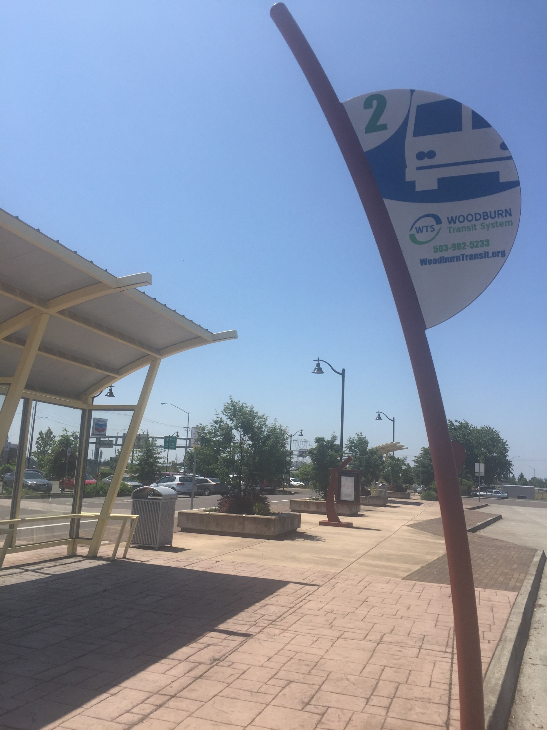

Existing Transit Service

Transit Plan Projects and Programs

4 Transit System

This page intentionally left blank

Transit System
Public transportation can provide important connections to destinations for people that do not drive or bike and can provide an additional option for all transportation system users. Transit complements walking, bicycling, or driving trips: users can walk to and from transit stops and their homes, shopping or work places, people can drive to park-and-ride locations to access a bus, or people can bring their bikes on transit vehicles and bicycle from a transit stop to their final destination.

Existing Transit Service
The transit system within Woodburn consists of fixed-route and paratransit services as well as school and shuttle bus service.

Fixed-Route Service
Public transportation in Woodburn today is provided by Woodburn Transit Service, Cherriots Regional, and Canby Area Transit, as described below. Figure 7 shows the existing transit facilities.

Woodburn Transit Service
Woodburn Transit Service operates a fixed-route bus line in Woodburn, providing connections throughout town as shown in Figure 7. As shown, fixed-route transit service is provided along the major east-west corridors linking neighborhoods to all major retail and commercial areas. The route also connects to the Woodburn Memorial Transit Facility located off of OR 214. Service is provided from 7:00 AM to 7:00 PM at approximately 1-hour headways.

Cherriots Regional
Cherriots Regional operates the 10X Woodburn/Salem Express bus line that provides weekday service between Salem and Woodburn along the 99E corridor. Stops are located along Front Street, OR 214, Settlemier Avenue and Downtown Woodburn. Cherriots Regional also operates the 20X N. Marion Co./Salem Express bus line that provides weekday services between Salem, Silverton, and Woodburn. Stops are located along OR 214 and 99E. The service operates Monday – Friday from 7:30 AM – 7:00 PM with 2 to 2.5 hour headways.

Canby Area Transit
Canby Area Transit (CAT) operates the Route 99 bus line which provides daily bus service between Woodburn and Canby along the 99E corridor. The Woodburn stop is located near the 99E/OR 214 intersection. The service operates Monday – Friday from 6:30 AM – 8:00 PM with headways that range from 1 to 2.5 hours.

Dial-A-Ride Service
Woodburn provides Dial-A-Ride service for people with disabilities and the elderly living within Woodburn who are not able to utilize the fixed route bus. The service operates Monday - Friday from 7:00 AM - 7:00 PM and utilizes a fully accessible van. The van provides door to door service for any purpose to any location within the Woodburn City limits.
The Dial-A-Ride program also arranges for volunteer drivers to take elderly Woodburn residents and those with disabilities to medical appointments in all areas between Portland and Salem. Requests for service must be made at least one day in advance.

Other Services

Greyhound
The Greyhound bus service provides a regional transportation option, with buses to Portland from Woodburn three times per day. The station is located on Front Street and is open from 9 a.m. to 8 p.m. everyday.

Park-and-Rides
The Woodburn Memorial Transit Facility (Park& Ride) is located off of Evergreen Road north of OR 214. Woodburn Transit Service regularly stops at the park & ride facility. The Cascades POINT bus service, operated by MTR Western in partnership with ODOT, makes 2 daily northbound stops and 2 daily southbound stops at the new transit facility. Riders can buy tickets to go as far as Eugene to the south, and Portland to the north. Schedule and ticket information is available at the website and the Amtrak Cascades site.

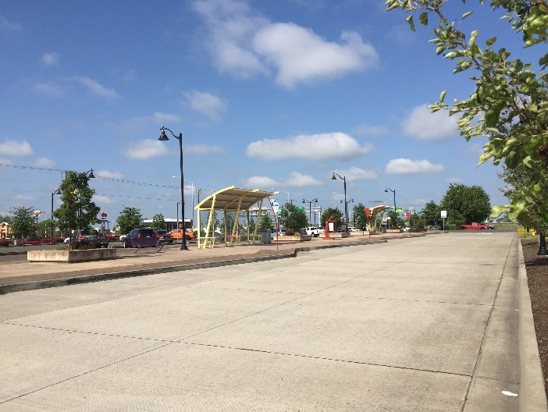  Woodburn Memorial Transit Center | 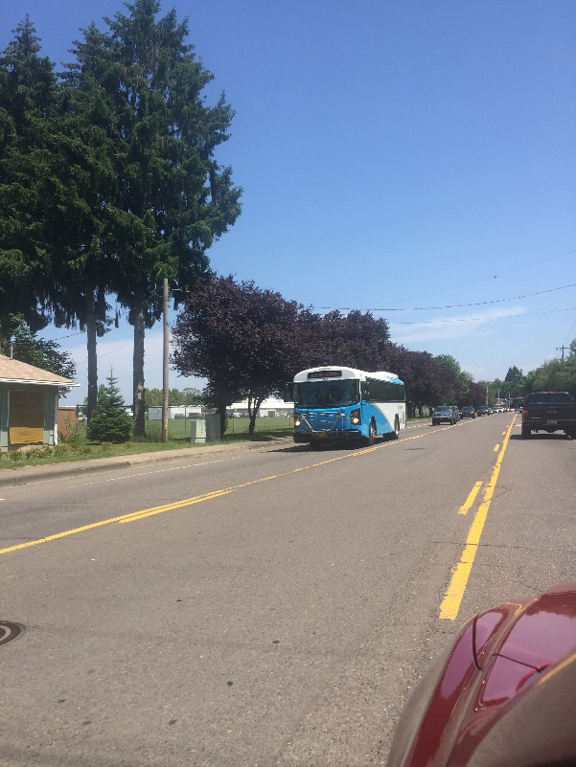  Bus

Figure 7: Existing Transit Facilities

Blank 11x17 page

Transit Plan Projects and Programs
Public transit service within Woodburn is provided by Woodburn Transit Service, supplemented by regional service provided by Cherriots Regional and Canby Area Transit. In addition to coordinating as needed with local and regional transit agencies to help implement their planned service enhancements, the City of Woodburn can support improved transit service by providing easy and safe walking and bicycling connections between key roadways, neighborhoods, and local destinations; by providing amenities, such as shelters and benches, at transit stops; by encouraging an appropriate mix and density of uses that support public transit; and by providing and planning for park-and-ride locations. Table 4 summarizes the transit plan identified for Woodburn.
Table 4: Transit Plan
Project Number | Location | Responsible Jurisdiction | Description | Priority | Cost Estimate
T1 | Woodburn Fleet | Woodburn Transit/City | Coordinate with Woodburn Transit to deliver service enhancements funded through the STIF:  Purchase of Category B and C vehicles (1 each) for use in the City's expanded transit services. (100% funding level 2020-21) | Medium | $5,000
T2 | Woodburn Fleet | Woodburn Transit/City | Coordinate with Woodburn Transit to deliver service enhancements funded through the STIF:  Purchase a Category B vehicle that will replace the second oldest full-size vehicle in the WTS fleet; will be used for the City's existing local fixed route circulator. (130% funding level 2021) | Medium | $5,000
T3 | Woodburn Fixed Route | Woodburn Transit/City | Coordinate with Woodburn Transit to deliver service enhancements funded through the STIF:  Addition of weekend service for Woodburn Transit Service fixed route and paratransit services (Sat. 9am-5pm, Sun.9am-3pm) by up to 2,156 revenue hours (FY20-21). (100% funding level 2020-21) | Medium | $5,000
T4 | Woodburn Fixed Route | Woodburn Transit/City | Coordinate with Woodburn Transit to deliver service enhancements funded through the STIF:  Modify the existing 60-minute fixed route loop; add an additional 30-minute route that will serve high frequency stops on weekdays (7am-7pm) within the Woodburn city limits. Total additional service will be up to 6,192 revenue hours (FY20-21). (100% funding level 2020-21) | Medium | $5,000
T5 | Woodburn Fixed Route | Woodburn Transit/City | Coordinate with Woodburn Transit to deliver service enhancements funded through the STIF:  Modify the existing 60-min. fixed route by adding a new 30 min. route that serves high frequency stops (up to 1,456 revenue hours); this service will operate Saturdays (9am-5pm) and Sundays (9am-3pm). Also includes Dial-a-Ride (DAR) service. (130% funding level 2020-21) | Medium | $5,000
T6 | Woodburn Fixed Route | Woodburn Transit | Increase frequency of existing route to 30 minutes | Medium | $0¹
T7 | Woodburn Fixed Route | Woodburn Transit | Convert existing route to two-way operations | Medium | $0¹
T8 | City-wide | Woodburn Transit/City | Work with Woodburn Transit as growth occurs to provide new or re-routed service to other areas of Woodburn including:  - Parr Road via an extension of Evergreen Road  - Crosby Road  - Butteville Road  - The employment center southwest of the I-5/OR 214 interchange  - Woodburn Industrial Park along the Progress Way and Industrial Avenue corridors  - Gateway subarea between Front Street and Mill Creek  - Neighborhoods in southeast Woodburn | Medium | $5,000
T9 | Woodburn Company Stores | Woodburn Transit/City | Coordinate with Woodburn Transit to establish a free shuttle between the Woodburn Company Stores and Downtown Woodburn, hourly during peak shopping and entertainment hours | Medium | $5,000
T10 | City-wide | Woodburn Transit/City | Coordinate with Woodburn Transit and major employers to establish a peak-only employer shuttle | Medium | $5,000
T11 | Urban and Rural Cherriots Regional Services | Cherriots/City | Coordinate with Cherriots to deliver service enhancements funded through the STIF:  Expand service for up to 7,557 revenue hours on urban & rural Regional services. Includes startup costs for hiring new employees, and coordination of schedules with connecting services. Also establishes a Youth fare category (ages 6-18).(100% funding level 2020-21) | Medium | $5,000
T12 | Keizer to Wilsonville | Cherriots/City | Coordinate with Cherriots to deliver service enhancements funded through the STIF:  Establish one new Regional route from Keizer to Wilsonville with a stop at the Woodburn Memorial Park and Ride. Increase service on weekdays by 30 percent on urban & rural Regional services by up to 5,245 revenue hours. (130% funding level 2020-21) | Medium | $5,000
T13 | Urban and Rural Cherriots Regional Services | Cherriots/City | Coordinate with Cherriots to deliver service enhancements funded through the STIF:  Add Saturday service to urban & rural Cherriots Regional services with up to 3,919 revenue hours of new service (FY20-21). Includes coordination of schedules with other connecting services. (100% funding level 2020-21) | Medium | $5,000
T14 | Urban and Rural Cherriots Regional Services | Cherriots/City | Coordinate with Cherriots to deliver service enhancements funded through the STIF:  Add 30 percent more Saturday service to urban & rural Regional services by up to 215 revenue hours (FY20-21). In FY21, adds 6 holidays to the same routes. Includes coordination of schedules with connecting services. (130% funding level 2020-21) | Medium | $5,000
T15 | City-wide | Woodburn Transit/ Cherriots/City | Coordinate transfers between the different agency services in Woodburn | Medium | $5,000
T16 | Woodburn | Cherriots/City | Coordinate with Cherriots to provide a stop in Woodburn for SMART Route 1X, providing service to WES station in Wilsonville and downtown Salem | Medium | $5,000
T17 | Woodburn to Portland | Cherriots/City | Coordinate with Cherriots to consider further new service connections for Woodburn including:  - Service to Portland - connect to TriMet via the Tualatin Park-and-Ride, directly into downtown Portland, or the MAX Orange Line light rail service.  - Demand-responsive service to Hubbard one day per week | Medium | $5,000
T18 | City-wide | Woodburn Transit/ Cherriots | Evaluate all bus stops to verify static bus route information signage is visible and accessible and that bike racks are available at major bus stops | Medium | $25,000
T19 | Stop 755016: Walmart | Woodburn Transit | New shelter | Low | $5,000
T20 | Stop 20419: Garfield Street | Woodburn Transit | New shelter | Low | $5,000
T21 | City-wide | Woodburn Transit | Investigate transferring the paratransit system to a local social service agency | Low | $5,000
TOTAL High Priority Costs |  |  |  |  | $0
TOTAL Medium Priority Costs |  |  |  |  | $100,000
TOTAL Low Priority Costs |  |  |  |  | $15,000
TOTAL Program Costs (20 years) |  |  |  |  | $115,000
1. Project to be funded by others.

This page intentionally left blank

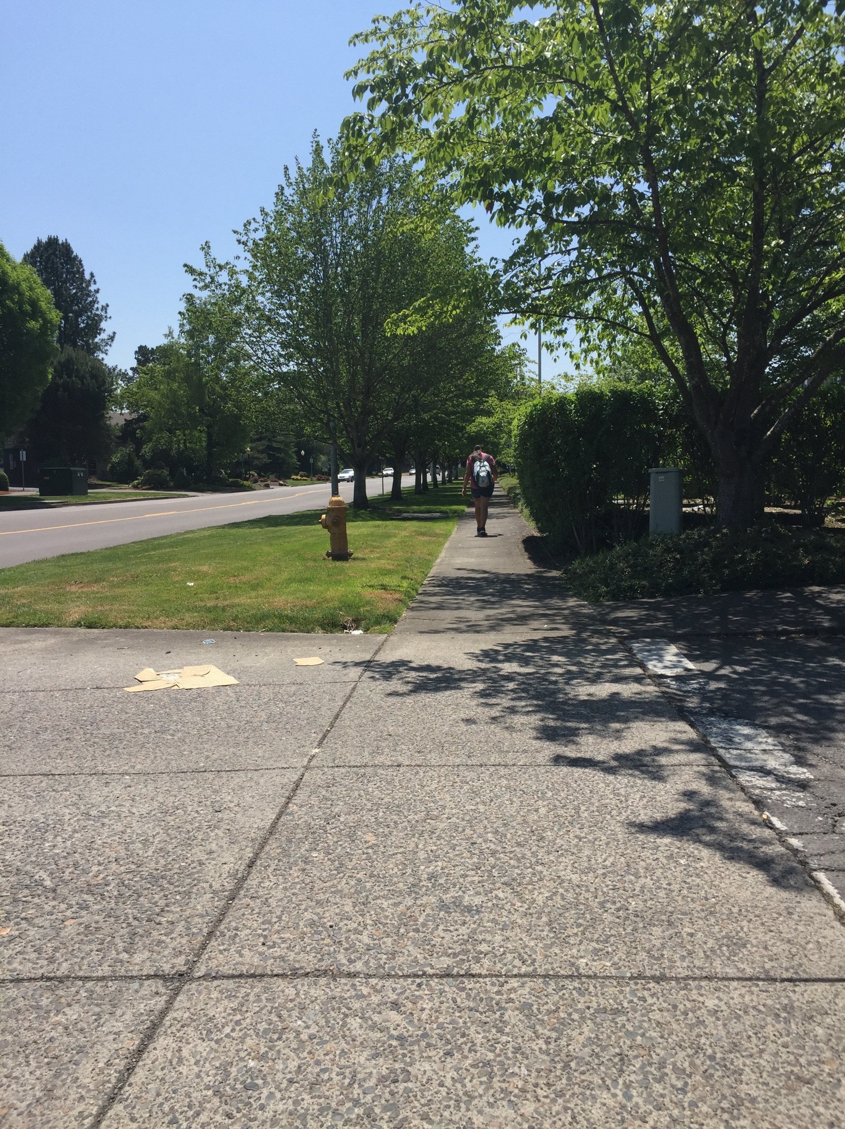

Pedestrian Facilities

Pedestrian Plan Projects

5 Pedestrian System

This page intentionally left blank

Pedestrian System
Woodburn’s pedestrian system consists of sidewalks, pedestrian crossings, and multi-use paths. A majority of city streets currently have sidewalks on at least one side of the roadway. The pedestrian plan includes several projects to construct new sidewalks where they are lacking and to fill in the gaps in the existing sidewalks along the city’s streets. Although many of the pedestrian projects are located on Service Collector streets or higher, a few local street pedestrian projects are included to provide access to essential destinations such as schools, parks, churches, and other land uses. The pedestrian plan also includes several enhanced pedestrian crossings, multi-use paths, and accessways that support the pedestrian system.

Pedestrian Facilities
This section summarizes the facility types integrated into the pedestrian plan, addressing gaps and deficiencies identified in the existing system and forecast as part of future needs.

Sidewalks
Sidewalks are the fundamental building blocks of the pedestrian system. They enable people to walk comfortably, conveniently, and safely from place to place. They also provide an important means of mobility for people with disabilities, families with strollers, and others who may not be able to travel on an unimproved roadside surface. Sidewalks are usually 6 to 8-feet wide and constructed from concrete. They are also frequently separated from the roadway by a curb, landscaping, and/or on-street parking. Sidewalks are widely used in urban and suburban settings. Ideally, sidewalks could be provided along both sides of the roadway; however, some areas with physical or right-of-way constraints may require that sidewalk be located on only one side. Sidewalk solutions include:
- Fill in the gaps
- Install sidewalks on one-side of the roadway
- Install sidewalks on both sides of the roadway
- Re-construct existing sidewalks with appropriate width and buffer
- Improve existing sidewalks with appropriate lighting

Accessways
Non-vehicular connections between cul-de-sacs and adjacent roadways can significantly reduce travel distances for pedestrians, thereby encouraging more people to walk. Woodburn has a few existing accessways that create connections between neighborhoods and pedestrian and bicycle routes. Potential new connections could use existing City right-of-way between cul-de-sacs or unconnected roadways to provide a paved path, unpaved path, or trail for non-motorized use.
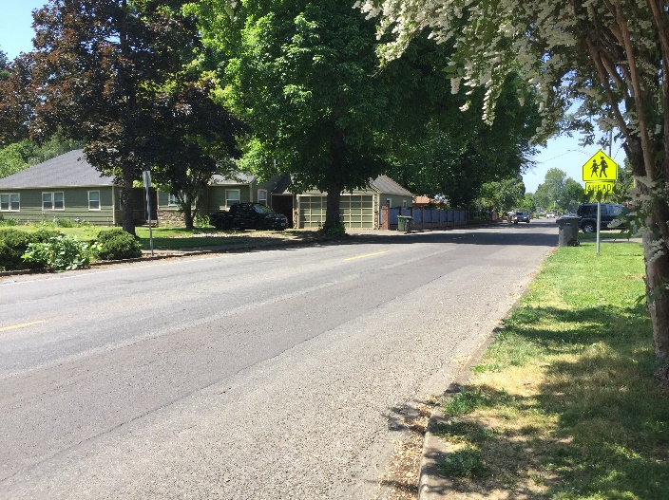  Sidewalk Gap | 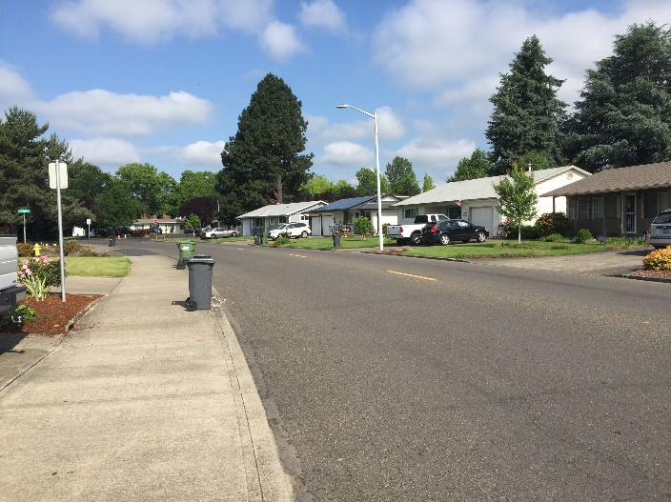  Sidewalk Improvements

Multi-use Paths and Trails
Multi-use paths are paved, bi-directional trails that can serve both pedestrians and bicyclists. Multi-use paths and trails can be constructed adjacent to roadways where the topography, right-of-way, or other issues don’t allow for the construction of sidewalks and bike facilities. A minimum width of 10 feet is recommended for low-pedestrian/bicycle-traffic contexts; 12 to 20 feet should be considered in areas with moderate to high levels of bicycle and pedestrian traffic. Multi-use paths can be used to create longer-distance links within and between communities. They play an integral role in recreation, commuting, and accessibility due to their appeal to users of all ages and skill levels.

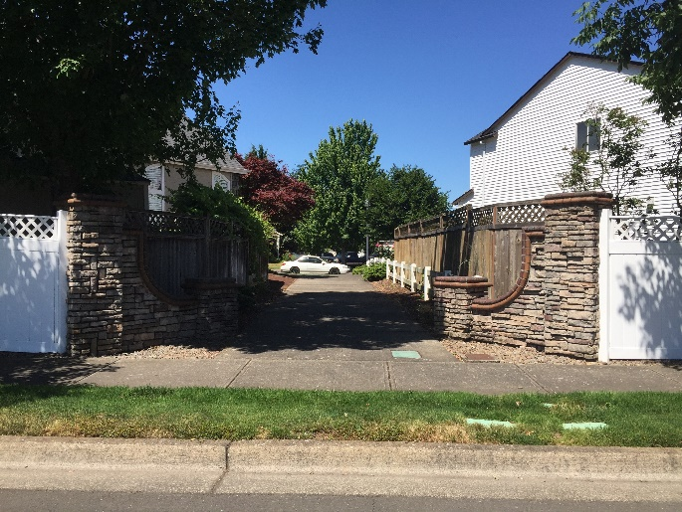Accessways | 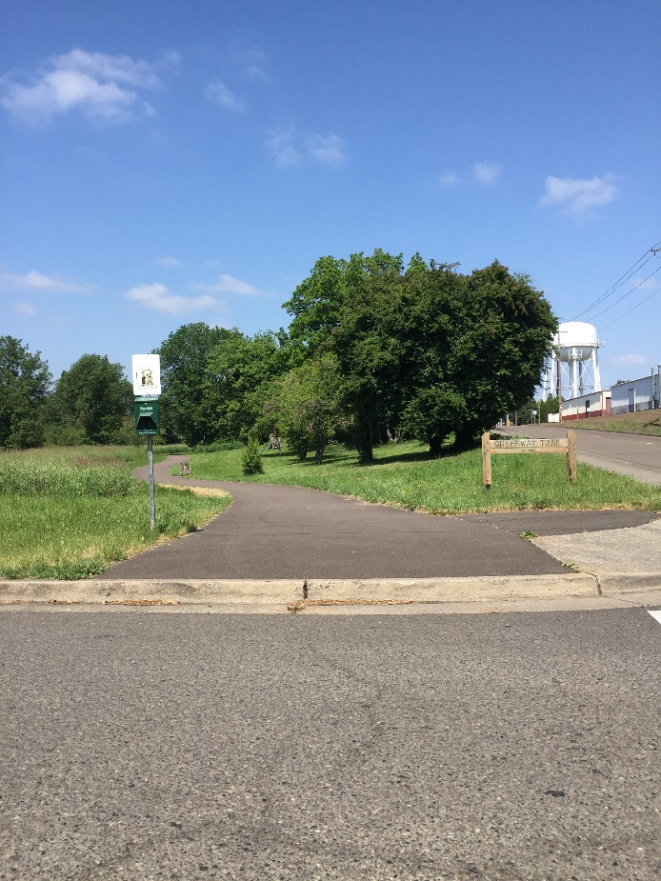  Multi-use Paths and Trails

Enhanced Pedestrian Crossings
Pedestrian crossing facilities enable pedestrians to safely cross streets, railroad tracks, and other transportation facilities. Planning for appropriate pedestrian crossings requires the community to balance vehicular mobility needs with providing crossing locations for desired routes of walkers. Enhanced pedestrian crossing treatments include:
- Median refuge islands  - High visibility pavement markings and signs  - Rapid rectangular flashing beacons (RRFB)  - Pedestrian Hybrid Beacons | - Curb extensions  - Pedestrian signals  - Pedestrian countdown heads  - Leading Pedestrian interval
Many of the treatments listed above can be applied together at one crossing location to further alert drivers of the presence of pedestrians in the roadway. See Attachment “A” for a detailed description of enhanced pedestrian crossing treatments.

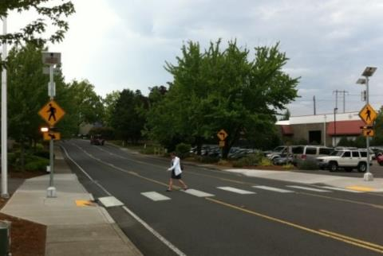  Enhanced Pedestrian Crossing with RRFBs | 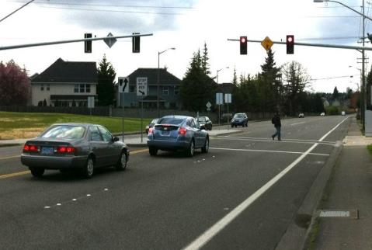  Enhanced Pedestrian Crossing with Pedestrian Signal

Pedestrian Plan Projects
Table 5 identifies the pedestrian plan projects for the Woodburn TSP update. As shown, the projects are separated into projects based on roadway classification, as well as projects at intersections and in other locations throughout the city. The priorities shown in Table 5 are based on the project evaluation criteria as well as input from the project team and the general public. The cost estimates are based on average unit costs for roadway improvements. Table 8 illustrates the location of the pedestrian plan projects.

Table 5: Pedestrian Plan Projects
Project Number | Location | Responsible Jurisdiction | Type | Description | Priority | Cost Estimate³
Major Arterials
P1 | OR 219 from Butteville Road to Willow Avenue | State | New sidewalks | Install new sidewalks in coordination with ODOT | Medium | Cost included in R2²
P2 | OR 99E from Lincoln Street to southern City Boundary | State | New sidewalks | Remove existing sidewalks and install new sidewalks in coordination with ODOT | Medium | Cost included in R4²
P3 | OR 99E from southern City Boundary to southern UGB | State | New sidewalks | Install new sidewalks in coordination with ODOT | Low | Cost included in R4²
Minor Arterials
P4 | Butteville Road/OR 219 from northern UGB to OR 219 | State/County | New sidewalks | Install new sidewalks in coordination with ODOT | Medium | $1,500 ,000
P5 | Butteville Road from current improved extents to southern UGB | County | New sidewalks | Install new sidewalks on the east side Butteville Road | Medium | Cost included in R6²
P6 | Evergreen Road from Stacy Allison Way to Boean Lane | City | Sidewalks - Fill in gaps | Fill in the gaps | High | $200,000
P7 | Boones Ferry Road from northern UGB to Hazelnut Drive | County/City | New sidewalks | Install new sidewalks on one side | Medium | $150 ,000
P8 | Settlemier Avenue from Oak Street to Parr Road | City | New sidewalks | Install new sidewalks on one side. This project improves safe routes to school for Nellie Muir Elementary School, Heritage Elementary School, and Valor Middle School | High | $300,000
P9 | Boones Ferry Road from Parr Road to southern UGB | County/City | New sidewalks | Install new sidewalks. This project improves safe routes to school for Heritage Elementary School and Valor Middle School | High | $800,000
P10 | Front Street from northern UGB to Hazelnut Drive | City | New sidewalks | Install new sidewalks on one side. This project improves safe routes to school for Woodburn High School | High | $400,000
P11 | Young Street | City | Sidewalks - Fill in gaps | Fill in the gaps | Medium | $200,000
P12 | OR 211 from OR 99E to eastern UGB | State | New sidewalks | Install new sidewalks in coordination with ODOT | Medium | $500,000
Service Collectors
P13 | Hayes Street from Harvard Drive to Settlemier Avenue | City | Sidewalks - Fill in gaps | Fill in the gaps. This project improves safe routes to school for Nellie Muir Elementary School | High | $600,000
P14 | Evergreen Road from Parr Road to Parr Road | City | New sidewalks | Install new sidewalks. This project improves safe routes to school for Heritage Elementary School and Valor Middle School | High | Cost included in R5²
P15 | Lincoln Street from Cascade Drive to OR 99E | City | Sidewalks - Fill in gaps | Fill in the gaps. This project improves safe routes to school for Washington Elementary School | High | $450,000
P16 | Industrial Avenue from Progress Way to OR 99E | City | New sidewalks | Install new sidewalks | Medium | $500,000
P17 | Progress Way from Industrial Avenue to OR 214 | City | New sidewalks | Install new sidewalks | Medium | $850,000
P18 | Hardcastle Avenue from Front Street to Cooley Road | City | Sidewalks - Fill in gaps | Fill in the gaps. This project improves safe routes to school for Washington Elementary School | High | $450,000
P19 | Brown Street from Cleveland Street to end of roadway | City | Sidewalks - Fill in gaps | Fill in the gaps | Medium | Cost included in R7²
P20 | Cooley Road from OR 211 to Hardcastle Avenue | County | Sidewalks - Fill in gaps | Fill in the gaps | Medium | $650,000
Access Streets
P21 | Woodland Avenue from Jory Street to Arney Road | City | New sidewalks | Install new sidewalks on one side | Medium | $250,000
P22 | Stubb Road from Harvard Drive to Parr Road | County | New sidewalks | Install new sidewalks on the west side of the corridor | Medium | Cost included in R26²
P23 | Oregon Way from Country Club Road to OR 214 | City | New sidewalks | Install new sidewalks | Medium | $250,000
P24 | Hazelnut Drive from Graystone Drive to Front Street | City | Sidewalks - Fill in gaps | Fill in the gaps. This project improves safe routes to school for Woodburn High School | High | $150,000
P25 | Gatch Street from Hardcastle Road to Cleveland Street | City | Sidewalks - Fill in gaps | Fill in the gaps. This project improves safe routes to school for Washington Elementary School | High | $350,000
P26 | Park Avenue from Hardcastle Avenue to Lincoln Street | City | New sidewalks | Install new sidewalks on one side. This project improves safe routes to school for Washington Elementary School | High | $65,000
Local Streets
P27 | Willow Avenue from McNaught Road to OR 219 | City | New sidewalks | Install new sidewalks on both sides | Medium | $350,000
P28 | Cascade Drive from OR 214 to Hayes Street | City | New sidewalks | Install new sidewalks. This project improves safe routes to school for Nellie Muir Elementary School | High | $400,000
P29 | Ben Brown Lane from end of roadway to Boones Ferry Road | City | Sidewalks - Fill in gaps | Fill in the gaps | Medium | $200,000
P30 | Oak Street from Boones Ferry Road to Front Street | City | New sidewalks | Install new sidewalks on one side | Medium | $150,000
P31 | Ogle Street from Cleveland Street to Boones Ferry Road | City | New sidewalks | Install new sidewalks on one side | Medium | $900,000
Pedestrian Crossing Enhancements
P32 | Front Street/Young Street | City | Enhanced crossing | Construct ADA-compliant ramps and sidewalks on the east leg of the intersection | Medium | $15,000
P33 | Front Street/Lincoln Street | City | Enhanced crossing | Construct ADA-compliant ramps and sidewalks on the east leg of the intersection. This project improves safe routes to school for St Luke's School | High | $15,000
P34 | Cascade Drive/Hayes Street | City | Enhanced crossing | Install an enhanced pedestrian crossing. This project improves safe routes to school for Nellie Muir Elementary School | High | $150,000
P35 | Park Avenue/Legion Park Driveway | City | Enhanced crossing | Install an enhanced pedestrian crossing. This project improves access to Legion Park | Medium | $150,000
P36 | Hazelnut Drive/ Broadmoor Place Accessway | City | Enhanced crossing | Install an enhanced pedestrian crossing. This project improves safe routes to school for Woodburn High School | High | $150,000
P37 | OR 214/N Bulldog Drive | State/City | Enhanced crossing | As identified in the Woodburn OR 214/OR 99E Pedestrian Safety Study, update the existing crossing to an enhanced pedestrian crossing with a pedestrian hybrid beacon coordinated with the surrounding traffic signals in coordination with ODOT. This project improves safe routes to school for Woodburn High School | High | $150,000
P38 | OR 99E from OR 214 to Young Street | State/City | Enhanced crossing – Signalized intersection | As identified in the Highway 99E Corridor Plan, install countdown pedestrian timers and construct ADA enhancements at key signalized intersections along OR 99E in coordination with ODOT, including:  - OR 214/OR 211  - Hardcastle Avenue  - Lincoln Road  - Young Street | Medium | $605,000
P39 | OR 99E from OR 214 to Young Street | State/City | Enhanced crossing | As identified in the Highway 99E Corridor Plan, install curb extensions on minor street legs of intersections (curb extensions to shorten pedestrian crossing distances parallel to OR 99E, not for crossing of OR 99E) between Arlington Street and Cleveland Street (up to 8 locations) in coordination with ODOT. Potential locations include:  - Alexandria Avenue  - James Street  - Williams Street  - Blaine Street  - Aztec Drive  - Laurel Avenue  - Tomlin Avenue | Medium | $950,000
P40 | OR 99E, north of Williams Street | State/City | Enhanced crossing | As identified in the Woodburn OR 214/OR 99E Pedestrian Safety Study, install an enhanced pedestrian crossing in coordination with ODOT, that may include raised median refuge island, sidewalk infill, supplemental street lighting, and a potential RRFB (RRFB cost not included). | High | $150,000
P41 | OR 99E, between NE Laurel Avenue and Tomlin Avenue | State/City | Enhanced crossing | As identified in the Woodburn OR 214/OR 99E Pedestrian Safety Study, install an enhanced pedestrian crossing in coordination with ODOT, that may include raised median refuge island, sidewalk infill, supplemental street lighting, and a potential RRFB (RRFB cost not included). | High | $150,000
P42 | OR 99E, between Blaine Street and Aztec Drive | State/City | Enhanced crossing | As identified in the Woodburn OR 214/OR 99E Pedestrian Safety Study, install an enhanced pedestrian crossing in coordination with ODOT, that may include raised median refuge island, sidewalk infill, supplemental street lighting, and a potential RRFB (RRFB cost not included). | High | $150,000
P43 | OR 99E, north of Mount Jefferson Avenue | State/City | Enhanced crossing | As identified in the Woodburn OR 214/OR 99E Pedestrian Safety Study, install an enhanced pedestrian crossing in coordination with ODOT, that may include raised median refuge island, sidewalk infill, supplemental street lighting, and a potential RRFB (RRFB cost not included). | Medium | $150,000
P44 | OR 99E, north of James Street | State/City | Enhanced crossing | As identified in the Woodburn OR 214/OR 99E Pedestrian Safety Study, install an enhanced pedestrian crossing in coordination with ODOT, that may include raised median refuge island, sidewalk infill, supplemental street lighting, and a potential RRFB (RRFB cost not included). | Medium | $150,000
P45 | Boones Ferry Road/ Constitution Avenue/Tukwila Drive | City | Enhanced crossing | Install an enhanced pedestrian crossing. This project improves safe routes to school for Woodburn High School | High | $150,000
Multi-use Pathways
P46 | Mill Creek Greenway | City | Multi-use pathway | As identified in the Mill Creek Greenway Master Plan, construct a multi-use path including at-grade mid-block crossing treatments at the following street connections:  - Hazelnut Drive  - Bulldog Drive (east crossing)  - OR 214 (state highway)  - Hardcastle Avenue  - Lincoln Street  - Young Street  - Cleveland Street and railroad tracks  This project improves safe routes to school for Woodburn High School | High | $2,000,000
P47 | Mill Creek Greenway – Northern tributary | City | Multi-use pathway | As identified in the Mill Creek Greenway Master Plan, construct a multi-use path including at-grade mid-block crossing treatments at the following street connections:  - Bulldog Drive (west crossing)  - Meridian Drive  - Boones Ferry Road  This project improves safe routes to school for Woodburn High School, Lincoln Elementary School, and French Prairie Middle School | Medium | $700,000
P48 | Mill Creek Greenway – Western tributary | City | Multi-use pathway | As identified in the Mill Creek Greenway Master Plan, construct a multi-use path including at-grade mid-block crossing treatments at the following street connections:  - Parr Road  - Ben Brown Lane  - Settlemier Avenue  - Front Street and railroad tracks  This project improves safe routes to school for Heritage Elementary School and Valor Middle School | Medium | $900,000
P49 | Evergreen Road Multi-Use Path | City | Multi-use pathway | Construct a multi-use path extending from Evergreen Road south to planned Mill Creek Greenway | Medium | $150,000
P50 | Washington Elementary School Multi-Use Path | City | Multi-use pathway | As identified in the Mill Creek Greenway Master Plan, construct a north-south multi-use path connection between Hardcastle Avenue and Lincoln Street, west of Washington Elementary School. This project improves safe routes to school for Washington Elementary School | Medium | $90,000
P51 | Mill Creek Greenway - Southern extension | City | Multi-use pathway | As identified in the Highway 99E Corridor Plan, construct extension of Mill Creek Greenway multi-use path to Belle Passi Road | Medium | $90,000
P52 | Evergreen Road Pedestrian Connection | City | Multi-use pathway | Construct a connection between the Evergreen Road multi-use path and pedestrian facilities that are part of future development to the south | Medium | $20,000
P53 | Centennial Park Pedestrian Connection | City | Multi-use pathway | Construct a connection between the Centennial Park multi-use path and pedestrian facilities that are part of future development to the west | Medium | $20,000
P54 | Santiam Drive Pedestrian Connection | City | Multi-use pathway | Construct a connection between Santiam Drive and pedestrian facilities that are part of future development to the south | Medium | $20,000
P55 | June Way Accessway | State/City | Multi-use pathway | As identified in the Highway 99E Corridor Plan and in coordination with ODOT, install a new accessway to OR 99E (near the Audrey Way intersection), may not connect directly as it runs parallel to OR 99E | Low | $80,000
P56 | Johnson Street Accessway | State/City | Multi-use pathway | As identified in the Highway 99E Corridor Plan and in coordination with ODOT, install a new accessway to OR 99E | Low | $45,000
P57 | Elm Street Accessway | State/City | Multi-use pathway | As identified in the Highway 99E Corridor Plan and in coordination with ODOT, install a new accessway to OR 99E, may not connect directly as it runs parallel to OR 99E | Low | $25,000
P58 | Wilson Street Accessway | State/City | Multi-use pathway | As identified in the Highway 99E Corridor Plan and in coordination with ODOT, install a new accessway to OR 99E | Low | $55,000
P59 | Hawley Street Accessway | State/City | Multi-use pathway | As identified in the Highway 99E Corridor Plan and in coordination with ODOT, install a new accessway to OR 99E (possibly part of future street extension), may not connect directly as it runs parallel to OR 99E | Low | $55,000
P60 | A Street Accessway | City | Multi-use pathway | Install a new accessway that connects A Street north to Cleveland Street and/or Mill Creek Greenway (western tributary). | Low | $25,000
P61 | Greenview Drive Multi-use Path | City | Multi-use pathway | Construct a multi-use path extending from Greenview Drive west to OR 99E | Low | $70,000
P62¹ | City-wide | City | Wayfinding | Provide wayfinding to bike routes, multi-use paths, parks, schools, and other essential destinations | Medium | $30,000
TOTAL High Priority Costs |  |  |  |  |  | $24,026,000
TOTAL Medium Priority Costs |  |  |  |  |  | $81,700,000
TOTAL Low Priority Costs |  |  |  |  |  | $9,860,000
TOTAL Program Costs (20 years) |  |  |  |  |  | $115,586,000
1. Project not shown on Pedestrian Plan Map
2. Cost estimates are not included for projects that would be completed as part of a roadway project, such as locations where roadway widening will relocate the curb and require new sidewalks to be installed. The cost for these projects is included in the corresponding roadway projects described later in the memo.
3. The cost estimates presented to not include costs associated with right-of-way acquisition due to its high variability depending on location, parcel sizes, and other characteristics.
Figure 8: Pedestrian Plan Projects

Blank 11x17 page

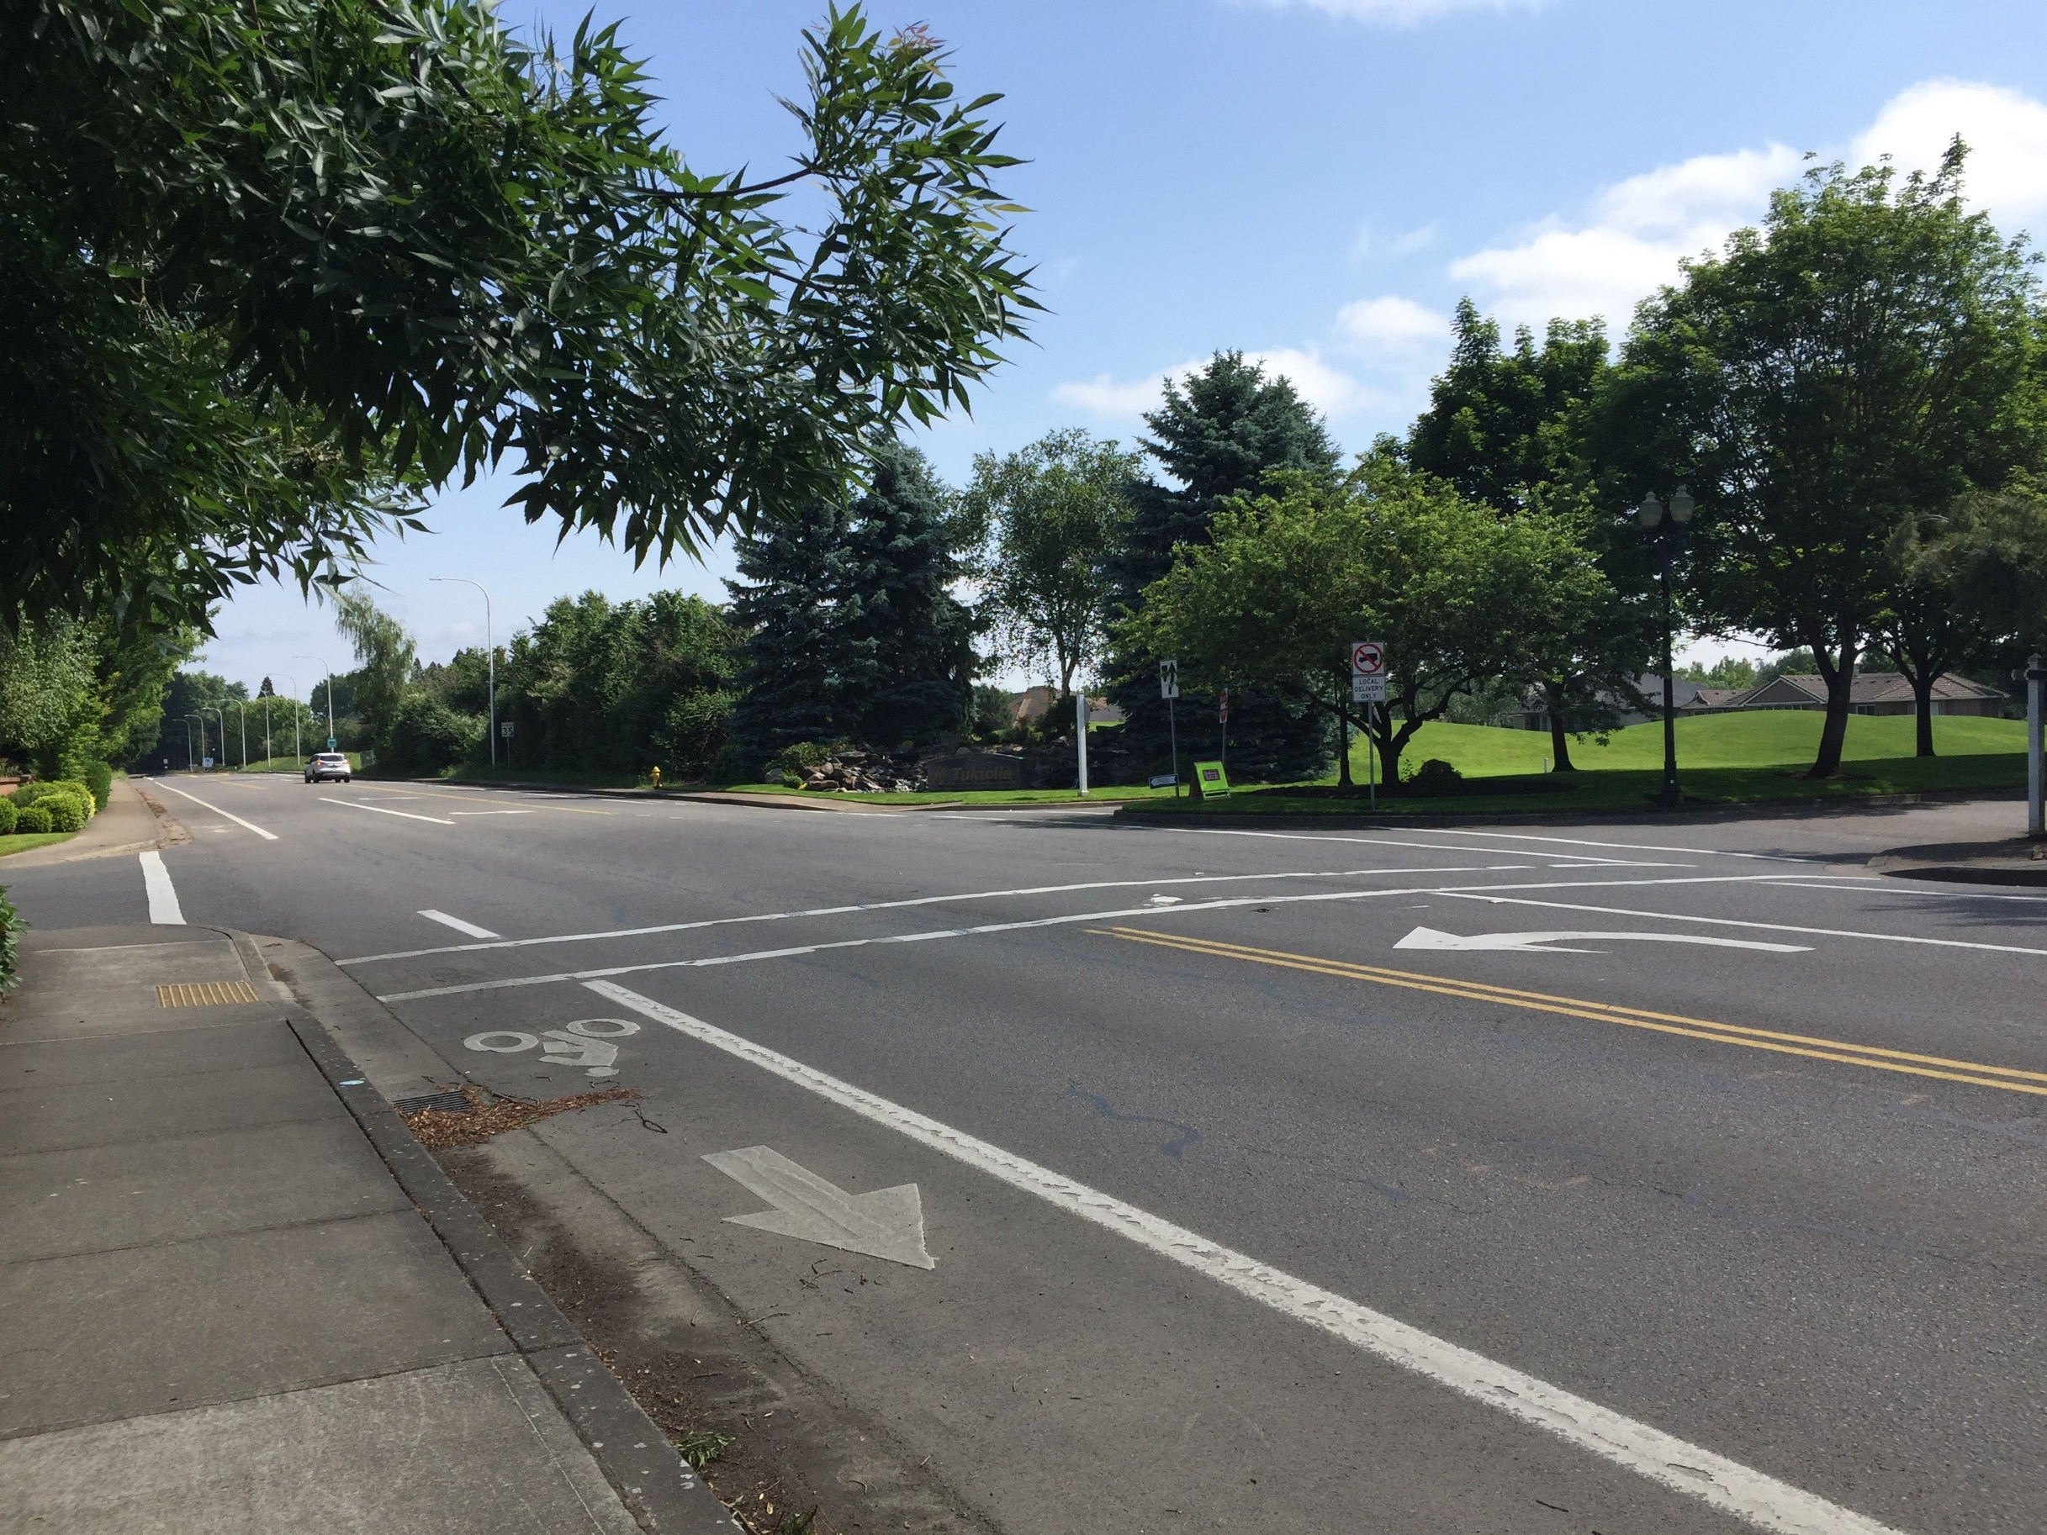

Bicycle Facilities

Bicycle Plan Projects

6 Bicycle System

This page intentionally left blank

Bicycle System
Woodburn’s bicycle system consists of on-street bike lanes and other bicycle provided on a few roadways within the city. The bicycle plan includes several projects along the city’s Major and Minor Arterial and Service Collector streets for connectivity throughout the city. The bicycle plan also includes projects on access and local street that provide direct access to essential destinations.

Bicycle Facilities

Alternative Routes
Designate an alternative route along a parallel street that provides a more comfortable environment for cyclists with the same level of connectivity. The alternative route could be identified by wayfinding signs, which could also be used to identify essential destinations that can be reached by the route. The alternative route may provide shared-lane pavement markings and signs, on-street bike lanes, or other bicycle facilities.

Shared Lane Pavement Markings and Signs
Shared‐lane pavement markings (often called “sharrows”) are not a bicycle facility, but a tool designed to help accommodate bicyclists on roadways where bike lanes are desirable but infeasible to construct. Sharrows indicate a shared roadway space for cyclists and motorists and are typically centered in the travel lane or approximately four feet from the edge of the travelway. Sharrows are suitable on roadways with relatively low travel speeds (<35 mph) and low ADT (<3,000 ADT); however, they may also be used to transition between discontinuous bicycle facilities. Sharrows could be applied along a variety of streets within Woodburn where room for on-street bike lanes is limited.

On-Street bike lanes
On-street bike lanes are striped lanes on the roadway dedicated for the exclusive use of cyclists. Bike lanes are typically placed at the outer edge of pavement (but to the inside of right‐turn lanes and/or on‐street parking). Bicycle lanes can improve safety and security of cyclists and (if comprehensive) can provide direct connections between origins and destinations. On-street bike lanes could be applied along a variety of streets within Woodburn where space allows.

Separated Bike Facilities
Separated bike facilities include buffered bike lanes and separated bike lanes, or cycle tracks. Buffered bike lanes are on-street bike lanes that include an additional striped buffer of typically 2-3 feet between the bicycle lane and the vehicle travel lane and/or between the bicycle lane and the vehicle parking lane. They are typically located along streets that require a higher level of separation to improve the comfort of bicycling. Separated bike lanes, also known as cycle tracks, are bicycle facilities that are separated from motor vehicle traffic by a buffer and a physical barrier, such as planters, flexible posts, parked cars, or a mountable curb. One-way separated bike lanes are typically found on each side of the street, like a standard bike lane, while two-way separated bike lanes are typically found on one side of the street.
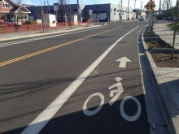  On-street Bike Lanes | 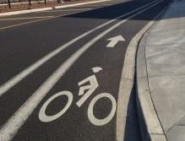  Buffered Bike Lanes

Enhanced Crossings
Enhanced bicycle crossing facilities enable cyclists to safely cross streets, railroad tracks, and other transportation facilities. Planning for appropriate bicycle crossings requires the community to balance vehicular mobility needs with providing crossing locations that the desired routes of cyclists. Enhanced bicycle crossings include:
- Bike Boxes – designated space at an intersection that allows cyclists to wait in front of motor vehicles while waiting to turn or continue through the intersection.
- Two-Stage Left-turn Boxes – designated space at a signalized intersection outside of the travel lane that provides cyclists with a place to wait while making a two-stage left-turn.
- Pavement marking through intersections – pavement markings that extend and bike lane through an intersection.
- Bike Only Signals – A traffic signal that is dedicated for cyclists
- Bicycle Detection – Vehicle detection for bicycles
Additional information on the enhanced bicycle crossing treatments is provided in Technical Memorandum 5: Alternative Analysis and Funding.

Wayfinding Signs
Wayfinding signs are signs located along roadways or at intersections that direct bicyclists towards destinations in the area and/or to define a bicycle route. They typically include distances and average walk/cycle times. Wayfinding signs are generally used on primary bicycle routes and multi-use paths.

Bicycle Plan Projects
Table 6 identifies the bicycle plan projects for the Woodburn TSP update. As shown, the projects are separated based on roadway classification. The priorities shown in Table 6 are based on the project evaluation criteria as well as input from the project team and the general public. The cost estimates are based on average unit costs for roadway improvements. Figure 9 illustrates the location of the bicycle plan projects.
Table 6: Bicycle Plan Projects
Project Number | Location | Responsible Jurisdiction | Type | Description | Priority | Cost Estimate³
Major Arterials
B1 | OR 219 from Butteville Road to Willow Avenue | State | Bike lanes | Widen roadway and install bike lanes in coordination with ODOT | Medium | Cost included in R2²
B2 | OR 214 from Progress Way to OR 99E | State | Bike lanes | Widen roadway and install bike lanes in coordination with ODOT | Medium | Cost included in R3²
B3 | OR 99E from Lincoln Street to southern City Boundary | State | Bike lanes | Widen roadway and install bike lanes in coordination with ODOT | Medium | Cost included in R4²
B4 | OR 99E from southern City Boundary to southern UGB | State | Bike lanes | Widen roadway and install buffered bike lanes in coordination with ODOT | Medium | Cost included in R4²
Minor Arterials
B5 | OR 219 from western UGB to Butteville Road | State | Bike lanes | Widen roadway and install bike lanes in coordination with ODOT | Medium | $1,000,000
B6 | Butteville Road/OR 219 from northern UGB to OR 219 | State/County | Bike lanes | Widen roadway and install bike lanes in coordination with ODOT | Medium | $3,200,000
B7 | Butteville Road from current improved extents to southern UGB | County | Bike lanes | Widen roadway and install bike lanes | Medium | Cost included in R6²
B8 | Evergreen Road from OR 214 to Hayes Street | City | Bike lanes | Widen roadway and install bike lanes | Medium | $500,000
B9 | Boones Ferry Road from northern UGB to Hazelnut Drive | County/City | Bike lanes | Widen roadway and install bike lanes | Medium | $500,000
B10 | Settlemier Avenue from Harrison Street to railroad tracks | City | Shared street | Install shared lane markings and signs. This project improves safe routes to school for Nellie Muir Elementary School, Heritage Elementary School, Valor Middle School, and St. Luke's School | Medium | $25,000
B11 | Boones Ferry Road from Dahlia Street to southern UGB | County/City | Bike lanes | Widen roadway and install bike lanes | Medium | $1,500,000
B12 | Front Street from northern UGB to Boones Ferry Road | City | Bike lanes | Widen roadway and install bike lanes. This project improves safe routes to school for Woodburn High School, Heritage Elementary School, Valor Middle School, and St. Luke's School | High | $8,050,000
B13 | Garfield Street from 3rd Street to Front Street | City | Shared street | Install shared lane markings and signs | Low | $10,000
B14 | Garfield Street from Smith Drive to 3rd Street | City | Shared street | Install shared lane markings and signs | Low | $10,000
B15¹ | Young Street | City | Study | Perform a corridor evaluation that would consider design treatments to improve bicycle comfort and safety such as striping, signing, and wayfinding | Medium | $15,000
B16 | OR 211 from OR 99E to eastern UGB | State | Bike lanes | Widen roadway and install bike lanes in coordination with ODOT | Medium | $1,000,000
Service Collectors
B17 | Arney Road from Robin Avenue to OR 219 | State | Shared street | Install shared lane markings and signs in coordination with ODOT | Low | $5,000
B18 | Harvard Drive from Stacy Allison Way to Evergreen Road | City | Bike lanes | Enhance the parallel route of Harvard Drive from Stacy Allison Way to Evergreen Road in place of Stacy Allison Way. Install buffered bike lane striping on both sides of the roadway | Medium | $15,000
B19 | Hayes Street from Harvard Drive to Cascade Drive | City | Bike lanes | Install bike lane striping. This project improves safe routes to school for Nellie Muir Elementary School | Medium | $35,000
B20 | Hayes Street from Cascade Drive to Settlemier Avenue | City | Bike lanes | Widen roadway and install bike lanes. This project improves safe routes to school for Nellie Muir Elementary School | Medium | $3,000,000
B21 | Parr Road from Stubb Street to Evergreen Road | City | Bike lanes | Widen roadway and install bike lanes. This project improves safe routes to school for Heritage Elementary School and Valor Middle School | High | Cost included in R5²
B22 | Lincoln Street from Cascade Drive to Front Street | City | Shared street | Install shared lane markings and signs. This project improves safe routes to school for Washington Elementary School | Medium | $20,000
B23 | Lincoln Street from Front Street to OR 99E | city | Bike lanes | Install bike lane striping. This project improves safe routes to school for Washington Elementary School | High | $55,000
B24 | Cleveland Street from Front Street to OR 99E | City | Shared street | Install shared lane markings and signs | Low | $15,000
B25 | Hardcastle Avenue from Front Street to OR 99E | City | Shared street | Install shared lane markings and signs. This project improves safe routes to school for Washington Elementary School | High | $15,000
B26 | Brown Street from Cleveland Street to the South Arterial | City | Shared street | Install shared lane markings and signs from Cleveland Street to Spring Boulevard. Install bike lane striping from Spring Boulevard to the South Arterial | Low | $30,000
B27 | Cooley Road from OR 211 to Aubrey Way | County | Bike lanes | Widen roadway and install bike lanes | Medium | $1,300,000
B28 | Cooley Road from Aubrey Way to Hardcastle Avenue | County | Bike lanes | Install bike lane striping | Medium | $15,000
Access Streets
B29 | Stubb Road from Harvard Drive to Parr Road | County | Shared street | Install shared lane markings and signs | Low | Cost included in R26²
B30 | Astor Way from Country Club Road to OR 214 | City | Bike lanes | Install bike lane striping | Low | $25,000
B31 | Tukwila Drive from Boones Ferry Road to Hazelnut Drive | City | Shared street | Install shared lane markings and signs | Low | $5,000
B32 | 5th Street from OR 214 to Garfield Street | City | Shared street | Install shared lane markings and signs. This project improves safe routes to school for St Luke's School | Medium | $20,000
B33 | Gatch Street from Hardcastle Road to Cleveland Street | City | Shared street | Install shared lane markings and signs. This project improves safe routes to school for Washington Elementary School | Medium | $15,000
B34 | Park Avenue from OR 214 to Lincoln Street | City | Shared street | Install shared lane markings and signs. This project improves safe routes to school for Washington Elementary School | Medium | $20,000
B35 | Evergreen Road from Country Club Court to OR 214 | City | Shared street | Install shared lane markings and signs | Low | $10,000
Local Streets
B36 | Country Club Road from Evergreen Road to Astor Way | City | Bike lanes | Install bike lane striping | Medium | $40,000
B37 | Cascade Drive from OR 214 to Hayes Street | City | Shared street | Install shared lane markings and signs. This project improves safe routes to school for Nellie Muir Elementary School | Medium | $10,000
B38 | Smith Drive from Hayes Street to Garfield Street | City | Shared street | Install shared lane markings and signs. This project improves safe routes to school for Nellie Muir Elementary School | Medium | $5,000
B39 | Meridian Drive from Hazelnut Drive to OR 214 | City | Shared street | Install shared lane markings and signs | Low | $10,000
B40 | 1st Street from Harrison Street to Cleveland Street | City | Shared street | Install shared lane markings and signs | Medium | $15,000
B40¹ | City-wide | City | Wayfinding | Provide wayfinding to bike routes, multi-use paths, parks, schools, and other essential destinations | Medium | $30,000
TOTAL High Priority Costs |  |  |  |  |  | $8,125,000
TOTAL Medium Priority Costs |  |  |  |  |  | $12,280,000
TOTAL Low Priority Costs |  |  |  |  |  | $120,000
TOTAL Program Costs (20 years) |  |  |  |  |  | $20,525,000
1. Project not shown on Bicycle Plan Map.
2. Cost estimates are not included for projects that would be completed as part of a roadway project, such as locations where additional roadway width is needed to install bike lanes. The cost for these projects is included in the corresponding roadway projects described later in the memo.
3. The cost estimates presented to not include costs associated with right-of-way acquisition due to its high variability depending on location, parcel sizes, and other characteristics.

Figure 9: Bicycle Plan Projects

Blank 11x17 page

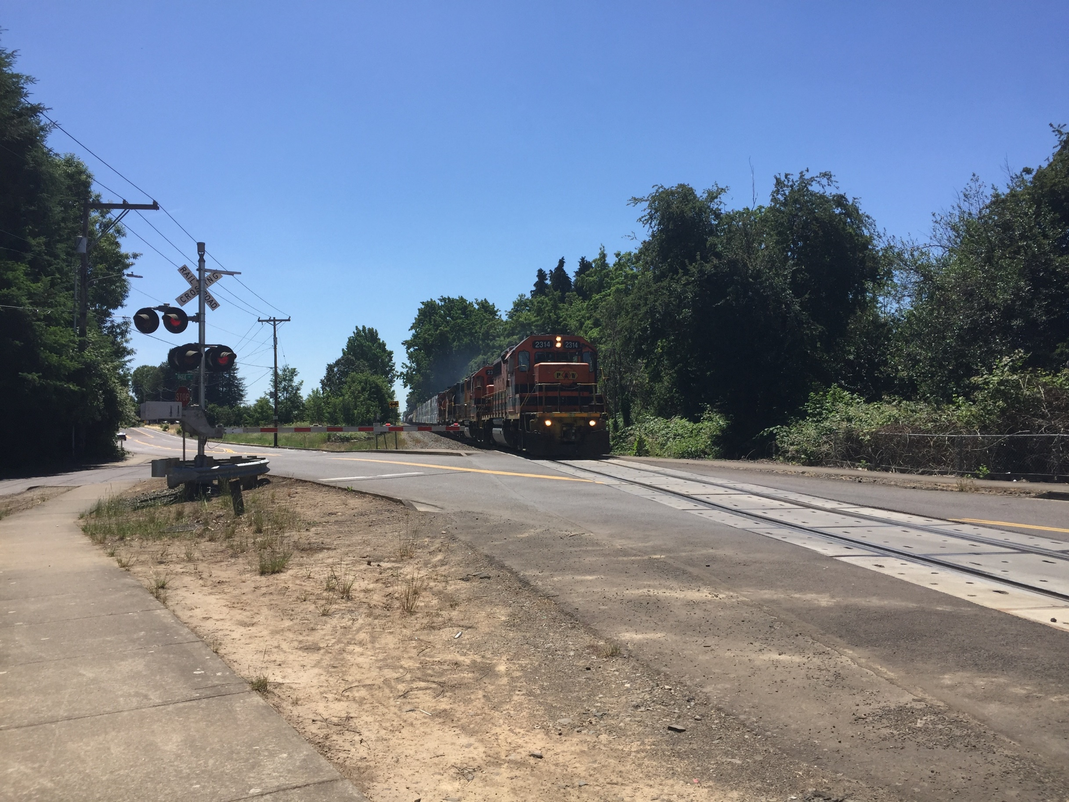

Transportation System Management and Operation Plan

Rail Plan

Air Transportation

Marine Transportation

Pipeline

7 Other Travel Modes

This page intentionally left blank

Other Travel Modes
This section summarizes the plans for other travel modes in Woodburn.

Transportation System Management and Operations (TSMO) Plan
Transportation System Management and Operations (TSMO) is a set of integrated transportation solutions intended to improve the performance of existing transportation infrastructure. Transportation Demand Management (TDM) and Transportation System Management (TSM) strategies are two complementary approaches to managing transportation and maximizing the efficiency of the existing system. TDM addresses the demand on the system: the number of vehicles traveling on the roadways each day. TDM measures include any method intended to shift travel demand from single occupant vehicles to non-auto modes or carpooling, travel at less congested times of the day, etc. TSM addresses the supply of the system: using strategies to improve the system efficiency without increasing roadway widths or building new roads. TSM measures are focused on improving operations by enhancing capacity during peak times, typically with advanced technologies to improve traffic operations.

Transportation System Management (TSM)
Transportation System Management (TSM) focuses on low cost strategies that can be implemented within the existing transportation infrastructure to enhance operational performance. Finding ways to better manage transportation while maximizing urban mobility and treating all modes of travel as a coordinated system is a priority. TSM strategies include traffic signal timing and phasing, traffic signal coordination, traffic calming, access management, local street connectivity and intelligent transportation systems (ITS). Traffic signal coordination and ITS typically provide the most significant tangible benefits to the traveling public. The primary focus of TSM measures are region-wide improvements, however there are a number of TSM measures that could be used in a smaller-scale environment such as within the City of Woodburn. TSM projects and programs that are recommended for the City of Woodburn to explore include the following:
- Update signal timing plans and coordinate signals to better match prevailing traffic conditions
  - OR 99E from Hardcastle Avenue to Young Street (or to the potential future Cleveland Street traffic signal) is one candidate corridor for coordination
- Implement truck signal priority at key signalized intersections along OR 214 and OR 99E. Truck signal priority can reduce delay, travel time, and the number of stops for freight vehicles, helping reduce vehicle emissions and improve travel time reliability.
- Work with ODOT to develop and implement a Traffic Management Plan for the OR 99E corridor that responds to increased congestion resulting from incidents on I-5 and regional events

Transportation Demand Management (TDM)
Transportation Demand Management (TDM) is a policy tool as well as a general term used to describe any action that removes single occupant vehicle trips from the roadway during peak travel demand periods. As growth in the City of Woodburn occurs, the number of vehicle trips and travel demand in the area will also increase. The ability to change a user’s travel behavior and provide alternative mode choices will help accommodate this potential growth in trips.
Technical Memorandum 5: Alternative Analysis and Funding identifies several policies and programs that may be effective for managing transportation demand in the City of Woodburn, especially within the next 10 to 20 years. Table 7 summarizes the strategies that best meet the goals and objectives of the TSP update. As with all new public and private investments, the implementation of TDM strategies is sure to draw opposition from some. Given Woodburn’s lack of experience with TDM strategies, it is important that decision-makers understand their long-term costs and benefits and are able evaluate these along-side arguments from opponents in achieving outcomes that best reflect the City’s vision and goals while effectively reducing travel demand.
Table 7: Transportation Demand Management Program Strategies
Program/Project Number | Name | Responsible Jurisdiction | Description | Priority | Cost Estimate
TDM1 | Carpool/Vanpool Match Services | County/City | Coordinate a rideshare/carpool/vanpool program that regional commuters can use to find other commuters with similar routes to work | High | $5,000/year
TDM2 | Carpool/Vanpool Parking Program | City | Coordinate with employers to designate carpool/vanpool preferential parking | Low | $5,000/year
TDM3 | Collaborative Marketing | County/City | Work with nearby cities, employers, transit service providers, and developers to collaborate on marketing for transportation options that provide an alternative to single-occupancy vehicles | Medium | $5,000/year
TDM4 | Limited and/or Flexible Parking Requirements | City | Update the Woodburn Development Ordinance to include strategies that encourage multi-modal transportation | High | $25,000
TDM5 | Parking Management | City | Modify the City’s current parking policy to allow for the potential to charge for parking | Low | $10,000
TDM6 | Transit Fare Subsidies | City/ Woodburn Transit | Work with Woodburn Transit to provide transit fare subsidies | Low | $5,000
TDM7 | Employer TDM Measures | City | Work with employers to encourage TDM measures such as allowing employees to work at home one day a week and scheduling shift changes to occur outside of peak travel periods | Low | $5,000/year
TOTAL High Priority Costs |  |  |  |  | $125,000
TOTAL Medium Priority Costs |  |  |  |  | $100,000
TOTAL Low Priority Costs |  |  |  |  | $215,000
TOTAL Program Costs (20 years) |  |  |  |  | $440,000

Other potential TDM projects include:
- Encourage the development of high-speed communication in all part of the city (fiber optic, digital cable, DSL, etc). The objective would be to allow employers and residents the maximum opportunity to rely upon other systems for conducting business and activities than the transportation system during peak periods.
- Encourage developments that effectively mix land uses to reduce vehicle trip generation. These plans may include development linkages (particularly non-auto) that support greater use of alternative modes.

Land Use
The types and intensities of land uses are closely correlated with travel demand. Land use patterns in many areas of the city are suburban in nature with low densities throughout the city and more industrial and commercial uses in the eastern part of the city near OR 99E. In the future the city will continue to have a mixture of housing and industrial densities, as well as areas of mixed-use development (i.e., a mix of residential, retail, commercial and/or office uses). Technical Memorandum 5: Alternative Analysis and Funding identifies several land use strategies that could be implemented in Woodburn. Table 8 summarizes the strategies that best meet the goals and objectives of the TSP update.
Table 8: Land Use Projects
Program/Project Number | Name | Responsible Jurisdiction | Description | Priority | Cost Estimate
LU1 | Commercial and Mixed-use Nodes | City | Establish neighborhood commercial and mixed-use nodes within the city | Low | $25,000
LU2 | Alternative Mobility Targets | State/City | Work with ODOT to develop alternative mobility targets at critical intersections along state highways. | Low | $25,000
LU3 | Right-of-way Dedications | City | Through development, right-of-way dedications should be provided to facilitate the future planned transportation system in the vicinity of the proposed development | Low | $0¹
LU4 | Half-street Improvements | City | Through development, half-street improvements (sidewalks, curb and gutter, bicycle lanes/paths, and/or travel lanes) should be provided along all site frontages that do not have full buildout improvements in place at the time of development | High | $0¹
TOTAL High Priority Costs |  |  |  |  | $0
TOTAL Medium Priority Costs |  |  |  |  | $0
TOTAL Low Priority Costs |  |  |  |  | $50,000
TOTAL Program Costs (20 years) |  |  |  |  | $50,000
1. Project to be funded by others.

Access Management Plan
Numerous driveways or street intersections increase the number of conflicts and potential for collisions and decrease mobility and traffic flow. The City of Woodburn, as with every city, needs a balance of streets that provide access with streets that serve mobility. Access management is a set of measures regulating access to streets, roads, and highways, from public roads and private driveways. It is a policy tool which seeks to balance mobility, the need to provide efficient, safe and timely travel with the ability to allow access to individual properties. Proper implementation of access management techniques should guarantee reduced congestion, reduced collision rates, less need for roadway widening, conservation of energy, and reduced air pollution. Measures may include but are not limited to restrictions on the type and amount of access to roadways, and use of physical controls, such as signals and channelization including raised medians, to reduce impacts of approach road traffic on the main facility.
City of Woodburn access spacing standards can be found in the Woodburn Development Ordinance Section 3.04.02 and OAR Division 51, which specifies access management spacing standards for ODOT facilities. In coordination with the access spacing standards presented in these documents, Table 9 summarizes the access management projects identified to help Woodburn balance access and mobility throughout the city.
Table 9: Access Management Projects
Program/Project Number | Name | Responsible Jurisdiction | Description | Priority | Cost Estimate
AM1 | Access Spacing Standard Modification | City | Develop access management standards that reflect functional classification of the roadway and that coordinate with the ODOT standards that regulate several major roadways in Woodburn | Low | $25,000
AM2 | Alternative Access | City | Investigate and implement opportunities to provide alternative access to nonstate facilities when reasonable access can occur (consistent with the State’s Division 51 access management standards) | Low | $25,000
AM3 | Access Variance Process | City | Define a variance process for when the standard cannot be met | Low | $25,000
AM4 | Access Consolidation | City | Establish an approach for access consolidation over time to move in the direction of the standards at each opportunity. Cross-over easements should be provided on all compatible parcels (topography, access, and land use) to facilitate future access between adjacent parcels and inter-parcel circulation. | Low | $25,000
AM5 | Access Movement Restrictions | City | Consider opportunities to restrict certain turning movements at accesses (such as a right in-right out access) | Low | $25,000
TOTAL High Priority Costs |  |  |  |  | $0
TOTAL Medium Priority Costs |  |  |  |  | $0
TOTAL Low Priority Costs |  |  |  |  | $125,000
TOTAL Program Costs (20 years) |  |  |  |  | $125,000

Rail Plan
The existing rail system in Woodburn includes freight rail, while there are currently no passenger rail terminals. Union Pacific Railroad operates a Class I rail line through Woodburn. These tracks parallel the east side of Front Street. A total of five at-grade crossings and one grade separated crossing exist along the rail line. Willamette Valley Railway operates a Shortline Railroad track that parallels the north side of Cleveland Street in the south side of town. A total of five public at-grade crossings exist along this rail line. In addition to these crossings, the rail line serves multiple local businesses along the corridor. Table 10 summarizes the rail system projects that best meet the identified goals and objectives of this plan.
Table 10: Rail Projects
Program/Project Number | Name | Responsible Jurisdiction | Description | Priority | Cost Estimate
RA1 | Front Street | City | Establish a downtown Amtrak passenger rail stop along Front Street in downtown Woodburn, potentially as a public-private partnership at the "Y" property adjacent to Locomotive Park | Low | $10,000
RA2 | Front Street and Cleveland Street | City | Investigate the opportunity to remove private grade railroad crossings by providing alternative access to parcels as development and redevelopment occurs | Medium | $10,000
RA3 | Butteville Road, north of OR 219 | State/County/ City | Explore a passenger rail stop if commuter rail is extended between Wilsonville and Beaverton down to Salem | Low | $5,000
TOTAL High Priority Costs |  |  |  |  | $0
TOTAL Medium Priority Costs |  |  |  |  | $10,000
TOTAL Low Priority Costs |  |  |  |  | $15,000
TOTAL Program Costs (20 years) |  |  |  |  | $25,000

Air Transportation
There are no airports located within the city limits. The closest airports include the Aurora State Airport (classified as an Urban General Aviation Airport) located approximately 8 miles to the north via OR 99E and OR 551 and the Mulino Airport located approximately 14 miles to the northeast via OR 211 and OR 213. No air projects or programs were identified as part of the TSP process.

Marine Transportation
Marine transportation is not available within the City of Woodburn, and no marine projects or programs were identified as part of the TSP process.

Pipeline
There are no major pipeline transport facilities within the Woodburn UGB, and no pipeline projects or programs were identified as part of the TSP process.

This page intentionally left blank

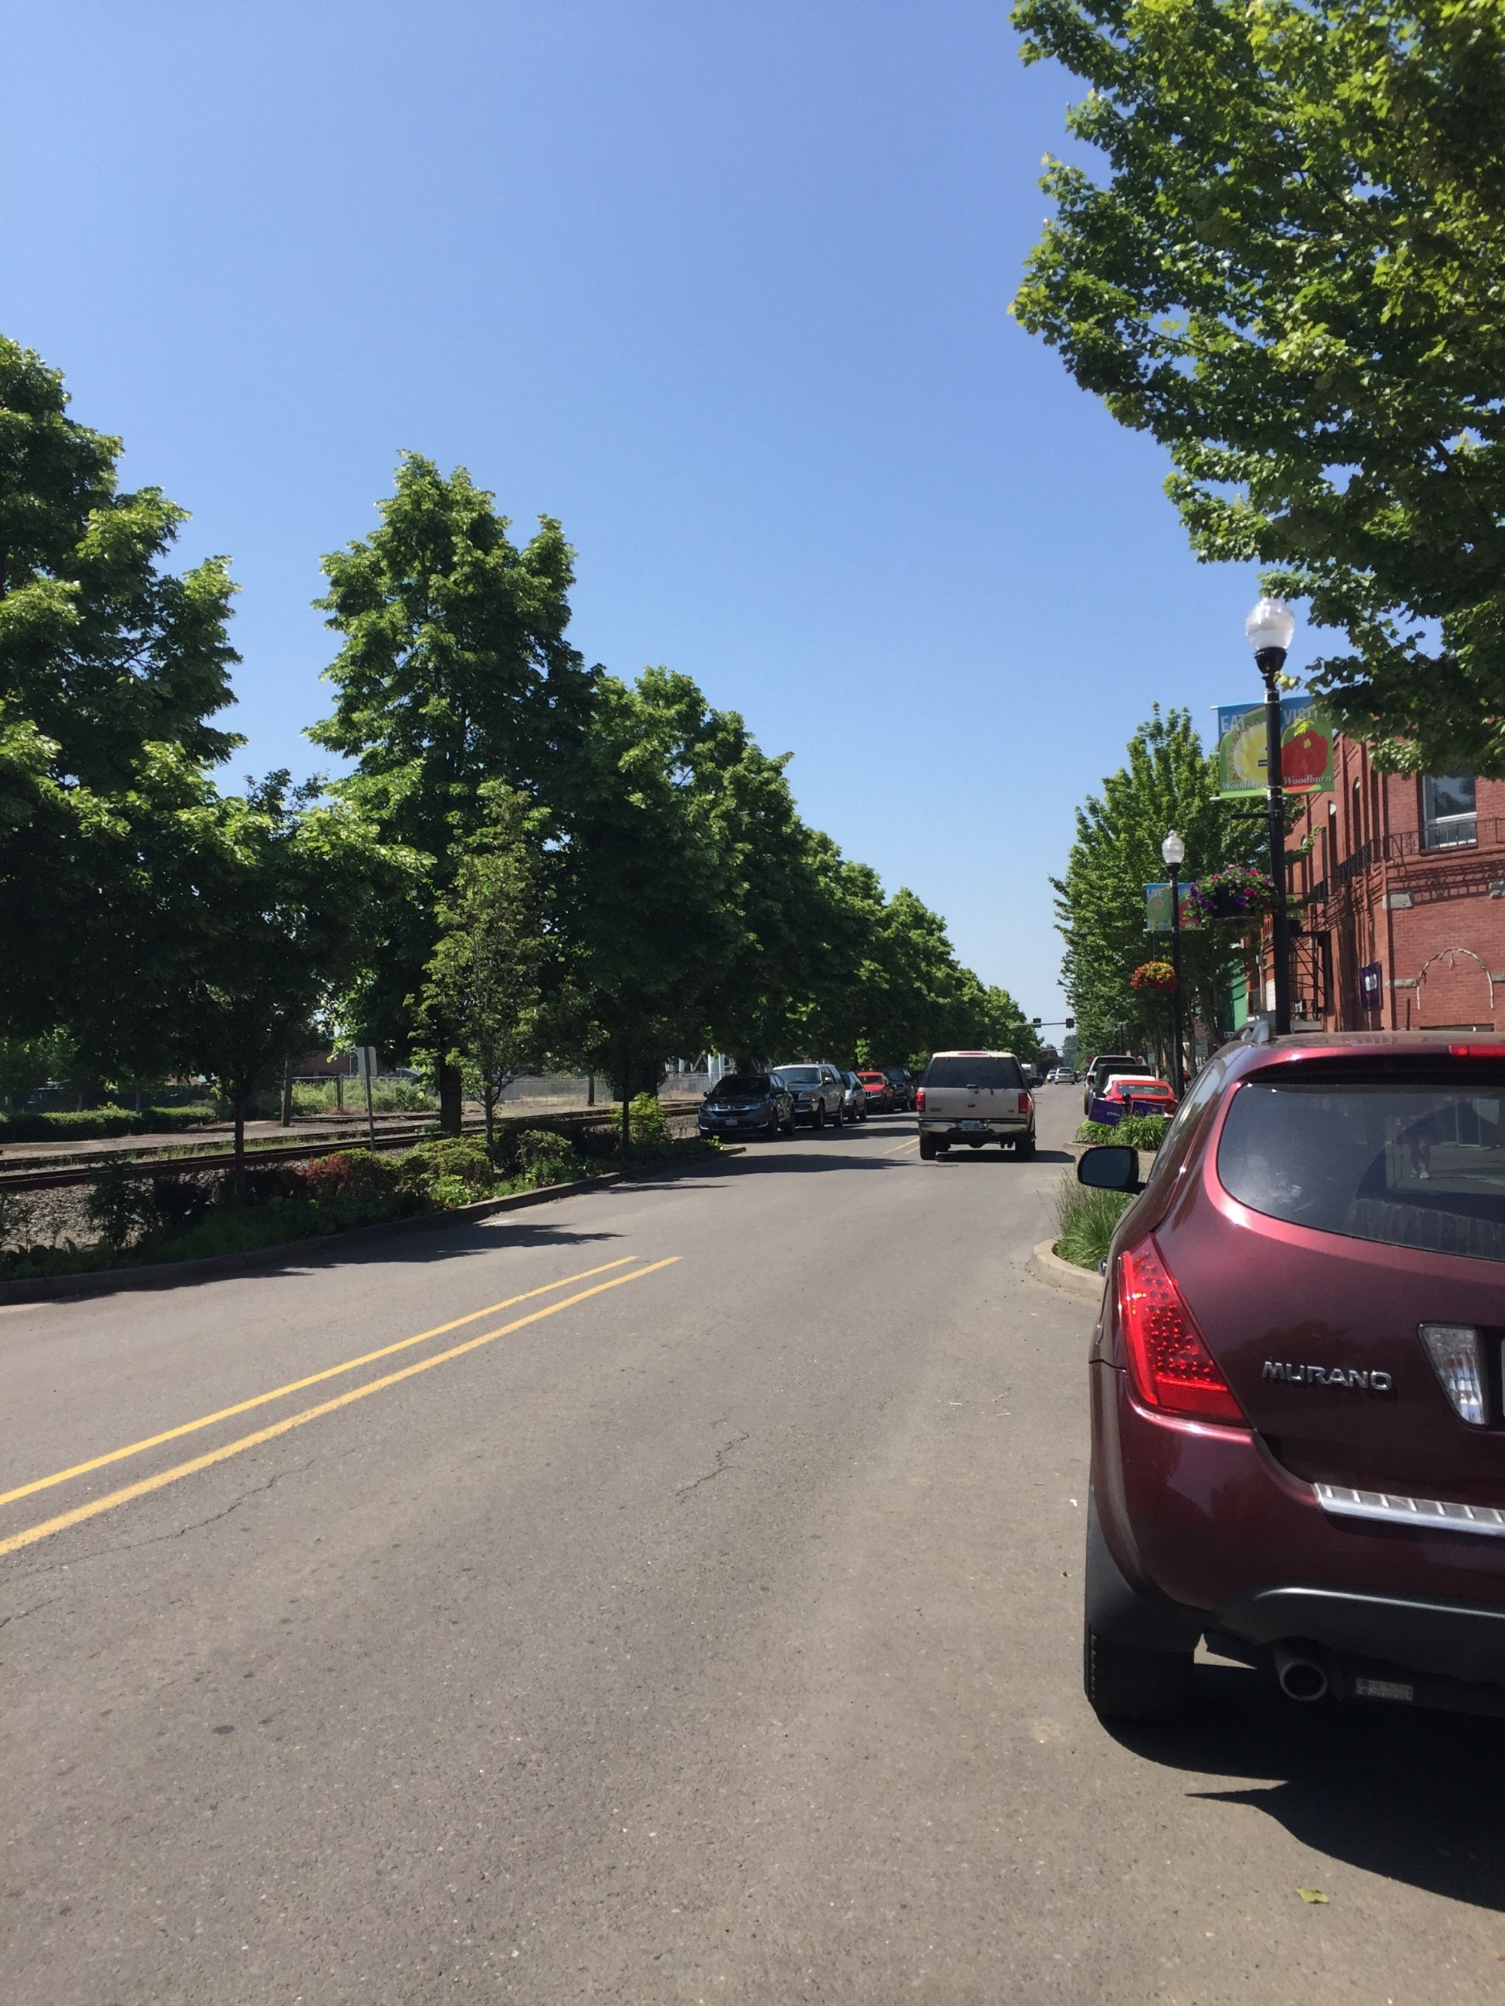

Funding Programs and Revenue

Planned Transportation System Cost Summary

8 Funding

This page intentionally left blank

Funding

Funding Programs and Revenue
The City of Woodburn has historically relied upon multiple revenue sources to fund the maintenance of its transportation network and make capital improvements. These local gas tax revenue, inter-governmental (primarily state gas tax revenue), franchise fees, and other miscellaneous revenue. Table 11 displays the total revenue by source used to fund transportation projects within Woodburn over the most recent seven years that comprehensive data was available.
Table 11: City of Woodburn Revenue History
Revenue Source | FY 2016-2017 | FY 2015-2016 | FY 2014-2015 | FY 2013-2014 | FY 2012-2013 | FY 2011-2012 | FY 2010-2011 |  | Average
Taxes | $129,412 | $115,692 | $102,517 | $101,761 | $106,537 | $182,109 | $121,196 |  | $122,746
Inter-Government | $1,480,082 | $1,454,076 | $1,409,311 | $1,384,277 | $1,597,518 | $1,312,024 | $1,116,011 |  | $1,393,328
Franchise | $359,820 | $357,983 | $336,707 | $360,046 | $353,381 | $326,713 | $347,621 |  | $348,896
Transportation SDC Fees | $33,396 | $183,698 | $440,595 | $521,933 | $411,527 | $400,172 | $153,268 |  | $306,370
Other | $69,856 | $59,518 | $49,532 | $319,086 | $49,457 | $88,767 | $27,147 |  | $94,766
Revenue Total | $2,072,566 | $2,170,967 | $2,338,662 | $2,687,103 | $2,518,420 | $2,309,785 | $1,765,243 |  | $2,266,107
Taxes = Local Gas Tax revenue
Inter-Government = State Gas Tax, State Fund Exchange
Other = Misc. revenue, interest income
Based on the information shown in Table 11, the City of Woodburn has generated an average of approximately $2,266,107 per year in total revenue for transportation-related maintenance/projects.

Potential Funding Sources
The projected transportation funding analysis shows that the City of Woodburn will have a limited source of funds that can solely dedicated to transportation-related capital improvement projects over the next twenty years. As such, Woodburn will likely need to seek additional funds via transportation improvement grants, partnerships with regional and state agencies, and other funding sources to help implement future transportation-related improvements. Table 12 identifies a list of potential Grant sources and Partnering Opportunities to consider during the course of the 20-year planning horizon. Following Table 12, Table 13 identifies a list of potential new funding sources for Woodburn to consider in an effort to bolster funds for additional capital improvement projects.
Table 12: Potential Grant Sources and Partnering Opportunities
Funding Source | Description | Potential Facility Benefit | Opportunities
Statewide Transportation Improvement Program (STIP) | The Statewide Transportation Improvement Program (STIP) is Oregon’s 4-year capital improvement program for major state and regional transportation facilities. This scheduling and funding document is updated every two years. Projects included on the STIP are allocated into the five different ODOT regions. | - Streets  - Sidewalks  - Bike lanes  - Trails | The next STIP (2018-2021) will be organized into two different categories that focus on projects that will fix/preserve the existing transportation network and enhance/improve the transportation network.
Federal Funding | Large trails or trail networks with a transportation purpose can compete for TIGER grant awards. Additional significant federal funding sources include TAP, STP and CMAQ. Depending upon the location and purpose, trails can also be funded by HUD CDBG funds, USDA rural development programs, or EPA funding. | - Multi-Use Trails | Projects in urban areas have traditionally been funded at a minimum of $10,000,000 and rural trails of lower project costs are considered for TIGER funding.
Oregon Bicycle and Pedestrian Program | The Oregon Pedestrian and Bicycle Grant program ended as a standalone solicitation process in 2012. Grant monies are now distributed through the “Enhance” process in the STIP program noted above. | See STIP above | See STIP above.
ATV Grant Program | Operation and maintenance, law enforcement, emergency medical services, land acquisition, leases, planning, development and safety education in Oregon’s OHV (off-highway vehicle recreation areas). | - Multi-Use Trails | http://www.oregon.gov/oprd/ATV/pages/grants.aspx

Table 13: Potential New Funding Sources for Consideration by the City of Woodburn
Funding Source | Description | Potential Facility Benefit | Opportunities
User Fees | Fees tacked onto a monthly utility bill or tied to the annual registration of a vehicle to pay for improvements, expansion, and maintenance to the street system. This may be a more equitable assessment given the varying fuel efficiency of vehicles. Regardless of fuel efficiency, passenger vehicles do equal damage to the street system. | Primarily Street Improvements | The cost of implementing such a system could be prohibitive given the need to track the number of vehicle miles traveled in every vehicle. Additionally, a user fee specific to a single jurisdiction does not account for the street use from vehicles registered in other jurisdictions.
Street Utility Fees/Road Maintenance Fee | The fee is based on the number of trips a particular land use generates and is usually collected through a regular utility bill. For the communities in Oregon that have adopted this approach, it provides a stable source of revenue to pay for street maintenance allowing for safe and efficient movement of people, goods, and services. | Preservation, restoration, and reconstruction of existing paved residential streets. Includes sidewalks, ramps, curbs and gutters, and utility relocation. | Other cities have adopted street maintenance utility fees at varying amounts charged to residential meters. Woodburn could consider a similar program.
Optional Tax | A tax that is paid at the option of the taxpayer to fund improvements. Usually not a legislative requirement to pay the tax and paid at the time other taxes are collected, optional taxes are usually less controversial and easily collected since they require the taxpayer to decide whether or not to pay the additional tax. | - Streets  - Sidewalks  - Bike lanes  - Multi-Use Trails  - Transit | The voluntary nature of the tax limits the reliability and stableness of the funding source.
Sponsorship | Financial backing of a project by a private corporation or public interest group, as a means of enhancing its corporate image. | - Multi-Use Trails | Sponsorship has primarily been used by transit providers to help offset the cost of providing transit services and maintaining transit related improvements.
Federal Funding | Trails with a transportation purpose can compete for TIGER grant awards. Depending upon the location and purpose, trails can also be funded by HUD, CDBG funds, USDA rural development programs, or EPA funding. | - Trails | Projects in urban areas have traditionally been funded at a minimum of $10,000,000 and rural trails of lower project costs are considered for TIGER funding.

Planned Transportation System Cost Summary
Table 14 provides a summary of the full cost of the planned and financially constrained transportation systems. As shown, the full cost of the planned system is approximately $130.6 million over the 20-year period, including $26.4 million in high priority projects, $102.7 million in medium priority projects, and $1.5 million in low priority projects. Based on the anticipated funds available for capital improvement projects, the financially constrained plan includes all of the high priority projects. This leaves no forecasted funding for the City to complete medium and low priority projects over the 20-year period.
Table 14: Planned Transportation System Cost Summary
Project Type | High Priority  (Financially Constrained Plan Projects) | Medium Priority | Low Priority | Total
Planned Transportation System
Bicycle | $8,125,000 | $12,280,000 | $110,000 | $20,515,000
Pedestrian | $6,750,000 | $10,300,000 | $355,000 | $17,405,000
Roadway | $9,200,000 | $74,670,000 | $500,000 | $84,370,000
Safety | $2,200,000 | $5,260,000 | $100,000 | $7,560,000
Transit | -- | $100,000 | $15,000 | $115,000
TDM¹ | $125,000 | $100,000 | $215,000 | $440,000
Land Use | -- | -- | $50,000 | $50,000
Access Management | -- | -- | $125,000 | $125,000
Rail | -- | $10,000 | $15,000 | $25,000
Total | $26,400,000 | $102,720,000 | $1,485,000 | $130,605,000
Available Funding
Total | $6,550,000 | $6,550,000 | $13,100,000 | $26,200,000
TDM: Transportation Demand Management
1: Includes annual costs occurred every year.

implementation
The Transportation Planning Rule (TPR), as codified in Oregon Administrative Rules (OAR) 660-012-0045, requires that local jurisdictions identify and adopt land use regulations and code amendments needed to implement the TSP. The land use regulations and code amendments are provided under separate cover.

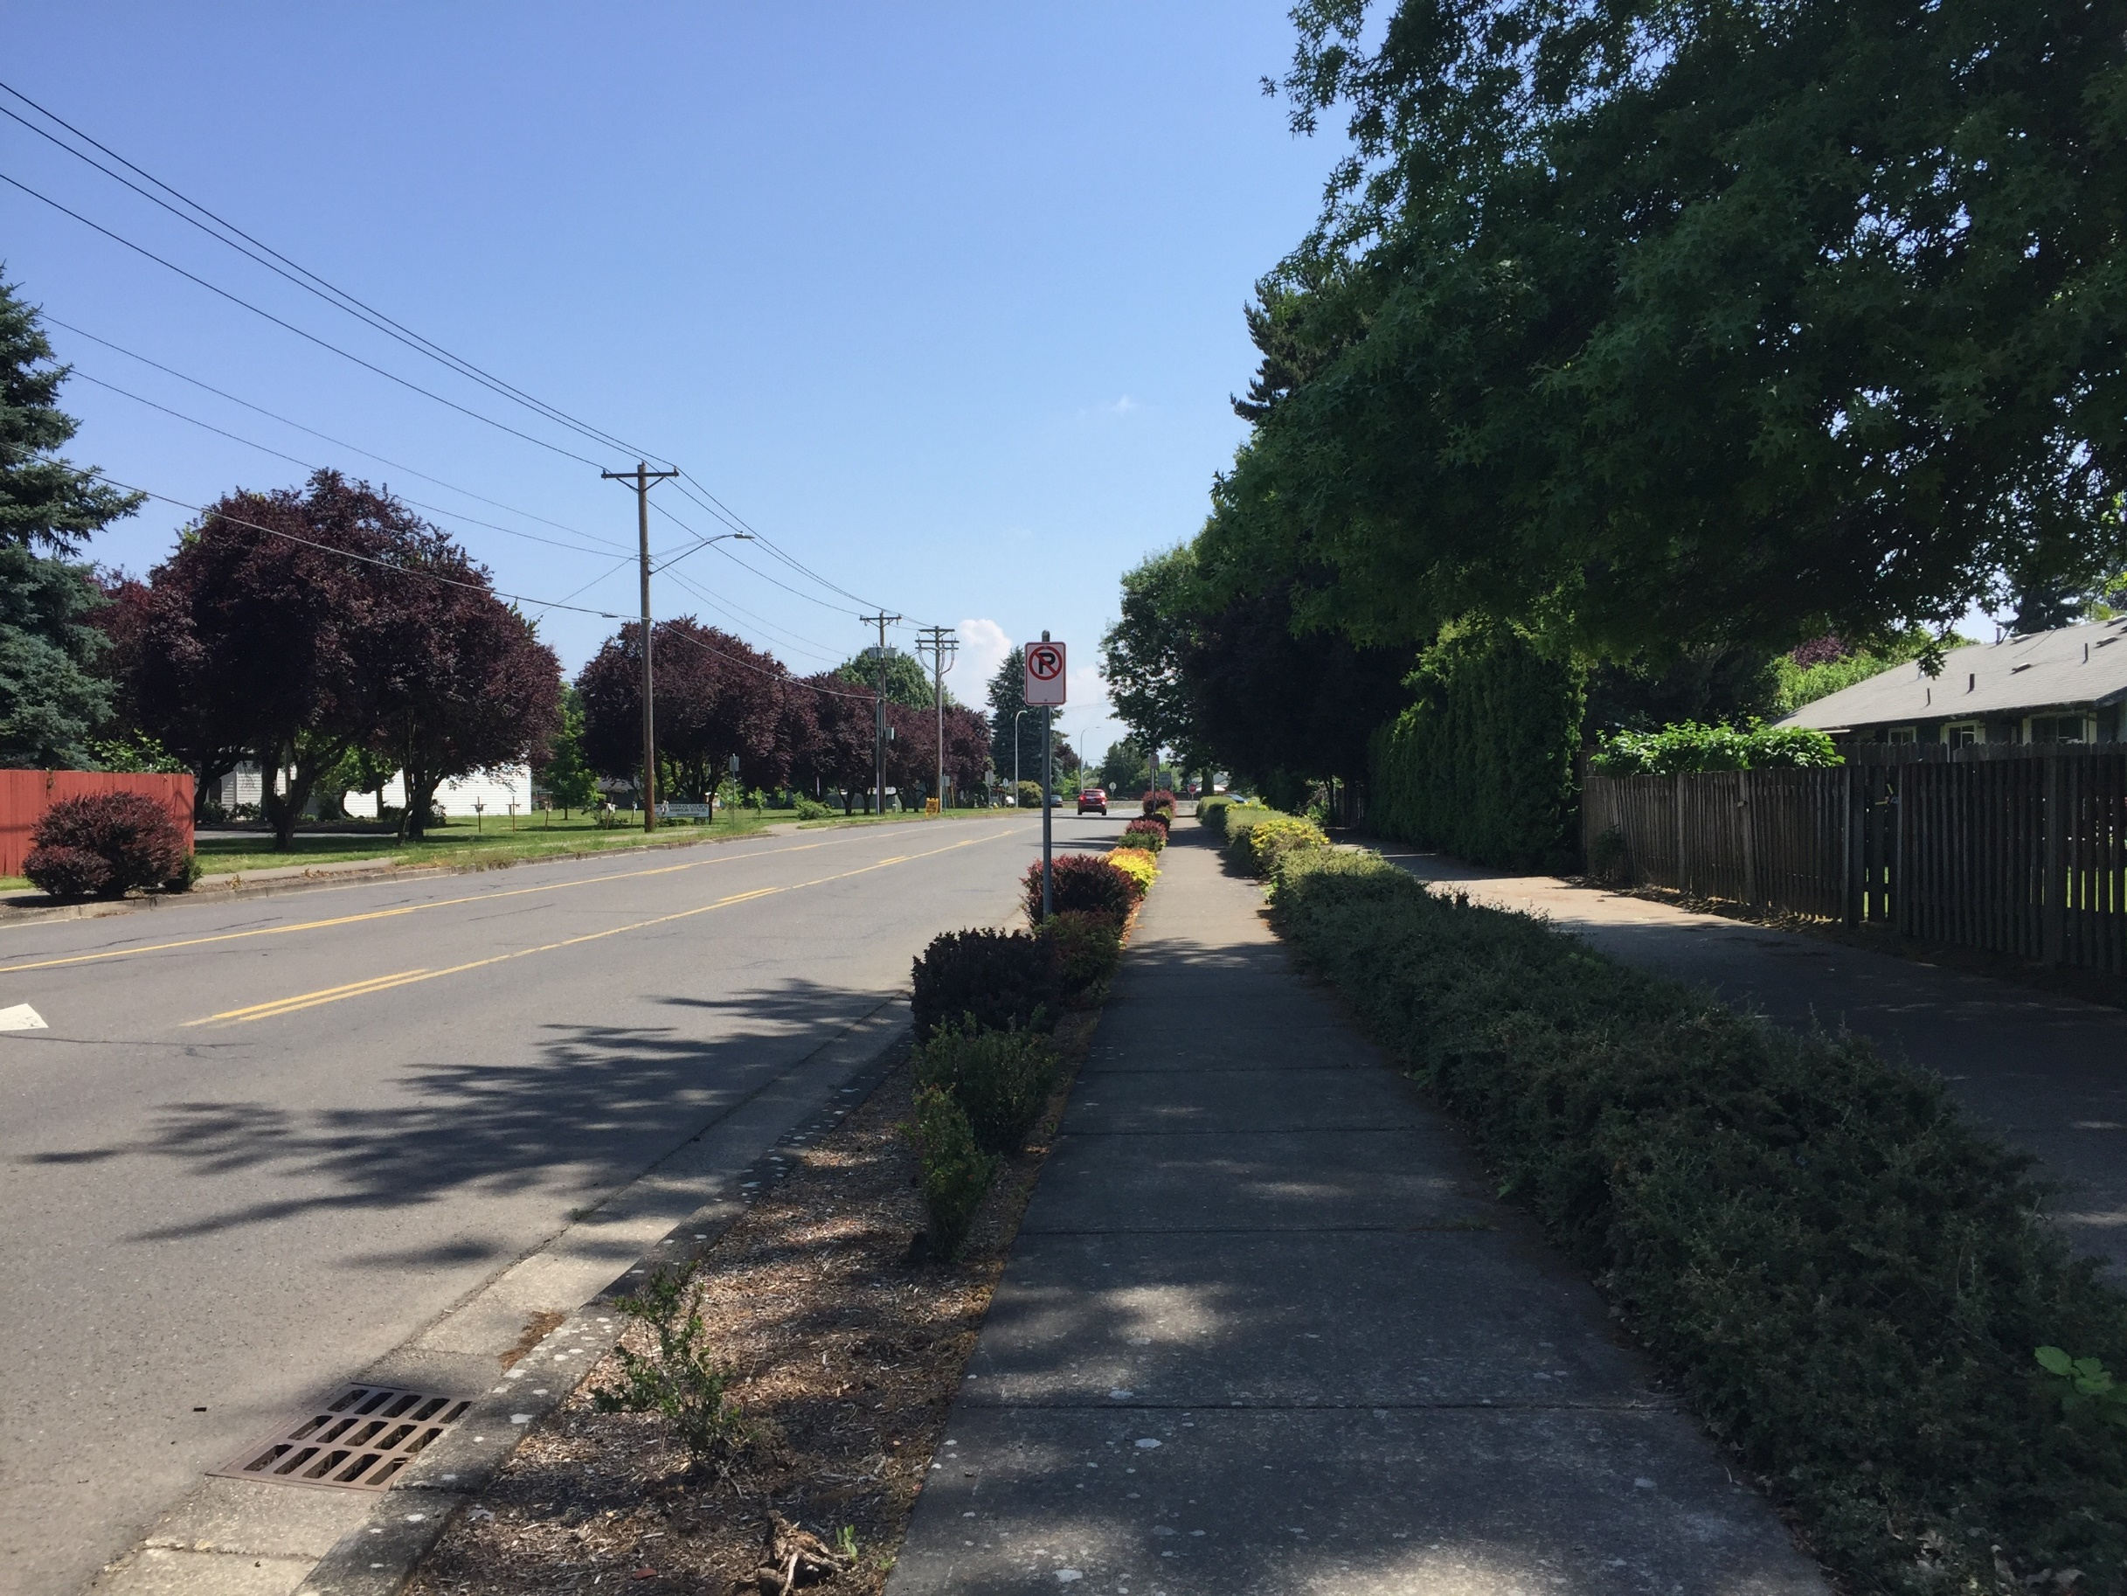

9 Glossary of Terms

This page intentionally left blank

Glossary of Terms
The following terms are applicable only to the Woodburn Transportation System Plan and shall be construed as defined herein.
Access Management: Refers to measures regulating access to streets, roads and highways from public roads and private driveways. Measures may include but are not limited to restrictions on the type and amount of access to roadways and use of physical controls such as signals and channelization including raised medians, to reduce impacts of approach road traffic on the main facility.
Access (Street): A street designated in the functional classification system that’s primary purpose is to connect residential neighborhoods with service collectors or arterials. On-street parking and access to adjacent properties is prevalent. Slower speeds should be provided to ensure community livability and safety for pedestrians and cyclists.
Accessway: Refers to a walkway that provides pedestrian and or bicycle passage either between streets or from a street to a building or other destination such as a school, park, or transit stop.
Alternative Modes: Transportation alternatives other than single-occupant automobiles such as rail, transit, bicycles and walking.
Americans with Disabilities Act (ADA): A civil rights law that prohibits discrimination against individuals with disabilities in all areas of public life, including jobs, schools, transportation, and all public and private places that are open to the general public.
Average Annual Daily Traffic (AADT): A measure used primarily in transportation planning and traffic engineering that represents the total volume of vehicular traffic on a highway or roadway for a year divided by 365 days.
Average Daily Traffic (ADT): This is the measurement of the average number of vehicles passing a certain point each day on a highway, road or street.
Bicycle Facility: Any facility provided for the benefit of bicycle travel, including bikeways and parking facilities.
Bicycle Network: A system of connected bikeways that provide access to and from local and regional destinations.
Bicycle Boulevard: Lower-order, lower-volume streets with various treatments to promote safe and convenient bicycle travel. Usually accommodates bicyclists and motorists in the same travel lanes, often with no specific vehicle or bike lane delineation. Assigns higher priority to through bicyclists, with secondary priority assigned to motorists. Also includes treatments to slow vehicle traffic to enhance the bicycling environment.
Bike Lane: Area within street right-of-way designated specifically for bicycle use.
Capital Improvement Plan (CIP): A community planning and fiscal management tool used to coordinate the location, timing and financing of capital improvements over a multi-year period.
Capacity: The maximum number of vehicles or individuals that can traverse a given segment of a transportation facility with prevailing roadway and traffic conditions.
Citizen Advisory Committee (CAC): An advisory committee consisting of volunteer citizens from the community they represent.
Congestion Mitigation/Air Quality (CMAQ): A program within the federal ISTEA and TEA-21 regulations that address congestion and transportation-related air pollution.
Crosswalk: Portion of a roadway designated for pedestrian crossing and can be either marked or unmarked. Unmarked crosswalks are the national extension of the shoulder, curb line or sidewalk.
Cycle Track: An exclusive bike facility that combines the user experience of a separated path with the on-street infrastructure of a conventional bike lane. A cycle track is physically separated from motor traffic and distinct from the sidewalk.
Demand Management: Refers to actions which are designed to change travel behavior in order to improve performance of transportation facilities and to reduce need for additional road capacity. Methods may include subsidizing transit for the journey to work trip, charging for parking, starting a van or carpool system, or instituting flexible work hours.
Department of Environmental Quality (DEQ): A regulatory agency whose job is to protect the quality of Oregon's environment.
Department of Land Conservation and Development (DLCD): A public agency that helps communities and citizens plan for, protect and improve the built and natural systems that provide a high quality of life.
Driveway (DWY): A short road leading from a public road to a private business or residence.
Eastbound (EB): Leading or traveling toward the east.
Fiscal Year (FY): A year as reckoned for taxing or accounting purposes.
Geographic Information Systems (GIS): A system designed to capture, store, manipulate, analyze, manage, and present all types of spatial or geographical data.
Grade: A measure of the steepness of a roadway, bikeway or walkway, usually expressed in a percentage form of the ratio between vertical rise to horizontal distance, (e.g. a 5% grade means that the facility rises 5 feet in height over 100 feet in length.)
Grade Separation: The vertical separation of conflicting travelways.
High Capacity Transit (HCT): A form of public transit distinguished from local service transit such as bus lines by higher speeds, fewer stops, more passengers, and more frequent service.
Highway Design Manual (HDM): A manual that provides uniform standards and procedures for the design of new roadways and the major reconstruction, rehabilitation, restoration, and resurfacing of existing roadways.
Intelligent Transportation Systems (ITS): the application of advanced technologies and proven management techniques to relieve congestion, enhance safety, provide services to travelers and assist transportation system operators in implementing suitable traffic management strategies.
Level of Service (LOS): A qualitative measure describing the perception of operation conditions within a traffic steam by motorists and or passengers. An LOS rating of "A” to “F” describes the traffic flow on streets and at intersections, ranging from LOS A, representing virtually free flow conditions and no impedance to LOS F representing forced flow conditions and congestion.
Local (Street): A street designated in the functional classification system that’s primary purpose is to provide direct access to adjacent land uses. Short roadway distances, slow speeds, and low traffic volumes characterize local streets.
Major Arterial (Street): A street designated in the functional classification system that’s primary functions are to serve local and through traffic as it enters and leaves the urban area, connect Woodburn with other urban centers and regions, and provide connections to major activity centers within the UGB.
Manual on Uniform Traffic Control Devices (MUTCD): A document issued by the Federal Highway Administration (FHWA) of the United States Department of Transportation (USDOT) to specify the standards by which traffic signs, road surface markings, and signals are designed, installed, and used.
Minor Arterial (Street): A street designated in the functional classification system that’s primary functions are to connection major activity centers and neighborhoods within the UGB and to support the major arterial system.
Multi-Modal: Involving several modes of transportation including bus, rail, bicycle, motor vehicle etc.
Multi-Use Path: Off-street route (typically recreationally focused) that can be used by several transportation modes, including bicycles, pedestrians and other non-motorized modes (i.e. skateboards, roller blades, etc.)
National Highway System (NHS): The National Highway System is interconnected urban and rural principal arterial and highways that serve major population centers, ports, airports and other major travel destinations, meet national defense requirements and serve interstate and interregional travel.
Northbound (NB): Traveling or leading toward the north.
Oregon Administrative Rules (OAR): The official compilation of rules and regulations having the force of law in the U.S. state of Oregon. It is the regulatory and administrative corollary to Oregon Revised Statutes and is published pursuant to ORS 183.360 (3).
Oregon Department of Transportation (ODOT): ODOT is a public agency that helps provide a safe, efficient transportation system that supports economic opportunity and livable communities throughout Oregon. ODOT owns and operates two roadways (OR 213 and OR 211) that are located in Molalla or provide access to the city. There are street design and operational standards for these roadways which supersede Molalla’s street design and operational standards.
Oregon Highway Plan (OHP): The document that establishes long range policies and investment strategies for the state highway system in Oregon.
Oregon Revised Statutes (ORS): The codified body of statutory law governing the U.S. state of Oregon, as enacted by the Oregon Legislative Assembly, and occasionally by citizen initiative. The statutes are subordinate to the Oregon Constitution.
Peak Period or Peak Hour: The period of the day with the highest number of travelers. This is normally between 4:00 p.m. to 6:00 p.m. on weekdays.
Pedestrian Connection: A continuous, unobstructed, reasonability direct route between two points that is intended and suitable for pedestrian use. These connections could include sidewalks, walkways, accessways, stairways and pedestrian bridges.
Pedestrian Facility: A facility provided for the benefit of pedestrian travel, including walkways, crosswalks, signs, signals and benches.
Pedestrian Scale: Site and building design elements that are oriented to the pedestrian and are dimensionally less than those sites designed to accommodate automobile traffic.
Regional Transportation Functional Plan (RTFP): A planning document that contains policies and guidelines to help local jurisdictions implement the policies in the Regional Transportation Plan (RTP) and its modal plans, include those for active transportation, freight movement, and high capacity transit.
Regional Transportation Plan (RTP): The transportation plan for the Portland Metro region.
Right-Of-Way (ROW or R/W): A general term denoting publicly owned land or property upon which public facilities and infrastructure is placed.
Safety Priority Index System (SPIS): An indexing system used by Oregon Department of Transportation to prioritize safety improvements based on crash frequency and severity on state facilities.
Service Collector (Street): A street designated in the functional classification system that’s primary function is to provide connections between neighborhoods and major activity centers and the arterial street system. Some degree of access is provided to adjacent properties, while maintaining circulation and mobility for all users.
Shared Roadway: Roadways where bicyclists and autos share the same travel lane. May include a wider outside lane and/or bicycle boulevard treatment (priority to through bikes on local streets).
Single-Occupancy Vehicle or Single-Occupant Vehicle (SOV): A vehicle containing only a single occupant, the driver.
Southbound (SB): Traveling or leading toward the south.
Statewide Transportation Improvement Plan (STIP): The capital improvement program that identifies founding and schedule of statewide projects.
System Development Charge (SDC): Fees that are collected when new development occurs in the city and are used to fund a portion of new streets, sanitary sewers, parks and water.
Technical Advisory Committee (TAC): An advisory committee consisting of state, county, and city staff that review and provide feedback on technical memorandums.
Technical Memorandum (TM): A document that is specifically targeted to technically capable persons, such as practicing engineers or engineering managers, who are interested in the technical details of the project or task.
Traffic Control Devices: Signs, signals or other fixtures placed on or adjacent to a travelway that regulates, warns or guides traffic. Can be either permanent or temporary.
Transportation Analysis Zone (TAZ): A geographic sub-area used to assess travel demands using a travel demand forecasting model. Often defined by the transportation network and US Census blocks.
Transportation Demand Management (TDM): A policy tool as well as any action that removes single-occupant vehicle trips from the roadway network during peak travel demand periods.
Transportation and Growth Management (TGM): A program of the Oregon Department of Transportation (ODOT) that supports community efforts to expand transportation choices. By linking land use and transportation planning, TGM works in partnership with local governments to create vibrant, livable places in which people can walk, bike, take transit or drive where they want to go.
Transportation Management Area (TMA): A Transportation Management Area is an area designated by the Secretary of Transportation, having an urbanized area population of over 200,000, or upon special request from the Governor and the MPO designated for the area.
Transportation Planning Rule (TPR): A series of Oregon Administrative Rules intended to coordinate land use and transportation planning efforts to ensure that the planned transportation system supports a pattern of travel and land use in urban areas that will avoid the air pollution, traffic and livability problems faced by other large urban areas of the country through measures designed to increase transportation choices and make more efficient use of the existing transportation system.
Transportation System Management (TSM): Management strategies such as signal improvements, traffic signal coordination, traffic calming, access management, local street connectivity, and intelligent transportation systems
Transportation System Management and Operations (TSMO): An integrated program to optimize the performance of existing multimodal infrastructure through implementation of systems, services, and projects to preserve capacity and improve the security, safety, and reliability of our transportation system.
Transportation System Plan (TSP): Is a comprehensive plan that is developed to provide a coordinated, seamless integration of continuity between modes at the local level as well as integration with the regional transportation system.
Two-Way Stop Control (TWSC): An intersection, where one or more approaches is stop controlled and must yield the right-of-way to one or more approaches that are not stop controlled.
Urban Area: The area immediately surrounding an incorporated city or rural community that is urban in character, regardless of size.
Urban Growth Boundary (UGB): A regional boundary, set in an attempt to control urban sprawl by mandating that the area inside the boundary be used for higher density urban development and the area outside be used for lower density development.
Vehicle Miles Traveled (VMT): The cumulative distance a vehicle travels, regardless of number of occupants.
Volume to Capacity Ratio (V/C): A measure that reflects mobility and quality of travel of a roadway or a section of a roadway. It compares roadway demand (vehicle volumes) with roadway supply (carrying capacity).
Westbound (WB): Leading or traveling toward the west.

https://www.woodburn-or.gov/dev-planning/page/woodburn-development-ordinance-wdo
https://www.fhwa.dot.gov/planning/national_highway_system/

