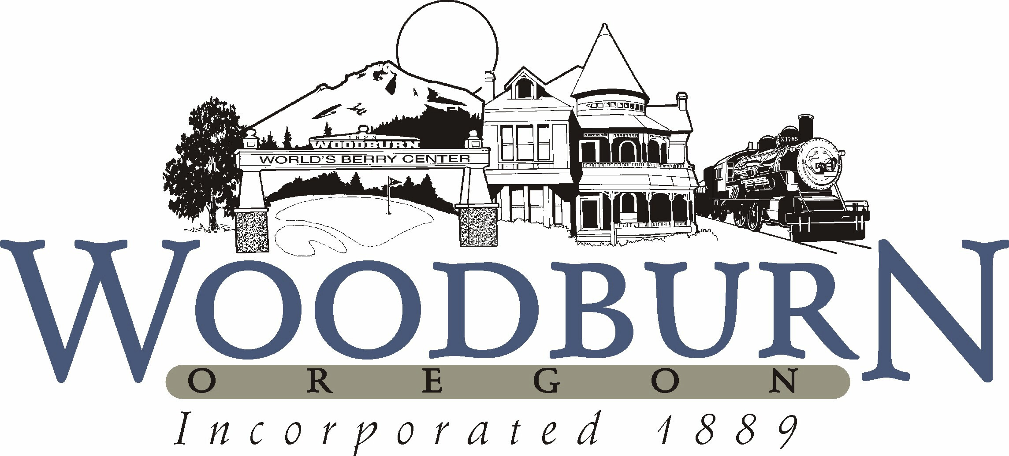
City of Woodburn
Recreation and Park Board Minutes
August 14, 2018 ● 5:30 p.m.

- CALL TO ORDER
  - 5:30 pm

- ROLL CALL
Position I Ricardo Rodrigues, Board Secretary (12/18) Present
Position II Uriel Cruz, Student Member (8/18) Absent
Position III Kasi Pankey, Member (12/21) Absent
Position IV Eric Swenson, Member (12/19) Present
Position V Donna Stone, Member (12/21) Present
Position VI Vacant, Member (12/20) Vacant
Position VII David Piper, Board Chair (12/20) Present

Staff Present: Josh Udermann, Jesse Cuomo

- APPROVAL OF MINUTES
Recreation & Park Board minutes from June 12, 2018 approved unanimously.

- BUSINESS FROM THE AUDIENCE
None.

- NEW BUSINESS
    - Art and Murals Committee – upcoming projects
      - Currently planning for Downtown Plaza Sculpture project, which will feature two children and bulldog (Woodburn High School mascot)
      - Another proposed project would be the addition of a peace pole outside of City Hall in rose garden
      - The next project would be to add art/mural to the water tower
      - Funding for these projects will come from the Urban Renewal budget, which helps to support projects that revitalize downtown
    - Summer program updates
      - Safety Camp for 3-5-year-olds – 16 children attended
        - Reviewed basic safety rules – for example getting on and off the school bus safely, being prepared with information such as name, address, and phone number in case of emergency
        - Police and Fire attended to emphasize safety rules and show that they are there to help
      - Zombie Camp
        - 30 participants
        - The camp focused on four elements for survival – food, water, shelter, and fire. Participants helped to build shelter and worked on different scenarios for survival each day
        - Camp focused on team building and problem-solving exercises
      - Craft Camp -7 participants
      - Lego Camp – 15 participants
      - Basketball Camp – 30 participants
      - Volleyball Camp – 26 participants (19 last year)
      - Tennis tournament – 17 registrations (7 last year), Eric Swenson mentioned that he saw roughly 30-40 people participating
    - Governor’s Camp-Out Program
      - 114 participants – 19 families (99 participants last year)
      - There were different stations and lots of activities – archery, kayaking, etc.
      - Camping gear and food was provided
      - Morning yoga was a popular activity
      - This is a great partnership for the City, this year Oregon State Parks and Recreation helped to sponsor the Fiesta Mexicana
    - Fiesta Mexicana – Jesse showed Fiesta highlight video
      - 25,404 people attended this year’s event (10% increase from last year
      - The Fiesta Parade was bigger than ever
      - 128 Fiesta survey responses –
        - Attendance: 55% Woodburn, 12% Salem/Keizer, 32% other areas
        - 21% stated it was their first time attending the Fiesta
        - 96% will return for next year’s Fiesta
      - Aquatic Center staff was a huge help staffing the First-Aid tent and responding to any incidents
      - 60,000 people reached through Fiesta Facebook posts, which is a great resource for spreading event information
      - 60 plus vendors participated
      - Eric Swenson mentioned that the band was a good choice, would like to have stage relocated to the soccer field next year to provide more space
    - Everybody Plays scholarship program
      - Kiwanis sponsor for a scholarship program to help pay for Aquatic Center membership and Aquatic Center & Recreation programming/classes
      - Kiwanis provided $4,000 toward scholarship program last year – will most likely provide the same level of funding this year
      - Sept 2017 – August 2018 $6,664 given out, which provided 158 participants with some level of scholarship, the average scholarship was $42
      - The scholarship helps to give access to families who might not be able to afford programs otherwise, matches both financial and physical need
      - The program is not entirely free – having participants contribute in some portion creates buy-in and scholarship recipients are more likely to use membership or attend programming
- OLD BUSINESS
  - None

- DIVISION REPORTS FROM DEPARTMENT
  - Aquatics

Financial Update –
- Expense – $21,826, seems to be not be updated yet and this might increase
- Revenue – $40,212, all-time monthly revenue record, $30,523 last summer
- Attendance – 5714 up from last year 5194, 10% increase
- FY 2017-2018 / Revenue: $303,141 / Expense: $552,560 = 54.8% cost recovery
Program Update -
- Struggling with recruits --- Hiring for many positions, Aquatic Coordinator (open for recruitment since early May), Fitness Instructor, Swim Instructors, and Lifeguards
  - Outreach online Facebook ad campaigns, 9x5 postcard mailer, emails to all local Aquatic Centers, flyers around facility, flyers at Fiesta
- Free lifeguard class August 22-24
- 674 in swimming lessons, expect to just break 700 by the end of summer
- Summer League Swim Team
- Cardboard Boat Races
- Neon Glow Splash Dance Party
- Advertising with Woodburn Advantage Magazine – 12 full-page color ads

  - Recreation
    - Fall programming updates
      - Soccer registration down 20%, extended registration period
      - Cheer program – hired cheer coach will start in a few weeks
      - Ballet class – 3 participants registered
  - Parks & Facilities
    - Club team – Woodburn FC came out before Fiesta to do a huge clean-up of the park, also will be helping with a few other service projects
    - Senior Estates park sprinkler repair

- FUTURE BOARD BUSINESS
September Park Board meeting is canceled. The next Park Board meeting will be held October 9, 2018.

- BOARD COMMENTS

- ADJOURNMENT
  - 6:21 p.m.

