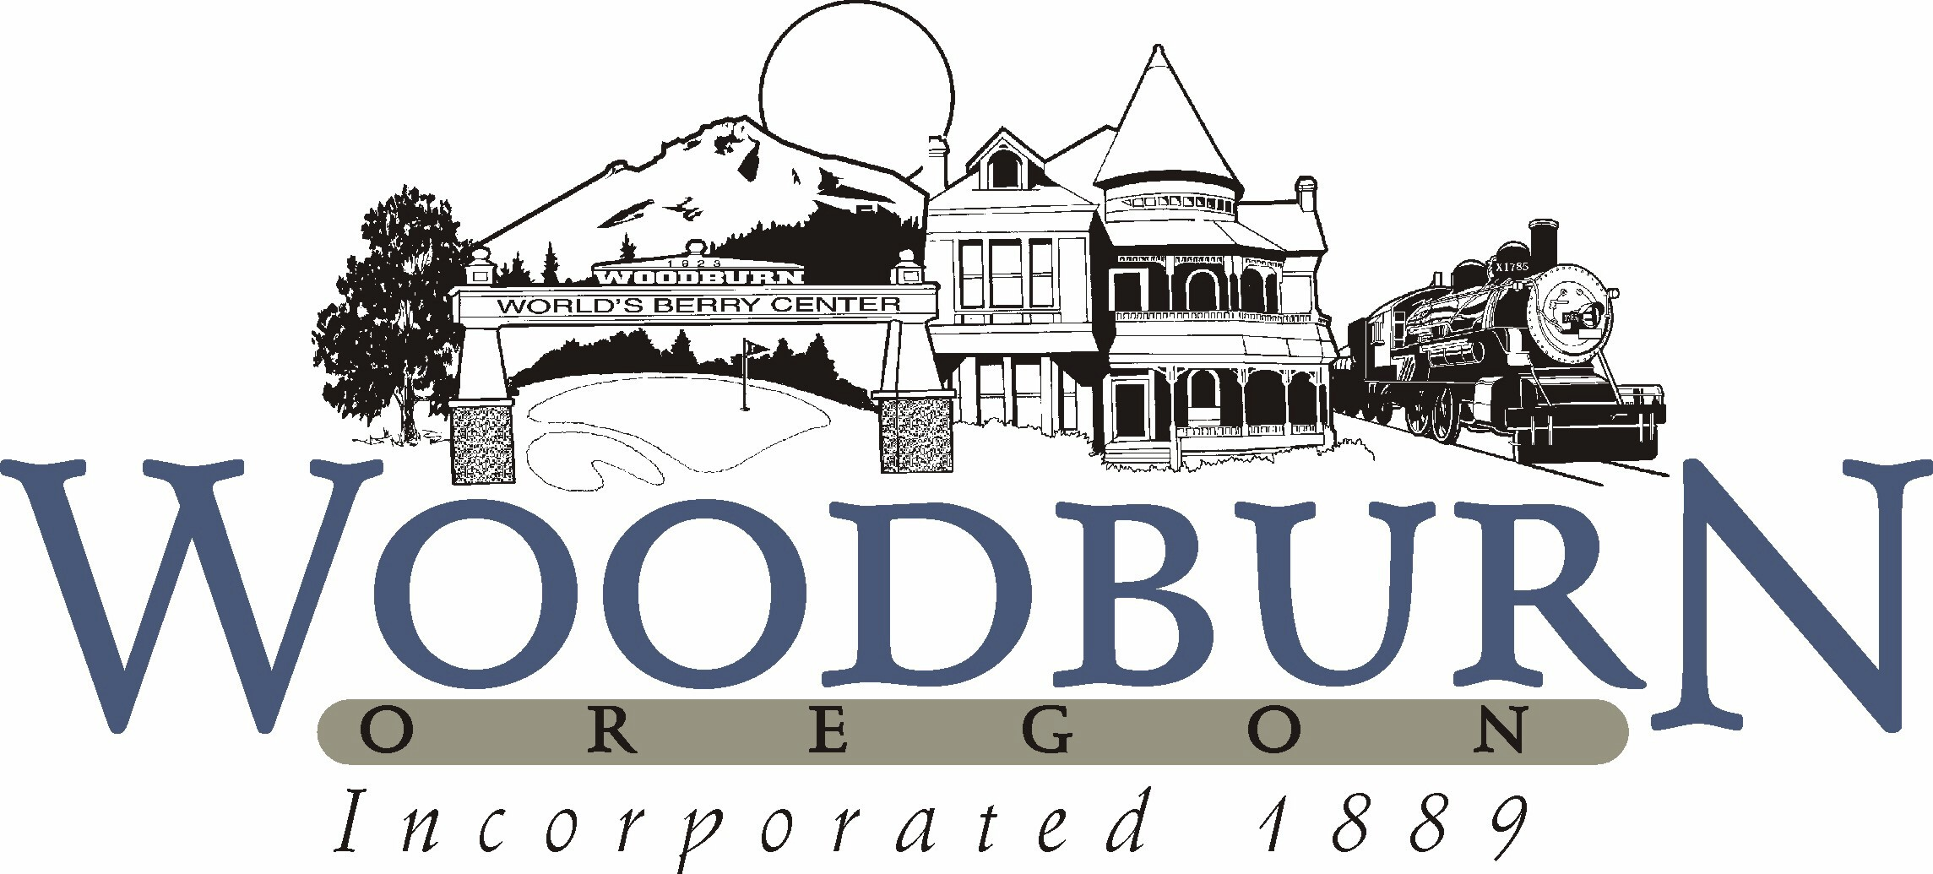
City of Woodburn
Recreation and Park Board Minutes
June 12, 2018 ● 5:30 p.m.

- CALL TO ORDER
  - 5:30 pm

- ROLL CALL
Position I Ricardo Rodrigues, Board Secretary (12/18) Present
Position II Uriel Cruz, Student Member (8/18) Present
Position III Kasi Pankey, Member (12/21) Present
Position IV Eric Swenson, Member (12/19) Present
Position V Donna Stone, Member (12/21) Absent
Position VI Vacant, Member (12/20) Vacant
Position VII David Piper, Board Chair (12/20) Present

Staff Present: Josh Udermann, Jesse Cuomo

- APPROVAL OF MINUTES
Recreation & Park Board Minutes from May 8, 2018 approved unanimously.

- BUSINESS FROM THE AUDIENCE
None.

- NEW BUSINESS
    - Future Park Board meetings – September meeting canceled. Would like to schedule a future facility tour of the Aquatic Center.
    - ORPA Training – Oregon Recreation Parks Association Josh Udermann and Jesse Cuomo attend yearly conference. Jesse helped to run ORPA Summer Leader training – 96 participants from throughout the state attended. Great resource sharing information. Park Board might be interested in being involved in future Summer Leadership training.

- OLD BUSINESS
  - Fall program updates – Looking for Cheer Coach, paid position. Registration on hold until a Cheer Coach is hired. Adding entry-level ballet class, the teacher is volunteering time.
  - Taste of Woodburn Event – Started developing event three months ago. Over the two-day event, nine bands performed. An estimated 1700-2000 people attended. Eric Swenson coordinated entertainment. All the downtown business were very successful during this event. Eric described how each day was filled with lively entertainment. Salsa tasting contest was held on Saturday and a Salsa dancing contest was held on Sunday. Mega Foods was the event’s title sponsor. Helen Koshkaroff was the key coordinator of this event and helped to organize a raffle to raise funds for the Fiesta Court Scholarship program. The event was the kick-off for the Taste of Woodburn passport, which covers the seven culinary regions of Mexico represented in Woodburn’s downtown restaurants. The Tourism Advisory Committee helped to organize this event and the passport. Complete the passport by visiting local businesses for prizes. Next year’s event may move to First Street due to upcoming construction projects.
  - Community Center update – Jesse shared updated Community Center plans. The next step will be community feedback. Will include Senior Center space and flexible event/programming space. Sauna space will move to the deck so that they are more closely monitored by Lifeguards and staff. Josh mentioned that the event space could use additional bathrooms.

- DIVISION REPORTS FROM DEPARTMENT
  - Aquatics

Financial Update –
- Expense – $20,705 → transferred $18,140 from building repairs in building maintenance budget, $38845 total (down from (40,040 last year)
- Revenue – $24,478 (up from $19,870 last year)
- Attendance – 4157, slight decrease from last year, down 300 visits
Program Update
- Swim team – change to new organization, Dolphins
- New fitness classes, aqua combat, youth boxing and adult boxing, starting Friday taekwondo and in July personal training
- All $5 swim week lessons sold out, within a few weeks
- Pool operator position (maintenance) vacant again, just 2 months in the position
- Aquatic Coordinator is entering 3rd recruitment period, first two have been very unsuccessful with unqualified and few candidates (I think a total of 5 applicants in two 3 week recruiting time periods)
- More volunteers starting from North Marion high school empower program working on our side yard area, as well as organization from Levi’s store
- Toured brand new Chehelam Aquatic Center facility
- 325 registered for summer lessons so far
- Group fitness class update:
2014
- Average total number of group exercise water class participants per month: 237
- Average total number of group exercise dryland class participants per month: 205
- 37 classes offered through the week or about 159 classes per month, with an average
- of 2.7 participants per class
2018
- Average total number of group exercise water class participants per month: 560
- Average total number of group exercise dryland class participants per month: 284
- 32 classes offered through the week or about 138 classes per month, with an average of 6.1 participants per class
- Today participation in these classes now makes up about 21% of our daily attendance, up from 12% in 2014.

  - Recreation
    - Spring Sports
      - Just finished spring men’s basketball league. Currently looking for a future sponsor to help with costs. Very well attended program.
      - Survey results from soccer – overall rating 3.7/5, Jesse and Alyssa have been discussing how to best support this
      - Survey results from T-ball – average 3.56/5, would like to do more coach development and change age ranges to 3-4-year-olds and 5-6-year-old group. Hoping to find sponsorship to provide hats.
    - Participation updates
      - Up 11% in Youth sports
      - Hoping to bring down the cost of Adult Sports
      - Up 6 % Youth Rec programming
      - Doubled Adult Rec programming – will offer craft classes in the fall
      - Museum – up 26% in visit, partnered with Marion County, part of passport program
      - Special events up 8%, community BBQ should help raise that number even more.
    - 4th of July event – more vendors than the past and include entertainment, the splash pad will be open
    - Governor’s camping kickoff Partnership – 150 participants come out and camp
  - Parks & Facilities
    - Splash Pad now open, renovations have been helping with drainage
    - Centennial Park Clean up and bark dust project at with volunteers scheduled for September

- FUTURE BOARD BUSINESS
None.

- BOARD COMMENTS

- ADJOURNMENT
  - 6:50 p.m.

