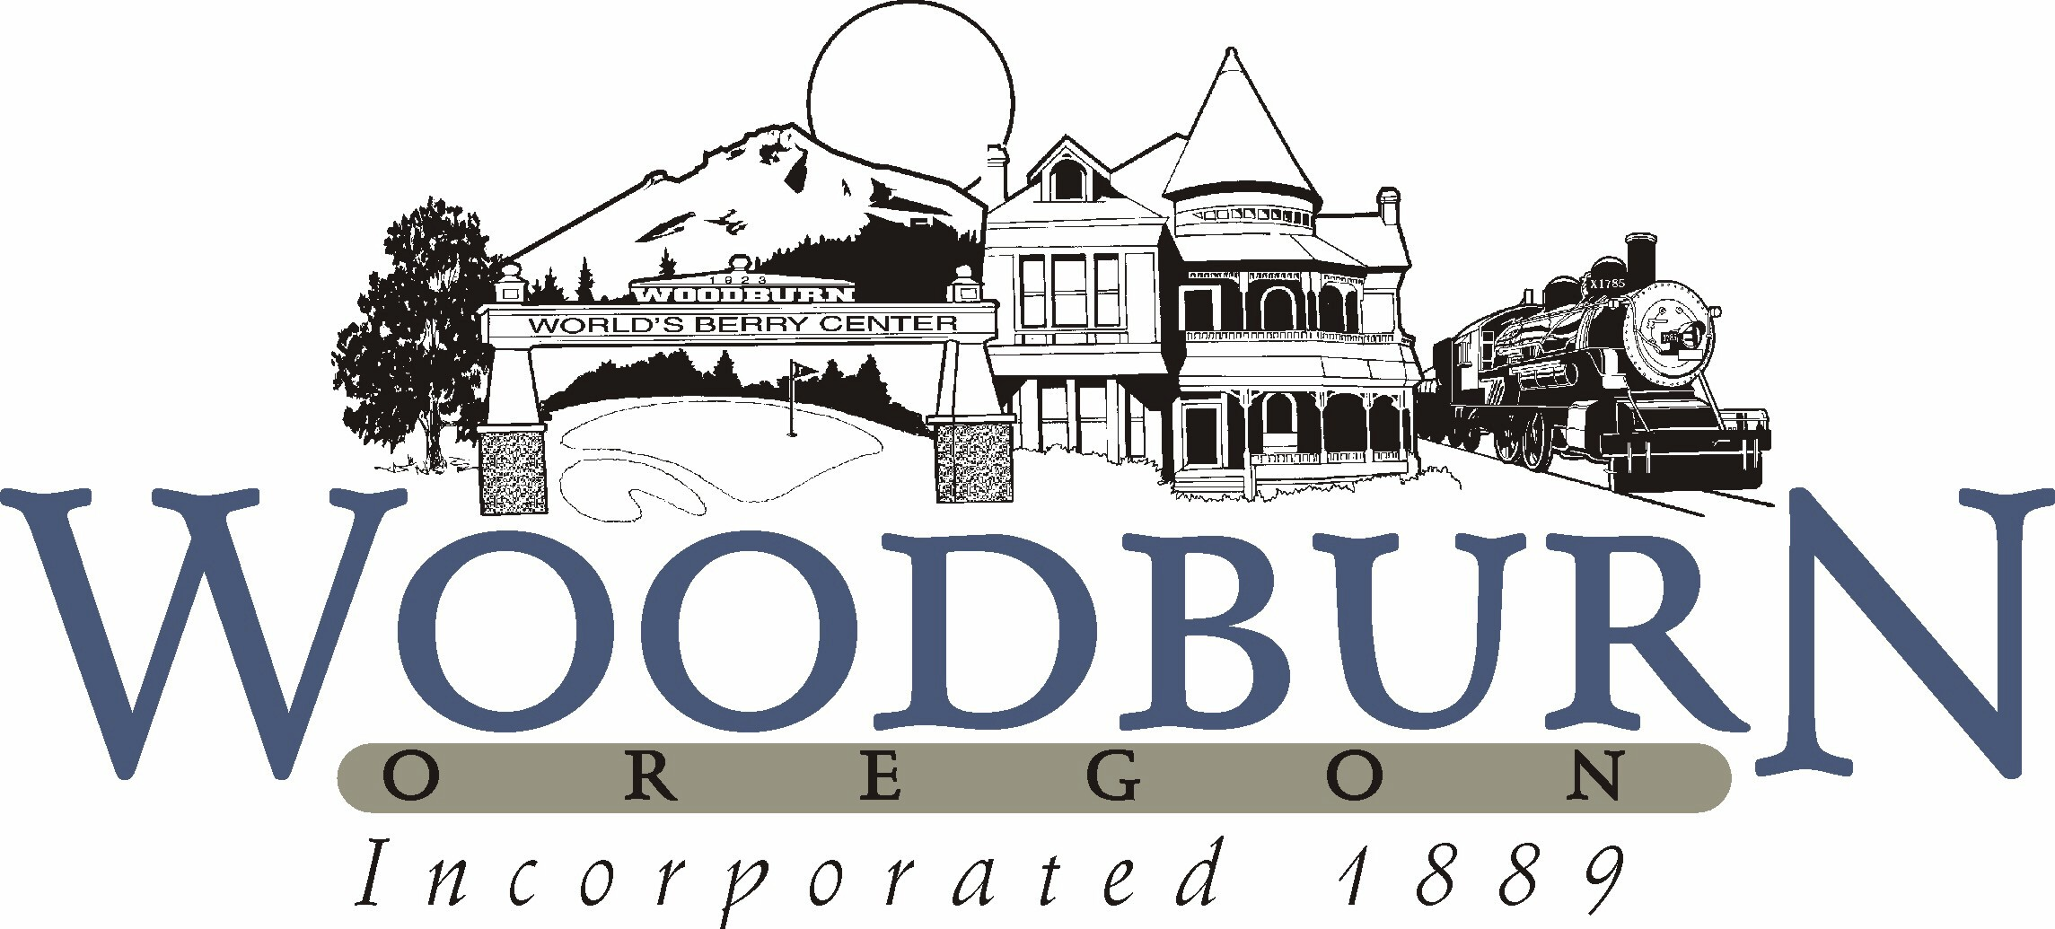
City of Woodburn
Recreation and Park Board Minutes
January 9, 2018 ● 5:30 p.m.

- CALL TO ORDER
  - 5:30 pm

- ROLL CALL
Position I Ricardo Rodrigues, Board Secretary (12/18) Present
Position II Uriel Cruz, Student Member (8/18) Present
Position III Kasi Pankey, Member (12/21) Present
Position IV Eric Swenson, Member (12/19) Present
Position V Donna Stone, Member (12/21) Absent
Position VI Vacant, Member (12/20) Vacant
Position VII David Piper, Board Chair (12/20) Present

Staff Present: Josh Udermann, Jesse Cuomo

- APPROVAL OF MINUTES
No minutes approved during this session.

- BUSINESS FROM THE AUDIENCE
None.

- NEW BUSINESS
  - Recreation Year in Review
    - Recreation - Introduction of new Recreation Supervisor, Alyssa Nichols.
    - Museum Remodel – four new exhibits
    - Applying for Heritage Award (Oregon Heritage Grant) – Would like to hold future Park Board meeting at the Museum
    - Museum Fundraiser - sent out 1500 mailers and have received $750 in donations back. Working with Friend’s of the Bungalow to keep the momentum going. Also, building into Main Street fund to raise additional funding for improvements.
    - Fiesta Mexicana – became an Oregon Heritage Tradition event last year. To be considered an Oregon Heritage Tradition the event must meet certain requirements including operating for 50 or more years and a significant celebration of community and culture. Last year’s Fiesta Mexicana attendance was 23,000, which included over 13,000 people on Sunday (the last day of the Fiesta).
    - Secured $12,000 sponsorship revenue through partnerships Jesse and Josh created through Kiwanis.
    - Sports participation – 6% increase. Jesse expects that to slowly continue to grow.
    - Cooking classes, trips, and other Recreation programming saw a 2½ % increase. Looking at offering more programming.
    - T3 Internship program through Boys and Girls Club - three interns assigned, the City was reimbursed for all of their hours ($1200 per person), and they have been hired on as Recreation Leaders. Working with HR to see if we can get reimbursed again.
    - Splash pad – very successful, still some development to be done including seating.
    - Bungalow Theater display downtown with fundraising information.
    - Zombie Camp & Safety Camp– excited to see Alyssa take on her new role and shape the direction of the program.
    - Upcoming programs – guitar lesson, lego robotics, fishing camp, soccer camp with Challenger Sports and Kidz Love Soccer, Rec Tennis family class and cardio tennis camp, craft camp, Spike Ball
  - Aquatics Year in Review
    - Facility maintenance projects – new main pool and wading pool heaters, exterior lighting upgrade to LED, Interior light replacements over the wading pool and spa to LED fixtures, main pool new chemical controller, new upgraded WIFI, slide structure repairs, enclosure front fitness space, addition of exit door and window to rear fitness space, back fitness room cardio equipment/ new HVAC/ security fencing / and new TV
    - Woodburn Triathlon – 57 participants
    - Facility Use – 1432 swimming lesson sessions, 45 swimmers on the summer league swim team, 8 swimmers on the high school club swim team, 50+ in splash dance end of summer party, 2 club swimming meets in July/December
    - Aquatic Center total admission for 2017 44,193, a 4.3% increase from 2016
    - Other Aquatic Center events included: Spooky splash, underwater egg hunt, fall carnival, Labor Day/Memorial Day BBQ, and parent’s night out
    - Fitness classes – group fitness class participation has steadily increased throughout the years. Attendance grew from 3,318 in 2012 to 7,755 in 2017.
    - For 2017-2018 Aquatic Center total revenue is up roughly 18%
    - Memberships – new Silver & Fit membership program started January of 2017. There have been 3,355 admissions, 80 members with at least two admissions. Black Friday membership sale set a record of $6,762. There has also been a large growth in 3-month family passes – RX Program.

- OLD BUSINESS
None.

- DIVISION REPORTS FROM DEPARTMENT
  - Aquatics
No updates at this time.
  - Recreation
No updates at this time.
  - Parks & Facilities
No updates at this time.

- FUTURE BOARD BUSINESS
None.

- BOARD COMMENTS
The Park Board is excited with the increase in programming and direction that the Recreation and Aquatics Departments are going.

- ADJOURNMENT
  - 5:52 pm

