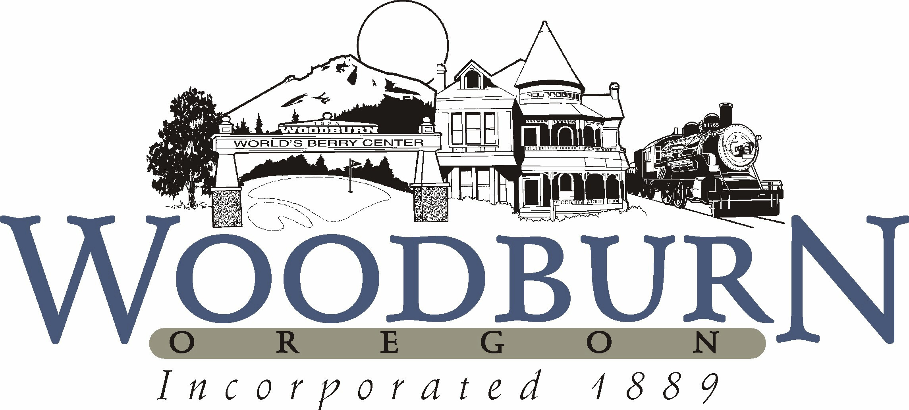
City of Woodburn
Recreation and Park Board Agenda
September 8, 2015 ● 5:30 p.m.

- CALL TO ORDER

- ROLL CALL
Position I Ricardo Rodrigues, Member (12/18)
Position II Vacant, Student Member (12/15)
Position III Joseph Nicoletti, Board Secretary (12/17)
Position IV Rosetta Wangerin, Board Chair (12/17)
Position V Chris Lassen, Member (12/17)
Position VI Ardis Knauf, Member (12/16)
Position VII David Piper, Member (12/16)

- APPROVAL OF MINUTES
Recommended Action: Approve Recreation & Park Board Minutes from July 14, 2015.

- BUSINESS FROM THE AUDIENCE
This portion of the agenda allows the public to introduce items for Board consideration not already scheduled on the agenda.

- NEW BUSINESS

- OLD BUSINESS
  - Fiesta Mexicana Update
  - Museum Grants
  - CIP Park Project List

- DIVISION REPORTS FROM DEPARTMENT
  - Aquatics
Financial Update – July & August
- Expenses – $103,106 a 1.3% or $1,372 increase over last year
- Revenues – $67,540 a 7.8% or $4936 increase over last year
- Attendance – 10,224, 188 fewer than last year
Program Update
- Swim Lessons
  - Group lessons - Summer 2014 689 – Summer 2015 781
- Ran Junior Lifeguard and Make-A-Splash Camps – 21 participants in both camps over two dates (July & August camps), 15 in 2014 dates
- 598 in group fitness classes for August
- Neon Splash Dance Party – Had 26 kids in attendance

Marketing/Other
- 1 week swim pass – Last week of August sold 32 memberships
- 1 week free – sorry to see you go, postcards sent today to all canceled monthly memberships over the past 3 years
- 1 month free – for new customers only, Safeway advertising, starts Oct 15th
- Advertisement at Frontier Golf Course in Canby, Or, Stone Creek Golf Club and the Charbannaeu Golf Course, OGA Course in Woodburn – 2 years at each of those locations, 2x3 ft sign on tee holes, on scorecards, and at the main entrance of the OGA course.
- Lifeguard class – hired 6 new lifeguards – 4 of them completed swim instructor training
- Labor Day BBQ – 136 people for the day, disappointing, donated leftover food
  - Recreation
Youth Sports
- Youth soccer underway! Have around 315 registered this season.
- Youth cheer is a new program and has booked full with 45 students! The demand for this program is exciting and we’re looking at ways to include an additional program in the winter.
- Youth volleyball is also a new additional with 20 registered in that program. Because gym space is very tight within the community, the program will be at the Foursquare Church gym.

Adult Programs
- Ft. Vancouver Active Adult Trip tomorrow with 15 registered.
- Recreation trip, a hike, scheduled for Saturday has 3 registered. Hikes will likely be taken off the schedule due to low demand.
- Oktoberfest Trip coming up on Sept. 17.

Events
- The Blazers are coming to town with a relay on Friday Sept. 18. This will include a school assembly, other activities and will conclude with an event in the Downtown Plaza from 4-6pm. The event is free and open to all ages.

Youth Advisory Board
- Doing recruitment and kick off parties currently to attract new members.
- Had 5 interested in the park board position and just waiting to receive applications.

Adult Sports
- Men’s Basketball Fall League starts up in October.

  - Parks & Facilities

- FUTURE BOARD BUSINESS

- BOARD COMMENTS

- ADJOURNMENT

